A NOTE TO THE EDUCATOR:

As students play “For Crown or Colony?” they are presented with a variety of characters presenting a broad spectrum of political opinions and perspectives. Some characters are more “for the Crown” (i.e., Loyalist), while others are more “for the Colony” (i.e., Patriot). Still other characters may fall somewhere “in between,” exhibiting neither particular allegiance to the Crown or the Colony. Students ultimately have to decide whether “their version” of Nat is, as the game title implies, “for Crown or Colony.”

A key element of the game is the notion that history is not always comprised of absolute, clear-cut distinctions. This can be a challenging idea for students. Different people can have different interpretations of the same event. An individual’s attitudes and ideas can change over time. Patriots and Loyalists alike had moderate to extreme viewpoints.

This activity asks students to consider where the characters of “For Crown or Colony?” fall on the political spectrum, ranging from hardcore Patriots to extreme Loyalists.

The activity can be used at various points while you and your students are using “For Crown or Colony?” Students can begin utilizing the activity after completing Parts 1 & 2 of the game, shifting and realigning characters based on new information, or complete the activity once after finishing the entire gameplay experience.

Materials (included in this file)
8 ½ by 11 sign with a CROWN
8 ½ by 11 sign with a DON’T TREAD ON ME flag
8 ½ by 11 sign reading “Patriot”
8 ½ by 11 sign reading “Loyalist”
8 ½ by 11 sign reading “We have to respect and obey the British troops in Boston.”
8 ½ by 11 sign reading “We have access to a huge market of people in England who want to buy our raw materials.”
8 ½ by 11 sign reading “We have access to merchants that sell us the finest goods money can buy from around the world.”
8 ½ by 11 sign reading “We have the King and Parliament looking out for our best interests.”
8 ½ by 11 sign reading “We have the benefits of a being part of an important Empire but freedoms of our own.”
8 ½ by 11 sign reading “As English subjects, we have a responsibility to help England pay its debts.”
8 ½ by 11 sign reading “We have local leaders who know and care about us.”
8 ½ by 11 sign reading “We have access to locally made goods that cost us less than imports.”
8 ½ by 11 sign reading “We have built up homes, businesses, and our own society.”
8 ½ by 11 sign reading “We should boycott imported goods.”
8 ½ by 11 sign reading “We have no duties to support or obey the British soldiers in Boston.”
8 ½ by 11 sign reading “We should spend our money supporting local merchants, farmers, and shopkeepers.”
Large images of Nat Wheeler, Hugh White, Constance Lillie, Theophilus Lillie, Mr. Edes, Mr. Wheeler, Royce Dillingham, Solomon Fortune, Mrs. Edes, Phillis Wheatley, and Paul Revere.

You will also need:
A long piece of wide ribbon, thick yarn, or wide tape
Tape or tacks

Steps for the Activity
1) Affix the long piece of ribbon, yarn, or tape horizontally along the wall of the classroom. Put the picture of the Crown at the right end of the ribbon and the picture of the “Don’t Tread on Me” flag (Colony) at the left end.

2) Begin the discussion by talking about the title of the mission, “For Crown or Colony?” What does it mean? What is its significance? How does the title relate to the action of the game?

3) Distribute the signs with words and phrases to the students. Explain to students that the signs contain terms and ideas that might be associated with or spoken by people who are either “for crown” or “for colony.” Some of the words and phrases may be applicable to both people who were for the crown and for the colony.

Ask students to review the terms and phrases on their individual signs, and consider whether the term or statement is more relevant to the Patriot viewpoint, more relevant to the Loyalist viewpoint, or if it falls somewhere “in between.”

Ask students to come up one at a time and tape their signs along the ribbon according to which political viewpoint the word or phrase represents. Signs placed near the crown should reflect ideas or terms related to Loyalists. Signs placed near the flag should reflect ideas or terms related to Patriots. Some ideas may fall somewhere in the middle of the spectrum. Students should try to explain why they are placing their sign at a particular place on the continuum.

Below are some general guidelines on where the signs could be placed on the spectrum. Students may be able to convincingly defend choices that do not align with the suggested placement listed below.

- “Patriot”
Should be placed near the flag on the left end of the spectrum.
- “Loyalist”
Should be placed near the crown on the right end of the spectrum.
- “We have to respect and obey the British troops in Boston.”
More of a Loyalist statement.
- “We have access huge market of people in England who want to buy our raw materials.”
Could be either Loyalist or Patriot statement.
- “We have access to merchants that sell us the finest goods money can buy from around the world.”
Could be either Patriot or Loyalist statement, though many Patriots were anti-importation.
- “We have the King and Parliament looking out for our best interests.”
More of a Loyalist statement.
- “We have the benefits of a being part of an important Empire but freedoms of our own.”
More of a Loyalist statement.
- “As English subjects, we have a responsibility to help England pay its debts.”
More of a Loyalist statement.
- “We have local leaders who know and care about us.”
Could be either Patriot or Loyalist statement, though Patriots were more supportive of local leadership.
- “We have access to locally made goods that cost us less than imports.”
More of a Patriot statement.
- “We have built up homes, businesses, and our own society.”
Could be either Patriot or Loyalist statement.
- “We should boycott imported goods.”
More of a Patriot statement.
- “We have no duties to support or obey the British soldiers in Boston.”
More of a Patriot statement.
- “We should spend our money supporting local merchants, farmers, and shopkeepers.”
More of a Patriot statement.

4) Show students the character signs one at a time. Ask a student to come up and place each character on the continuum where they feel the character’s allegiances lie. Allow students to discuss what they believe the characters’ perspectives to be, based on their experiences playing the game.

Encourage students to place characters on the line in a position reflecting how strongly they feel about the Patriot vs. Loyalist cause (middle of the line is “on the fence,” extreme ends of the line would be “passionate supporter”).

5) Review the placement of all the terms, phrases, and characters. Ask students if they agree. Reinforce that while some statements (and characters) are very clear cut as far as having a Patriot or Loyalist perspective, others are hazier and not as clear cut.

6) Ask students to reflect on the reasons why the characters have such different perspectives. What are the motivations for the various viewpoints? Ask students to imagine where they would fall on the continuum if they had lived in Boston in 1770, and didn’t know what the results of the American Revolution were going to be.

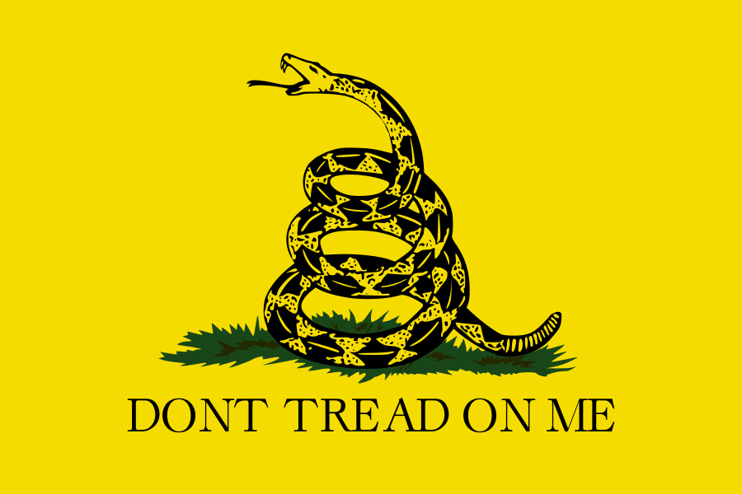
Source: Wikimedia Commons, http://commons.wikimedia.org/wiki/File:Gadsden_flag_large.png

Patriot
Loyalist
We have to respect and obey the British troops in Boston.
We have access to a huge market of people in England who want to buy our raw materials.
British merchants sell us the finest goods money can buy from around the world.
We have the King and Parliament looking out for our best interests.
We have the rights and privileges of being part of the British Empire, and additional freedoms to shape our own communities.
As English subjects, we have a responsibility to help England pay its debts.
We have local leaders who know and care about us.
We have access to locally made goods that cost us less than imports.
We have built up homes, businesses, and our own society.
We should boycott imported goods.
We have no duty to support or obey the British soldiers in Boston.
We should spend our money supporting local merchants, farmers, and shopkeepers.
It is our duty to obey the King and Parliament.

All men have rights and deserve to be treated equally.
Nathaniel “Nat” Wheeler

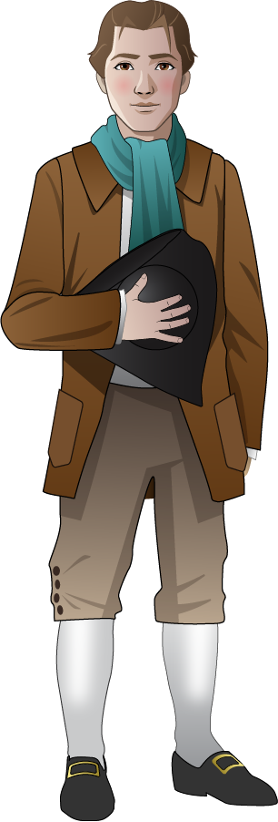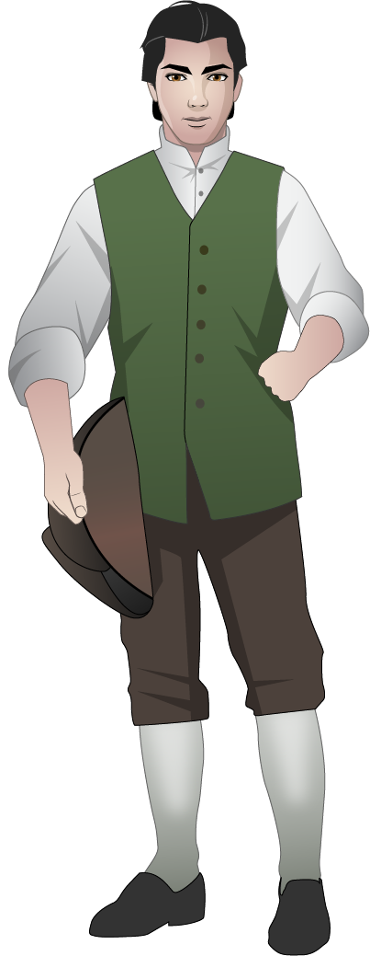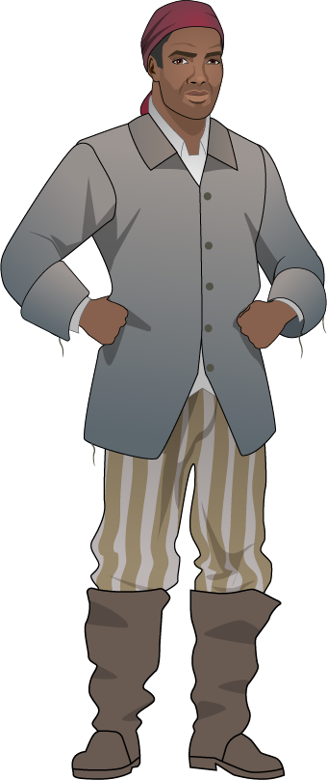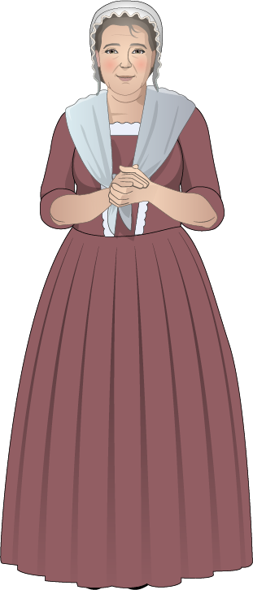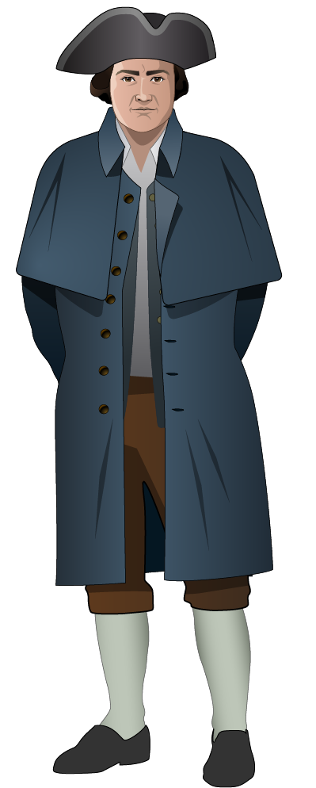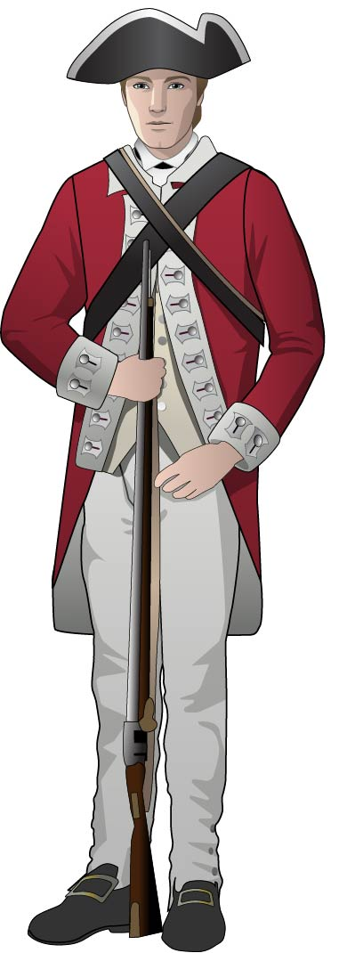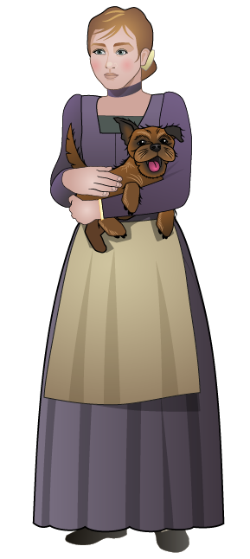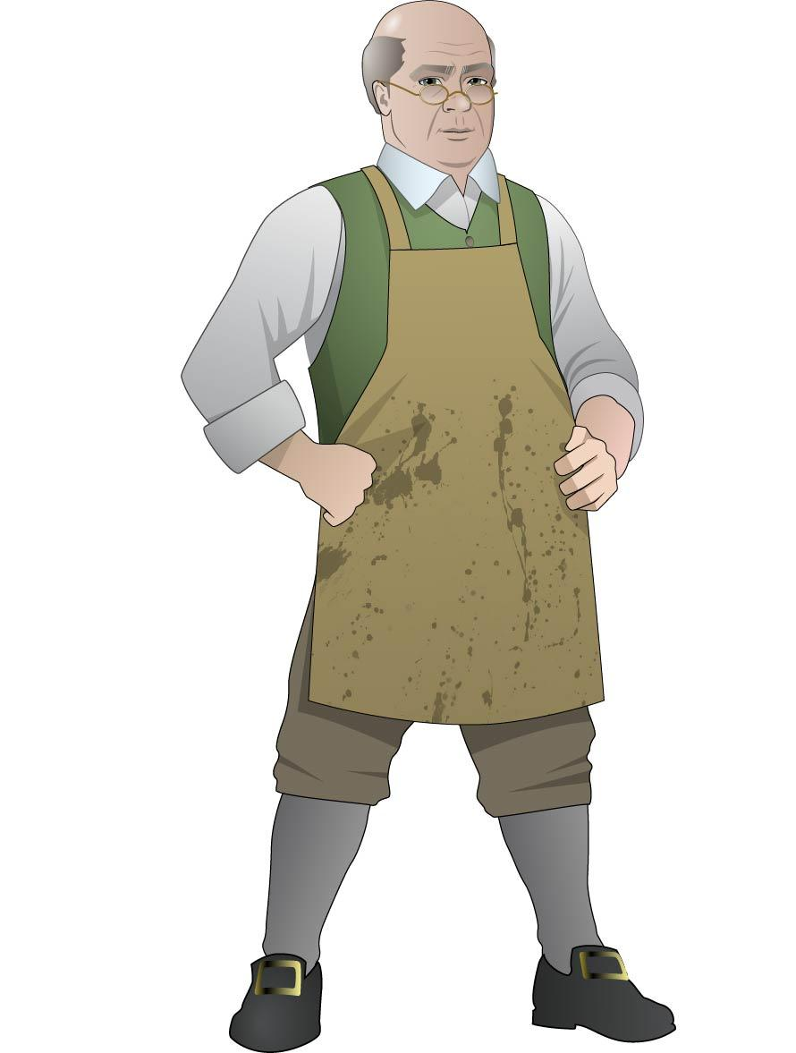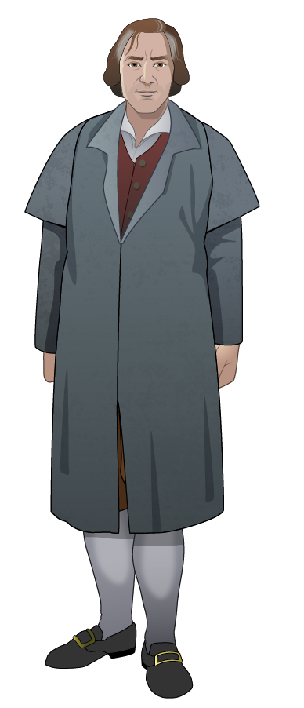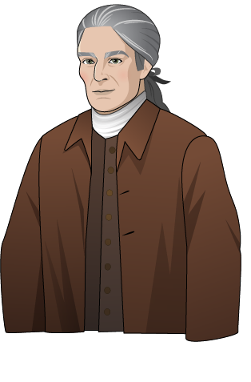
Nathaniel “Nat” Wheeler
Royce Dillingham
Solomon Fortune
Martha Edes
Phillis Wheatley
Paul Revere
Hugh White
Constance Lillie
Benjamin Edes
Mr. Wheeler
Nathaniel “Nat” Wheeler
Royce Dillingham
Solomon Fortune
Mrs. Martha Edes
Phillis Wheatley
Paul Revere
Hugh White
Constance Lillie
Mr. Benjamin Edes
Mr. Wheeler
Theophilus Lillie

