Slave Quarter Photographs

The following photographs were taken long after the Civil War. The people seen in the photographs are most likely sharecroppers who lived lives too similar to their enslaved ancestors, but they give some idea, if not a precise one, of the conditions in which the enslaved lived. Also, bear in mind the photographs taken in the 1930s represent what actual slave quarters looked like sixty years after the end of slavery, though at that time, many were still being used to house poor farm workers with minimal amenities.

A Note to the Educator:
You should decide how to present these photographs to your students, that is, in sets for small groups or individuals, projected for the whole class to see, etc. It’s often helpful for students to have time to mull over one or two photographs by themselves. The Photo Analysis sheet will help students to be thorough in their examination of a picture.

There are many photographs of slave quarters online and, should you want to have your class complete more research about this particular aspect of slavery, they will find pictures that range from neat, sturdy brick buildings to hovels that hardly look habitable by farm animals. In your discussion of the pictures, try to elicit from your students the understanding that the slave experience differed in many ways from one place to another because of many factors (climate, location, the attitudes and temperament of the slaveholders, and the quarters), but there was no good slavery.
Name: ___________________ Class: __________ Date: ____________

Photograph Analysis Guide

What is the title of the photograph? | Where was the photograph taken? When was it taken?
Who is the photographer? | Who are the people in the photograph?
What objects, things, or animals do you see in the photograph? What are these things made of? | What words are in the photograph that may help you understand what the photograph is about (if there are any)?
Write about things you see that indicate when the picture was taken (clothing styles, what things look like and how they are made, etc.) What might you say about the level of technology available to people at that time and place? | What are the people (or animals) doing?
What do you infer about the people and the place from all that you notice? Do the people or objects seem posed or arranged? Does it seem as if the photographer wants you to come away with a certain feeling about what is in the picture? | I can’t make any sense of the photograph. This is probably because… (List as many reasons as you can.)

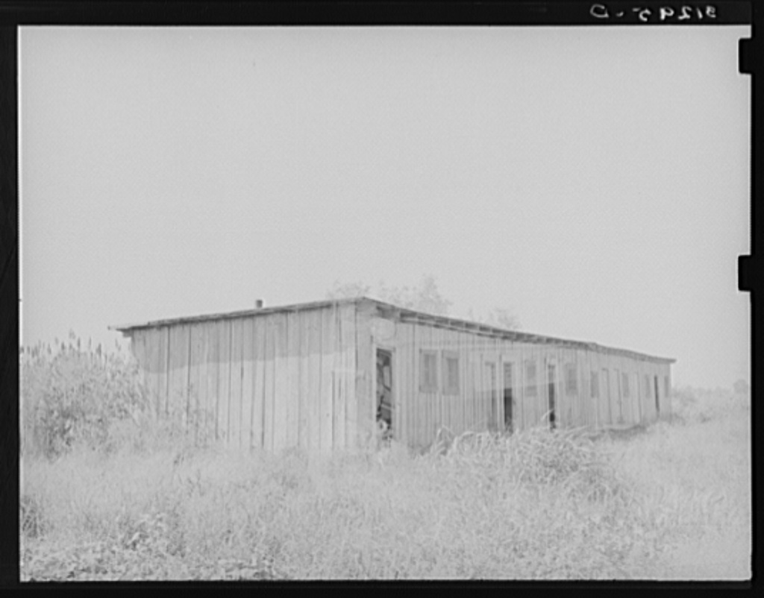

Old slave quarters near Caruthersville, Missouri.
Farm Security Administration - Office of War Information Photograph Collection
(Library of Congress)
Lee, Russell, 1903-1986, photographer.
CREATED/PUBLISHED- 1938 Aug.
http://memory.loc.gov/service/pnp/fsa/8b20000/8b20300/8b20394v.jpg

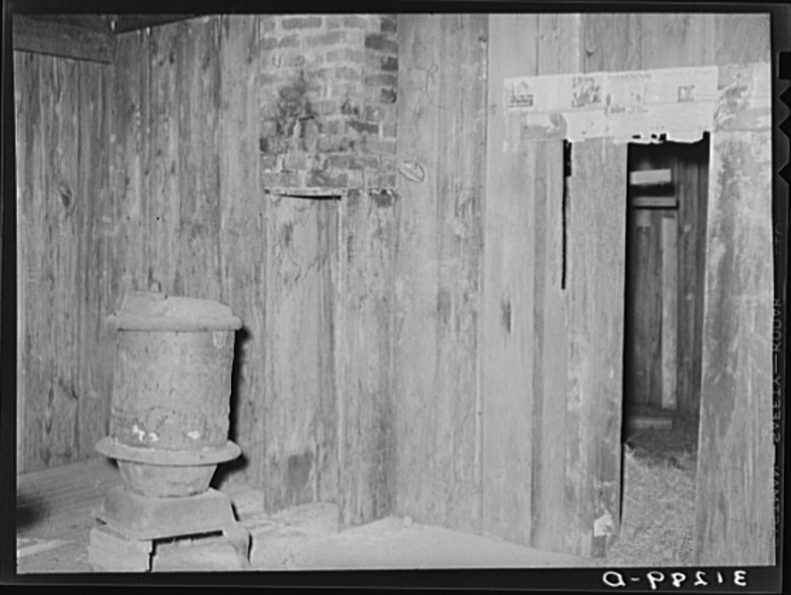

Interior of old slave quarters near Caruthersville, Missouri.
Farm Security Administration - Office of War Information Photograph Collection
(Library of Congress)
Lee, Russell, 1903-1986, photographer.
CREATED/PUBLISHED- 1938 Aug.
http://memory.loc.gov/service/pnp/fsa/8b20000/8b20300/8b20388v.jpg

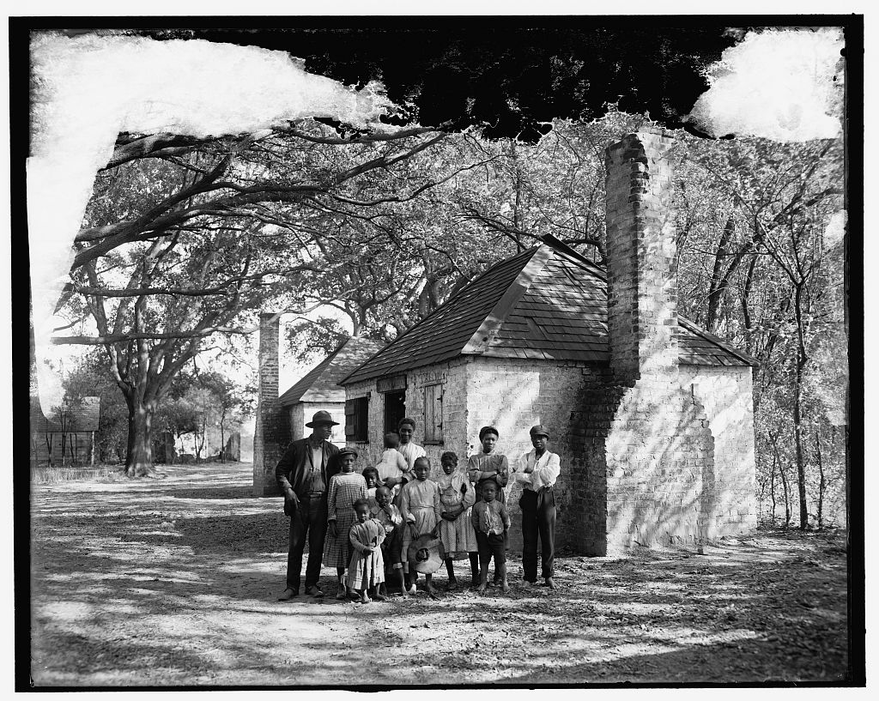

The Whole black family at the Hermitage, Savannah, Ga.

Detroit Publishing Company Photograph Collection- no. 034666

CREATED/PUBLISHED: 1907?

Gift; State Historical Society of Colorado; 1949
http://memory.loc.gov/service/pnp/det/4a10000/4a18000/4a18100/4a18122v.jpg

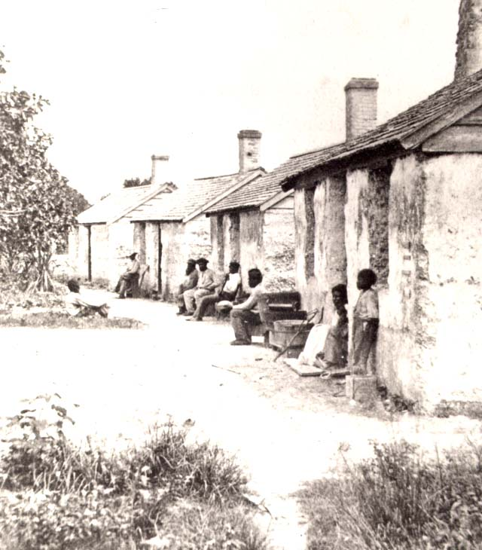
Slave quarters on St. Georges Island
Collection of the New-York Historical Society
http://www.pbs.org/wgbh/aia/part4/images/4sqsg17b.jpg

