A NOTE TO THE EDUCATOR:

On the following pages, you will find “flashcards” with terms and definitions (both combined and separate) that your students may encounter while playing Part 1 of “Flight to Freedom.” These terms and definitions can be introduced and practiced before or during the time students see or hear them in the context of Mission US or in their American history study. The discussion questions and writing prompts will provide further opportunities for students to have more practice with the words and terms.

Divide your students into small groups of four or five, and ask each group to review the terms and definitions.

After your students have had a chance to review and discuss the terms and definitions, distribute the excerpt from the reporter’s interview with Lucy. Review the directions with your students, and ask them to complete the text using the terms they studied.

Here are the terms which should be inserted into each paragraph of Lucy’s life story:
Paragraph 1- plantation, Lexington, hemp
Paragraph 2- master, slaves, slop, chicken coop, big house
Paragraph 3- slave quarters, plantation, road pass, overseer
Paragraph 4- hemp-break, “sold south”
Paragraph 5- smokehouse, auction

plantation  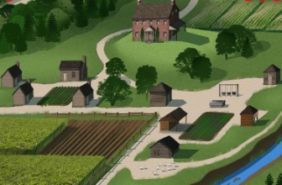  a large farm, normally specializing in the growth of one cash crop and worked by slaves | Lexington  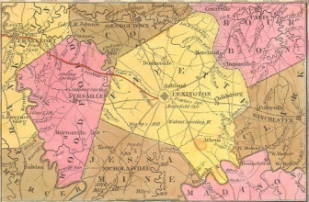  a city in northern Kentucky, located about 80 miles from the Ohio border
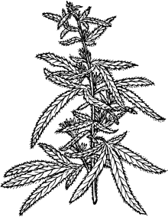  hemp  a plant, the coarse fibers of which can be used to make rope, clothing, or paper | master  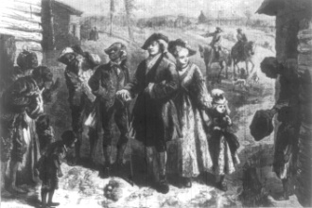  a person who owned a slave
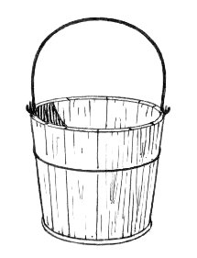  slop  bran or cornmeal mixed with water and fed to pigs and other livestock | slaves  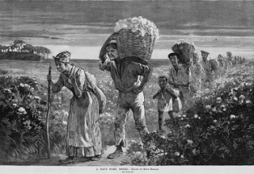  people owned by and forced to work for someone else, not earning money or reward for their effort
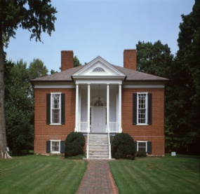  Big House  a reference to the plantation owner’s home, the biggest house on the plantation | 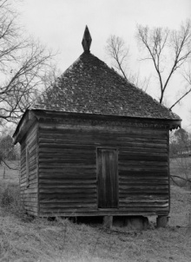  chicken coop  a shed or other enclosure where chickens are kept and raised

road pass  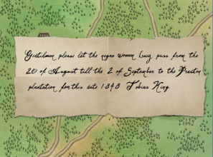  a pass needed by slaves (and sometimes by free blacks) giving them legal permission to travel in the South | slave quarters  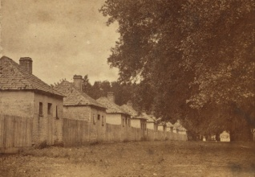  the housing for slaves, oftentimes small shack-like houses with very few comforts
hemp-break  a machine used to separate hemp fibers from the plant’s stalk | overseer  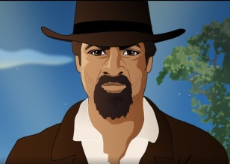  a person, usually white, who was in charge of the day-to-day operations of a plantation, including the discipline of slaves
smokehouse  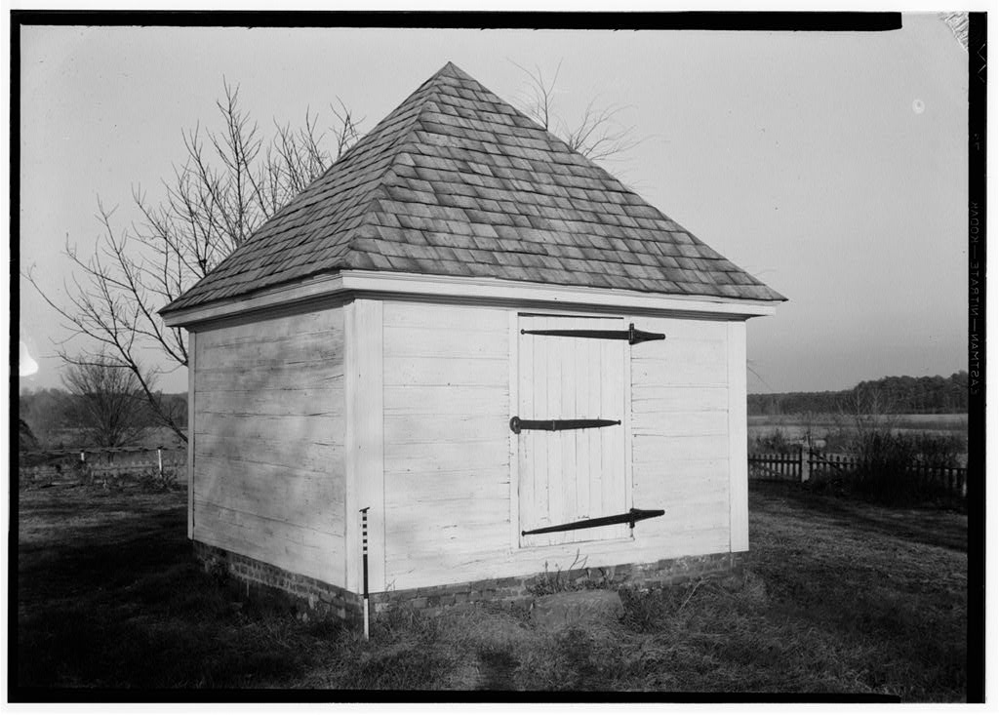  a place to “smoke,” or preserve, meat | “sold south”  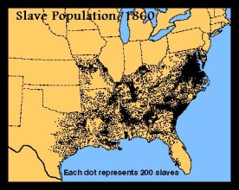  the term used when slave owners decided to sell either disobedient or nonessential slaves further south as punishment or to make money
auction
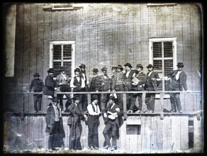
a public sale where goods or services go to the highest bidder

plantation  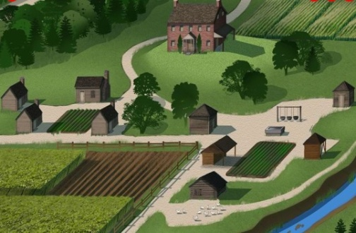 | Lexington  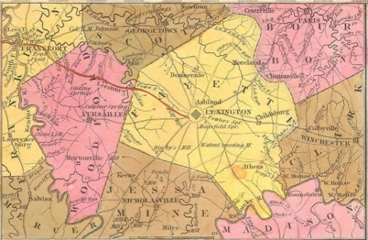
hemp  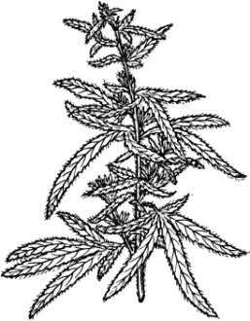 | master  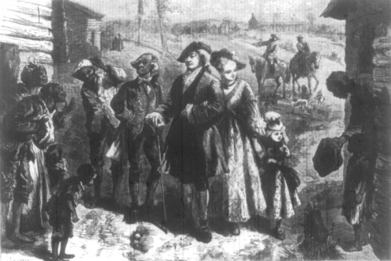
slop | slaves  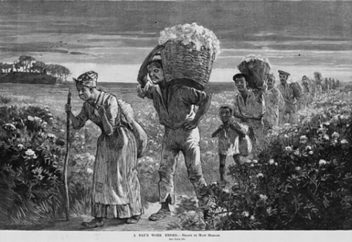
Big House  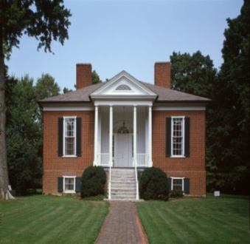 | chicken coop  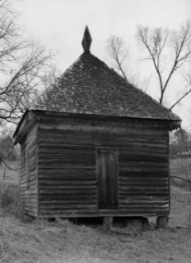

road pass  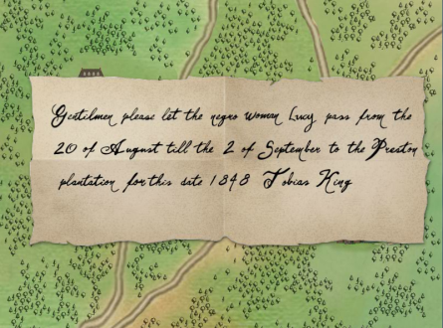 | slave quarters  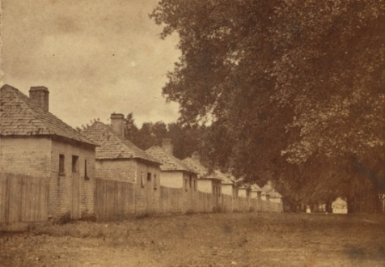
hemp break | overseer
smokehouse | “sold south”
auction
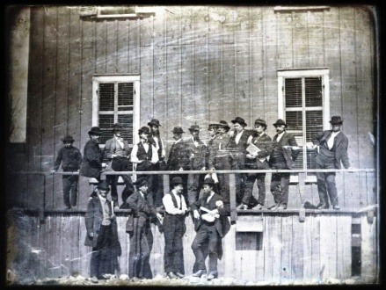

a large farm, normally specializing in the growth of one cash crop and worked by slaves | a city in northern Kentucky, located about 80 miles from the Ohio border
a plant, the coarse fibers of which can be used to make rope, clothing, or paper | a person who owned a slave
bran or cornmeal mixed with water and fed to pigs and other livestock | people owned by and forced to work for someone else, not earning money or reward for their effort
a reference to the plantation owner’s home, the biggest house on the plantation | a shed or other enclosure where chickens are kept and raised

a pass needed by slaves (and sometimes by free blacks) giving them legal permission to travel in the South | the housing for slaves, oftentimes small shack-like houses with very few comforts
a machine used to separate hemp fibers from the plant’s stalk | a person, usually white, who was in charge of the day-to-day operations of a plantation, including the discipline of slaves
a place to “smoke,” or preserve, meat | the term used when slave owners decided to sell either disobedient or nonessential slaves further south as punishment or to make money
a public sale where goods or services go to the highest bidder
Name: Date:

Activity: In the years following the Civil War, former slaves celebrated the end of slavery with a holiday called “Juneteenth.” Juneteenth, held annually on June 19, commemorated the day on which slaves in Texas learned of slavery’s abolition.

This activity imagines Lucy is telling a reporter about her life and adventures at a Juneteenth picnic in 1868, twenty years after the beginning of “Flight to Freedom.”

After reading and talking about the words and terms on the flash cards, read this excerpt from Lucy’s interview with the reporter, describing what her life was like in Kentucky. Use the cards and your memory to help you fill in the missing words and terms. Some words may be used more than once.

Auction  master  chicken coop  slave quarters | big house  hemp-brake  overseer  slop | hemp  plantation  slaves  smokehouse | Lexington  road pass  sold south

“I was born on the King _________________, not far from the city of _________________, in northern Kentucky. The King family grew _____________, which was used to make rope. They needed lots of rope in those days, to bundle up the cotton being grown further south.

_______________ King and his family owned me and about fifteen other ________________. We worked hard, day in and day out. I had to do all sorts of work for the Kings: I had to do the laundry, give the hogs their_______________, and gather eggs from the_________________. Sometimes, I also got called up to the _________________ to answer to Miss Sarah, Master King’s daughter. I had to do any little thing she wanted, no questions asked. Miss Sarah and I were friendly when we were children, but as I grew older she ordered me around and made me work hard for her, too. I worked from the moment I got up in the morning until the moment I went to bed at night. It was a hard life.

I lived in the __________________ with my mother and my brother Jonah. My daddy lived on another _________________, a few miles away. Sometimes, we could get a __________________ from Mr. Otis to go and visit my daddy. Mr. Otis was the Kings’_________________. He was not a kind man. He would yell at me, and frighten me, and sometimes he whipped or beat the other slaves. It was his job to make sure we did our work.

One year, not long after my fourteenth birthday, there was some big trouble. Henry, one of the slaves, had run off and been brought back. Mr. Otis thought Henry purposefully broke the __________________, to slow down the hemp harvest and cost Master King money. Henry was afraid he would be _________________, to one of the big cotton plantations, where they worked slaves to death. He would never see any of us ever again.

I had to do Henry’s work for him, because Mr. Otis had beaten him so badly. One night, the __________________ burned to the ground, and Mr. Otis thought I’d done it. I’d never been so scared in all my life. I was sure I’d be sold at an _________________. I would never see my mother or Jonah again. I had no choice. I had to run away.”

