A NOTE TO THE EDUCATOR:
“Flight to Freedom” is largely about cause and effect, emphasizing how a slave’s choices—to comply with authority or resist in some manner—may impact her life, the lives of others, and the nation. At the same time, the game and classroom materials demonstrate how national events, such as the Fugitive Slave Act, have implications on the lives of individuals. Ultimately, Mission 2 will show students that through acts of resistance, Americans—both white and black, free and slave—shaped the world in which they lived.

This Pre-Game Activity has two parts. Part I focuses on individual choices, examining common scenarios students or their peers might confront in daily life. Part II asks students to think historically, examining acts of resistance across different eras of US History.

Part I:
The goal of Part I is to introduce students to the concepts of cause, effect, and resistance. It will also introduce students to the names and roles of the badges they will be earning in the “Flight to Freedom” game. Teachers will present a series of scenarios to their students. Each scenario will present a situation a student or their peers might confront in their daily lives. Each scenario is followed by three choices: 1) to reluctantly comply, 2) to provide moderate resistance, and 3) to completely resist what’s being asked.

You can opt to divide your students into pairs or small groups to review the scenarios and determine the best course of action, to read the scenarios aloud to the class and discuss options, or to present the scenarios and take a vote (with student eyes hidden) on the best option.

After your students have decided on the best course of action for each scenario, review the “Badges Earned” organizer as a group. If they were earning a badge for the choices they made in the given scenario, what badge might it be? Why? Ask your students how their choices exhibit particular traits or characteristics.

As students play “Flight to Freedom” and make choices for Lucy, they will earn badges representing different qualities or characteristics their “version” of Lucy has exhibited. The badges represent different ways that slaves, individually and together, responded to the conditions of slavery, in ways that ultimately helped hasten its end. Some badges represent choices that helped slaves preserve Family and Community in the face of enslavement. Others represent choices to develop skills of reading, writing and speaking (Literacy/Persuasion/Leadership) that helped former slaves and freedmen become a powerful force for abolishing slavery. Some badges reflect slaves’ efforts to survive slavery by avoiding direct confrontation with slave masters’ power. Others represent choices to directly Resist or break the rules of the slave system, by being Self-Reliant, engaging in Sabotage, or otherwise showing a Fighting Spirit. This activity sets the stage for the badge system students will encounter in the game.

However you decide to present the scenarios to your students, be sure to follow up the scenario and your students’ choices with group discussion that includes the “Badges Earned” Organizer. Ask students what the outcome of their choices might be, and to emphasize what the consequence (effect) would be for the chosen action (cause). Choose the number of scenarios you present to your students based on available class time.

Part II:
The goal of Part II is to provide historical context for cause, effect, and resistance. The activity illustrates that throughout U.S. History, there have been times when people felt so deeply about a political or social cause, they resisted the status quo in some manner. While playing “Flight to Freedom,” students will see how both slaves and those in the antislavery movement resisted slavery.

In Part II of the Pre-Game Activity, teachers will show students several pictures of resistance throughout American history. Though students may have not yet studied the historical eras presented, you can ask students questions about the pictures, such as:
- What do you think these people are resisting?
- Why do you think they are resisting?
- Do you think they were successful?
- Is this action important even if it does not succeed?
- What are some possible positive or negative outcomes of this form of resistance?

After completing both of these exercises, students will better understand see how acts of resistance can lead to social or political change. As your students start to play “Flight to Freedom,” ask them to focus on how Lucy and the various people she encounters resist the institution of slavery, how they earn badges in the game, and why.

Part 1: Scenarios
1. Maggie, 12, and her brother Tim, 8, have been living with a foster family for several years. While she and her brother miss their birth parents, who live hundreds of miles away, they are managing. Maggie and Tim are very close to each other. Last week, Maggie and her brother read a letter they found accidentally mixed in with some junk mail. In it, they learned their stay with their current foster family was coming to an end. Maggie will be moving to another state to live with her very, very old grandmother. Tim will move in with an uncle, a man who doesn’t like children, in another state.

What would you tell Maggie and her brother to do?
a) Go along with it because kids have no power and adults can see the bigger picture, but make sure everyone along the way knows how upset they are.
b) Try to convince the foster agency to move both Maggie and Tim to their grandmother’s house.
c) Refuse to go anywhere because the grandmother and uncle are unfit to take care of children.

After making your choice, take a look at the “Badges Earned” Organizer to see what traits or characteristics your advice may have exhibited in this scenario, as well as which badges your choice may have earned.

2. Reuben, 14, and his sister Polly, 12, have parents who run a small store. It is impossible for their parents to do everything at the store alone, so they depend on Reuben and Polly to help out. As they have gotten older, the siblings have had to take on more and more responsibility. Now, there is no time for them to socialize with their friends. If they are not doing their homework, they are working in the store. Their parents tell them their duty to their family is more important than socializing with their friends. This weekend, everyone is going to a dance at school, and they really want to go. Their parents tell them they must paint a storage room at the store.

What should Reuben and Polly do?
a) Complete the chore as asked of them, but make sure that every chance they can, they let their parents know that they have ruined their lives.
b) “Accidentally” spill the paint meant for the storage room.
c) Pretend they didn't know they were expected to do the painting and go to the dance instead.

After making your choice, take a look at the “Badges Earned” Organizer to see what traits or characteristics your advice may have exhibited in this scenario, as well as which badges your choice may have earned.

3. Della, 15, and Hardy, 12, have a bad relationship with their father, a man who is mean to them and everyone else. They decide to run away from home when they discover that he plans to do something very mean, very soon. That night, they are camping out in the woods by their house. While Della is out looking for some kindling for a fire, Hardy is cornered by a private investigator who tells him he has been sent by their father to bring them back. Della sees and hears this from where she is hiding.

What should Della do?
a) Come out of hiding and reluctantly return to her father’s house with the private investigator and her brother.
b) Sneak up on the detective and hit him with a tree branch so that she and Hardy can run away.
c) Run away, even though her brother will be taken home, and then spend the rest of the night planning how she will help Hardy escape from their father’s house.

After making your choice, take a look at the “Badges Earned” Organizer to see what traits or characteristics your advice may have exhibited in this scenario, , as well as which badges your choice may have earned.

4. Eliza, 13, has had her pet dog, Lester, a three-year-old Labrador retriever, since he was a puppy. One day, she is told she may not bring him into a drug store, where she needs to pick up some medicine for her sister. She ties Lester to a tree and goes inside to get the medicine. When she returns, Lester is gone. He never would have run away, so she knows that he has been dognapped. Over the next few months, Eliza is unsuccessful in all her efforts to find Lester. Two years later, she sees a dog that looks a lot like Lester. She calls him, and he responds. She confronts the people with Lester, who produce papers for the dog and who explain how they bought him for $400 from a woman who was leaving the country. They are happy to sell Lester to her for that amount. Eliza cannot prove the dog is hers; the other people can. The law isn’t on Eliza’s side.

What would you advise Eliza to do?
a) Tell them it is not fair for her to have to pay for something she already owns and demand they give Lester to her.
b) Ask to pay $20 each month until the people receive their $400, but mention whenever possible that it is unfair to pay for something she already owns.
c) Follow the people to where they live, see where they keep Lester, and then take back the dog once they go to sleep.

After making your choice, take a look at the “Badges Earned” Organizer to see what traits or characteristics your advice may have exhibited in this scenario, as well as which badges your choice may have earned.
5. Tom, 13, is unconnected. He doesn’t own or have access to a computer outside of school, and he feels as though he is at a disadvantage: his friends know more about technology and the world because of their digital access. When Tom asks his parents for a computer, they tell him they can’t afford it. One night, Tom overhears a whispered conversation between his parents and his aunt and uncle. They say that the real reason they forbid him to have technology is that there are too many inappropriate things out there, many of which would be confusing or even dangerous to Tom. They feel they wouldn’t be able to provide him with proper parental guidance if he was “infected” by all the crazy ideas he might find on the Internet.

What will you tell Tom to do?
a) Use every spare minute he’s not with his parents to use technology at school or in the library to catch up with his friends, but to keep it secret from his parents.
b) Refuse to do any chores around the house until his parents buy a computer and accept that he’s responsible enough to use the Internet.
c) Forge a letter from his principal that says that all students need Internet access at home in order to be able to do their work and graduate.

After making your choice, take a look at the “Badges Earned” Organizer to see what traits or characteristics your advice may have exhibited in this scenario, as well as which badges your choice may have earned.

6. Kevin, 12, and his little brother, Mike, 7, live with their mother in a big city. Kevin dreams of being a professional baseball player, spending nearly every afternoon practicing with the kids in the neighborhood or his teammates. His mother works two jobs to make sure Kevin and Mike have a roof over their heads, food in their stomachs, and clothing on their backs. One night, Kevin’s mother receives an unexpected phone call asking her to come in to work. She asks Kevin, who has a baseball game that evening, to watch Mike. Kevin’s team needs him because if they win this game, they’ll be in the playoffs. He cannot miss this game.

What should Kevin do?
a) Tell his mother that he’ll watch Mike, then leave Mike alone in the apartment while he goes to his baseball game.
b) Bring Mike along with him to the baseball game, even though he knows he won’t be able to watch him while playing the game.
c) Refuse to watch Mike, telling his mother his dream of being a professional baseball player is more important than watching his little brother.
After making your choice, take a look at the “Badges Earned” Organizer to see what traits or characteristics your advice may have exhibited in this scenario, as well as which badges your choice may have earned.

7. Alejandra and Ana, 12, are twins. They like doing everything together, from shopping to playing basketball to even doing their homework. Alejandra and Ana’s parents moved to the United States right before their daughters were born, which makes the girls are U.S. citizens. One day, government officials come to their apartment, tell the girls’ parents that they must move back to their home country, and take the twins to a local police station. They say that both Alejandra and Ana can stay in the country because they were born here. The girls want to continue living with their parents, and they want their parents to be able to continue living in the United States. And they definitely don’t want to be sent to separate homes.

What advice would you give Alejandra and Ana?
a) Pack their bags and wait to be sent to another country with their parents.
b) Ask community members to organize a rally demanding the release of their parents.
c) Try to break into the facility their parents are being held in, rescue their parents, and then escape and start their lives over in a new town/city.

After making your choice, take a look at the “Badges Earned” Organizer to see what traits or characteristics your advice may have exhibited in this scenario, as well as which badges your choice may have earned.

Badges Earned
Student Organizer

As you play MISSION US “Flight to Freedom,” you will earn badges in the game for the decisions you make as Lucy. As you review the scenarios accompanying this organizer, think about which badge listed below you might earn for each choice you make.

Possible Badges | Badge Description | Scenario and Choice That Might Earn This Badge  (list the Scenario Number and the letter of Your Choice)
Play It Safe | You do not engage in any acts of resistance and stay on the good side of authority figures, avoiding punishment for you and your loved ones.
Resistance | You take direct action against rules and policies you don’t support. When times are tough you rally by taking action against your oppressors.
Family Matters | You care deeply about keeping your family together and safe. You turn to your family in your times of need.
Sabotage | You take every available action possible against those trying to oppress you, demonstrating active resistance – even if this means harm or destruction.
Fighting Spirit | You actively struggle against those who may be trying to harm or deceive you.
Self-Reliant | You trust yourself more than others and prefer to work on your own. You take actions that demonstrate your survival instinct.
Persuasion | You have a way with words and you can convince people of your position or get what you want by speaking.
Hard Bargain | You turn to money or bribery to convince people to do what you want.
Literacy | You value reading and education, and show a passion for leaning new words, trying new things, and picking up new skills.
Leadership | You show initiative and can easily lead community efforts.
Community | You turn to others in your community in hard times, and will rely on the support of your community to save another community member.
Escape Master | Thanks to a combination of skills, wit, and luck, you are able to easily escape difficult environments.

Badges Earned
Student Organizer-ANSWER KEY

This key lists potential badges students could earn for the choices they make related to the scenarios in this activity. Feel free to debate the badges listed here, or ask your students to come up with new badges based on their reactions to the scenarios and their choices.

Scenario 1
Choice A. Play It Safe badge
Choice B. Persuasion badge, Family Matters badge
Choice C. Family Matters badge, Resistance badge

Scenario 2
Choice A. Play It Safe badge, Family Matters badge
Choice B. Sabotage badge
Choice C. Resistance badge

Scenario 3
Choice A. Play It Safe badge, Family Matters badge
Choice B. Fighting Spirit badge, Resistance badge
Choice C. Self Reliant badge, Resistance badge

Scenario 4
Choice A. Hard Bargain badge
Choice B. Persuasion badge
Choice C. Resistance badge

Scenario 5
Choice A. Literacy badge
Choice B. Resistance badge
Choice C. Literacy badge, Resistance badge

Scenario 6
Choice A. Resistance badge
Choice B. Resistance badge
Choice C. Resistance badge

Scenario 7
Choice A. Play It Safe badge
Choice B. Leadership badge, Community badge, Resistance badge
Choice C. Escape Master badge, Resistance badge
Part II: Resistance in U.S. History
Distribute copies of the following images or project them onto a screen for your students. Provide students with the location, date, and the “hint” related to each image. Then ask your students the following questions about the images:
- Do you know what this event is?
- What do you think these people are resisting?
- What words would you use to describe their resistance? Is it peaceful or violent? Is it destructive or calm?
- Why do you think they are resisting?
- Do you think they were successful? Why or why not?

(Image 1 is the Boston Tea Party, Image 2 is the New York City Draft Riots during the Civil War, Image 3 is a suffragist being arrested after chaining herself to the White House fence, Image 4 is a labor protest/work slowdown at an automotive plant, Image 5 is a lunch counter sit-in during the Civil Rights movement, and Image 6 is a man advocating boycott of an oil company in the wake of a recent spill.)

After reviewing the images, tell your students that as they play “Flight to Freedom,” they should pay special attention to how Lucy and the people she encounters resist the institution of slavery.

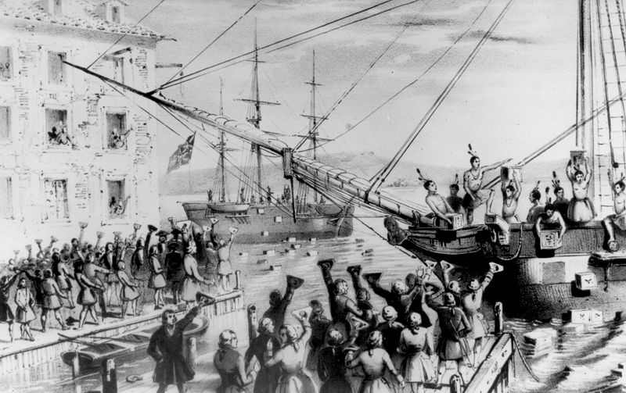
Boston, Massachusetts 1773
Hint: The Indians aren’t real, and there’s tea in those crates.

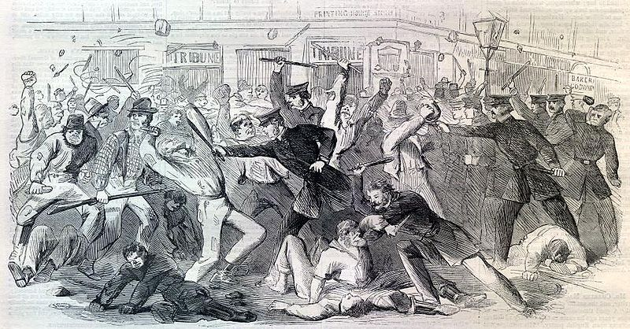
New York City, 1863
Hint: Some of the people in the picture were unhappy with the government’s policies for drafting men into the army.

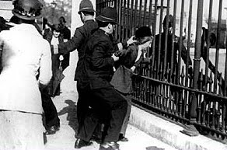
Washington, DC 1917
Hint: This woman chained herself to this fence at the White House. She did not vote for the President because she couldn’t.

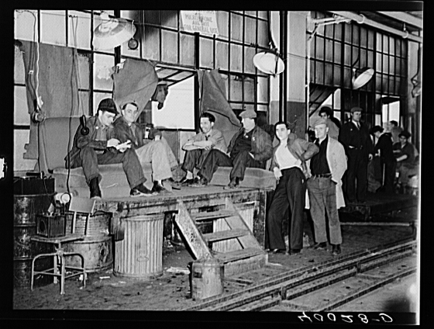
Flint, Michigan 1936
Hint: These men are where they work. It’s the middle of the work day.
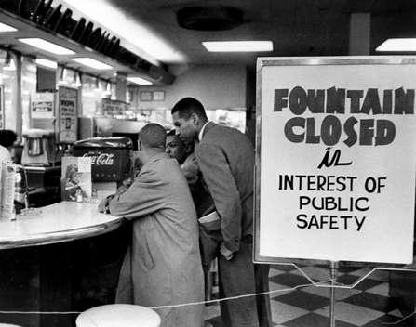
Nashville, Tennessee 1960
Hint: The store is refusing to serve the men seated at the counter. And they won’t leave.

Brooklyn, New York 2010
Hint: Remember the oil well explosion that released millions of barrels of oil into the Gulf of Mexico?

