“A Bold Stroke for Freedom,” Print (1855)

On Christmas Eve, 1855, patrollers finally caught up with a group of teenaged slaves who had escaped by wagon from Loudon County, Virginia. But the posse was driven off when Ann Wood, leader of the group, brandished weapons and dared the pursuers to fire. The fugitives continued on to Philadelphia. Although proponents of the Fugitive Slave Law hoped it would reduce the number of slaves escaping to the North, the law fueled abolitionist sentiment. Popular opposition in cities like Boston and Philadelphia, which at times led to the emancipation by force of captured slaves, at times made the law unenforceable.

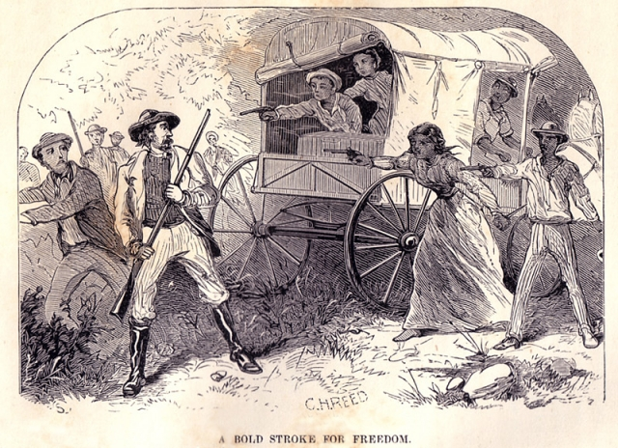

Source: William Still, The Underground Rail Road (Philadelphia: Porter & Coats, 1872), 125.

