“Great Sale of Slaves” Auction Poster (1855)

The twenty-three people to be sold belonged to a Kentucky planter named John Carter. He decided to “liquidate his assets” before moving to the free state of Indiana. Cheapside, the area of Lexington mentioned in the auction notice, was the largest slave trading district in the state. Slave traders established offices, residences, and slave pens in cities throughout the South in order to be located near transportation and business hubs. It was not uncommon to see slave auctions take place in public markets and squares.
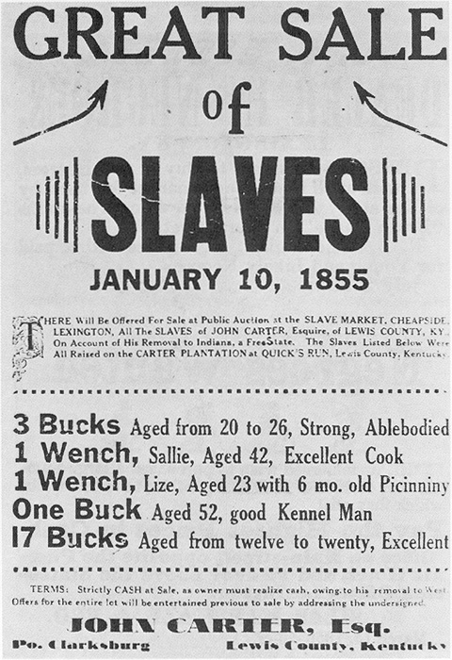

Source: John Winston Coleman, Slavery Times in Kentucky, 1940.

