“Political Chart of the United States” (1856)

This 1856 Republican Party map delineates the geographic contours of slavery. A portrait of Republican presidential candidate John C. Frémont is displayed at the top of the document.

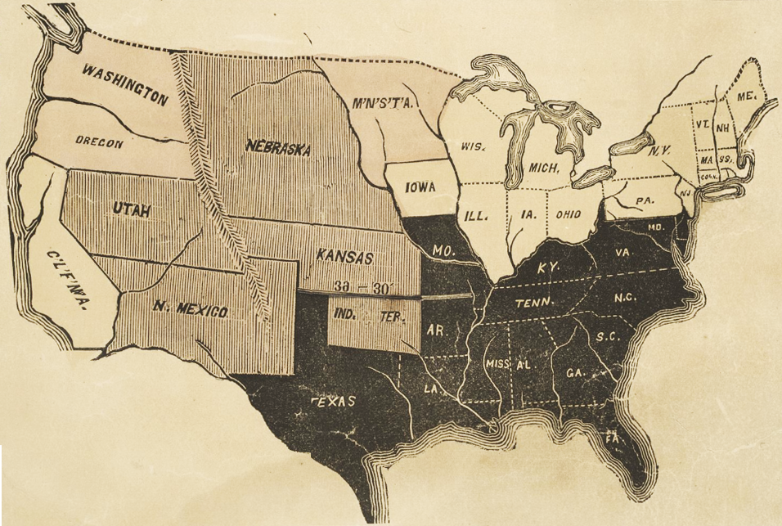

Source: Chicago Historical Society, http://lincolnat200.org/items/show/166

