Table of Contents

James Franklin’s Indenture Contract to his Uncle Benjamin Franklin, 1740 . . . . . . . . . . ...p. 2
Selections from Poor Richard’s Almanac . . . . . . . . . . . . . . . . . . . . . . . . . . . . . . . . . . . . . . . . . p. 4
“No Stamp Act” Tea Pot, 1766 . . . . . . . . . . . . . . . . . . . . . . . . . . . . . . . . . . . . . . . . . . . . . . . . . . p. 5
The Townshend Duties, 1767 . . . . . . . . . . . . . . . . . . . . . . . . . . . . . . . . . . . . . . . . . . . . . . . . . . . p. 6
“The Liberty Song” by John Dickinson, 1768 . . . . . . . . . . . . . . . . . . . . . . . . . . . . . . . . . . . . . .p. 7
Letters of a Loyalist Lady, June 1768 – July 1770 . . . . . . . . . . . . . . . . . . . . . . . . . . . . . . . . . . .p. 9
Poem on a Spinning Bee, 1769 . . . . . . . . . . . . . . . . . . . . . . . . . . . . . . . . . . . . . . . . . . . . . . . . . .p. 11
Handbill from Boston’s Non-Importation Protest, c. 1768 – 70 . . . . . . . . . . . . . . . . . . . . . . p. 12
Boston Gazette’s List of Importers, 1770 . . . . . . . . . . . . . . . . . . . . . . . . . . . . . . . . . . . . . . . . . . p. 13
Boston Gazette, Ladies’ Agreement against Drinking Foreign Tea, 1770 . . . . . . . . . . . . . . .p. 15
Boston Gazette Advertisements, February 19, 1770 – March 12, 1770 . . . . . . . . . . . . . . . . . .p. 16
Boston Gazette’s Article on the Murder of Christopher Seider . . . . . . . . . . . . . . . . . . . . . . .p. 17
Thomas Hutchinson’s Diary entry on the Seider Murder, 1770 . . . . . . . . . . . . . . . . . . . . . .p. 19
Portrait of Craftsman Paul Revere, c. 1770 . . . . . . . . . . . . . . . . . . . . . . . . . . . . . . . . . . . . . . . p. 20
Letter by Theophilus Lillie Opposing the Non-Importation Agreement, 1770 . . . . . . . . . p. 21
Eyewitness Accounts from the Boston Massacre, 1770 . . . . . . . . . . . . . . . . . . . . . . . . . . . . . p. 22
Paul Revere’s Engraving Depicting the Boston Massacre, 1770 . . . . . . . . . . . . . . . . . . . . . . p. 25
Phillis Wheatley, “To the Right Honourable William, Earl of Dartmouth,” 1773 . . . . . . . p. 27
Slaves Petition the Massachusetts Legislature, 1777 . . . . . . . . . . . . . . . . . . . . . . . . . . . . . . . .p. 28
Thomas Paine, Common Sense, 1776 . . . . . . . . . . . . . . . . . . . . . . . . . . . . . . . . . . . . . . . . . . . . . .p. 29
James Franklin’s Indenture Contract to his Uncle Benjamin Franklin, 1740
This contract indentures James Franklin, Benjamin Franklin’s nephew, to serve as an apprentice to his uncle, who in turn promises to teach James the trade of printing. The strict terms of the contract, as well as the period of indenture lasting seven years, were typical of the arrangements by which thousands of adolescent boys and young men apprenticed themselves to skilled tradesmen during the colonial period.

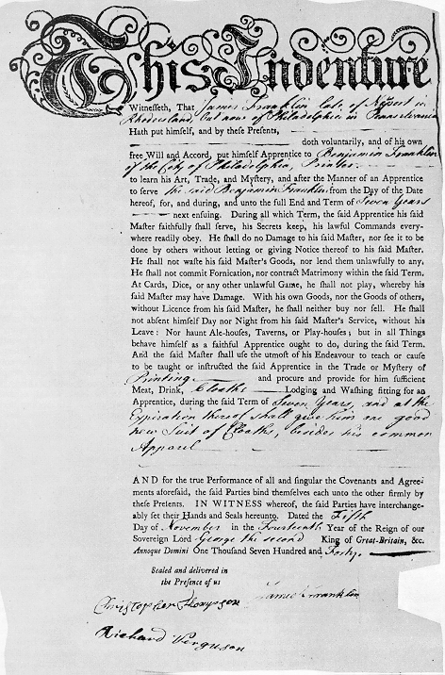

Transcript:
This Indenture
Witnessth, That James Franklin late of Newport in Rhode island, And now of Philadelphia in Pennsylvania Hath put himself, and by these Presents, doth voluntarily, and of his own Will and Accord, put himself Apprentice to Benjamin Franklin of the City of Philadelphia, Printer --------to learn his Art, Trade, and Mystery, and after the Manner of an Apprentice to serve the said Benjamin Franklin from the Day of the Date hereof, for, and during, and unto the full End and Term of Seven Years ----next ensuing. During all which Term, the said Apprentice his said Master faithfully shall serve, his Secrets keep, his lawfull Commands everywhere readily obey. He shall do no Damage to his said Master, norr see it to be done by others without lettting or giving Notice thereof to his said Master. He shall not waste his said Master's Goods, nor lend them unlawfully to any. He shall not commit Fornication, nor contract Matrimony within the said Term. At Cards, Dice, or any other unlawful Game, he shall not play, whereby his said Master may have Damage. With his own Goods, nor the Goods of others, without Licence from his said Master, he shall neither buy nor sell. He shall not absent himself Day nor Night from his said Master's Service, without his Leave: Nor haunt Ale-houses, Taverns, or Play-houses; but in all Things behave himself as a faithful Apprentice ought to do, during the said Term. And the said Master shall use the utmost of his Endeavour to teach or cause to be taught or instructed the said Apprentice in the Trade or Mystery of Printing and procure and provide for him sufficient Meat, Drink, Cloaths----- Lodging and Washing fitting to an Apprentice, during the said Term of Seven Years and at the Expiration thereof shall give him one good new Suit of Cloaths, besides his common Apparel.

AND for the true Performance of all and singular the Covenants and Agreements aforesaid, the said Parties bind themselves each unto the other firmly by these Pretents. IN WITNESS whereof, the said Parties have interchangeably set their Hands and Seals hereunto. Dated the Fifth Day of November in the Fourteenth Year of the Reign of our Sovereign Lord George the second King o Great-Britain, &c. Annoque Domini One Thousand Seven Hundred and Forty.

Sealed and delivered in
the presence of us

[Signatures of Christopher Thompson, James Franklin, and Richard Ferguson]

Source: Prof. Gerald Zahavi, Dept. of History, University at Albany-SUNY
http://www.albany.edu/faculty/gz580/His316/jf-ind-h.gif

Selections from Poor Richard’s Almanack
Benjamin Franklin’s Poor Richard’s Almanack was perhaps the most popular advice book published in colonial America. Although many of Franklin’s proverbs are now clichés, at the time they reflected the strong belief of farmers and skilled artisans in the dignity and importance of their labor in New England colonial society.

There are no gains without pains.

Well done is better than well said.

Keep thy shop, and thy shop will keep thee.

Work while it is called today for you know not how much you may be hindered tomorrow.

Diligence is the mother of good luck.

God gives all things to industry.

Up, sluggard, and waste not life; in the grave will be sleeping enough.

Plough deep while sluggards sleep and you shall have corn to sell and to keep.

Tart Words make no Friends: a spoonful of honey will catch more flies than a Gallon of Vinegar.

Industry gives comfort and plenty and respect.

Sell not virtue to purchase wealth nor liberty to purchase power.

Nothing brings more pain than too much pleasure; nothing more bondage than too much liberty.

Having been poor is no shame; but being ashamed of it is.

Source: Richard Saunders, ed., Poor Richard: The Almanacks for the Years 1753-1758 (1964).
“No Stamp Act” Tea Pot, 1766
This teapot commemorated colonial opposition to the Stamp Act of 1765, which required colonists to pay a tax on virtually all printed material including legal documents, wills, contracts, newspapers, pamphlets, and playing cards. The teapot was made in Britain where opposition to the Stamp Act was also strong, especially among British merchants and manufacturers who feared that economic problems in the colonies would weaken demand for their export goods. In response to pressure on both sides of the Atlantic, Parliament repealed the Stamp Act in 1766 while insisting on its power to tax the colonies “in all cases whatsoever.”

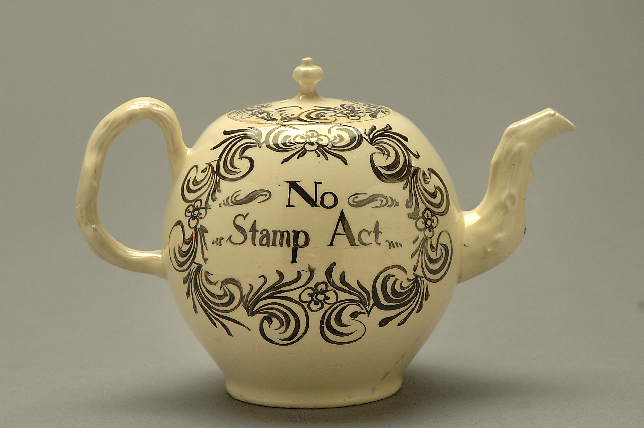

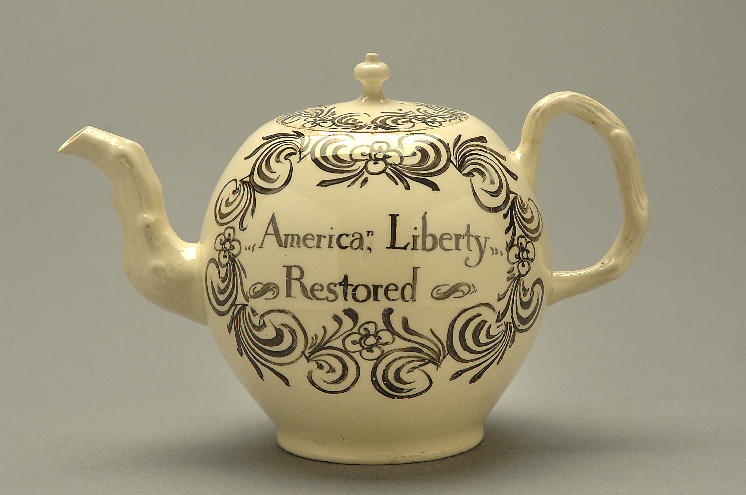

Source: National Museum of American History. Smithsonian Institution, Behring Center
The Townshend Acts, 1767
After the French and Indian War (Seven Years War) ended in 1763, Britain tried to tighten the reins on the colonists and rebuild its weakened treasury through a series of colonial taxes. When its first attempt – the Stamp Act –failed due to strong colonial opposition, the British Parliament tried again, passing the Townshend Duties two years later. The Townshend Duties (also known as the Revenue Acts) passed a tax on all paint, paper, lead, glass and tea that was imported into the colony. The new law also carried with it tougher enforcement measures including “writs of assistance” which gave customs agents the power to search and seize private property without a warrant.

. . . WHEREAS it is expedient that a revenue should be raised in your Majesty’s dominions in America, for making a more certain and adequate provision for defraying the charge of the administration of justice, and the support of civil government, in such provinces where it shall be found necessary; and towards further defraying the expenses of defending, protecting, and securing, the said dominions; we, your Majesty’s most dutiful and loyal subjects, the commons of Great Britain, in parliament assembled, have therefore resolved to give and grant unto your Majesty the several rates and duties herein after mentioned . . ..

And whereas by an act of parliament made in the fourteenth year of the reign of King Charles the Second . . . it is lawful for any officer of his Majesty’s customs, authorized by writ of assistance under the seal of his majesty’s court . . . to take a constable . . . to enter and go into any house, shop, cellar, warehouse, or room or other place, and, in case of resistance, to break open doors, chests, trunks, and other package there, to seize, and from thence to bring, any kinds of goods or merchandize whatsoever prohibited or uncustomed, and to put and secure the same in his Majesty’s store-house . . .

Source: The statutes at large ... [from 1225 to 1867] by Danby Pickering. Cambridge: Printed by Benthem, for C. Bathhurst ; London, 1762-1869

“The Liberty Song” by John Dickinson, 1768
“The Liberty Song,” published in the Boston Gazette in 1768, was written to be sung to the tune of a popular English tune called “Heart of Oak.” Perhaps the first patriotic song in America, its lyrics were written by John Dickinson, a member of the Pennsylvania Assembly who later fought in the Revolutionary War and became Governor of Pennsylvania.

Come, join hand in hand, brave Americans all,
And rouse your bold hearts at fair Liberty's call;
No tyrannous acts shall suppress your just claim,
Or stain with dishonor America's name.

Chorus
In Freedom we're born and in Freedom we'll live.
Our purses are ready. Steady, friends, steady;
Not as slaves, but as Freemen our money we'll give.

Our worthy forefathers, let's give them a cheer,
To climates unknown did courageously steer;
Thro' oceans to deserts for Freedom they came,
And dying, bequeath'd us their freedom and fame.

Chorus

The tree their own hands had to Liberty rear'd,
They lived to behold growing strong and revered;
With transport they cried, Now our wishes we gain,
For our children shall gather the fruits of our pain.

Chorus

Then join hand in hand, brave Americans all,
By uniting we stand, by dividing we fall;
In so righteous a cause let us hope to succeed,
For heaven approves of each generous deed.

(continues next page)

Chorus

In Freedom we're born and in Freedom we'll live.
Our purses are ready. Steady, friends, steady;
Not as slaves, but as Freemen our money we'll give

Source: John Dickinson, “The Liberty Song,” The Boston Chronicle, August 29, 1768; from the Dickinson College Archives and Special Collections, Carlisle, Pennsylvania.

Letters of a Loyalist Lady, June 1768-July 1770
These letters were written by Englishwoman Ann Hulton, whose brother, Henry Hulton, was sent to Boston as a Customs Commissioner in the years leading up to the Revolution. Hulton’s vivid correspondence describes many famous events, including the Boston Massacre, from the less familiar historical perspective of a “loyalist lady.”

Castle William Boston Harbor
June 30, 1768

[T]he Mobs here are very different from those in [old] England…here they act from principle & under countenance, no person daring or willing to suppress their outrages, or to punish the most notorious offenders for any crimes whatever, these Sons of Violence after attacking houses, breaking windows, beating, stoning & bruising several gentlemen belonging to the Customs, the Collector mortally, and burning his boat…. All was ended with a speech from one of the [Patriot] leaders, concluding thus, “We will defend our Liberties & property, by the Strength of our Arm & the help of our God.”

…From the inherent Republican, & leveling principles, here is no subordination in the society. Government is [exterminated] and & it is quite a state of anarchy. There are some sensible and good people that are greatly alarmed…the infant Colonies have been advancing toward a state of independancy.

Castle William
July 12, 1768

Its reported that a Regiment of Soldiers is on the way from New York to Boston….

Boston,
April 10, 1769

I hope we shall be in no more dangers or alarms from lawless mobs…it is certain that our safety & quiet depends on the army & navy being here.

(continues next page)

…the tyranny of the Multitude is the most arbitrary and oppressive…many persons awed by the people, are obliged to court popularity for their own security, this is only to be done by opposing government at home…Several persons were threatened…for no other reason than visiting us at the Castle, & it would certainly have been done, with a deal more mischief, had not the Troops, arrived seasonably for our Protection, as well as that of every person of property. Yet there are very few [people] to be met with that will allow the right of taxation to the British Parliament, therefore we avoid politicks.

Source: [Ann Hulton], Letters of a Loyalist Lady; Being the Letters of Ann Hulton, Sster of Henry Hulton, Commissioner of Customs at Boston 1767-1776 (Cambridge: Harvard University Press, 1927), 11-21.

Poem on Spinning Bee, 1769
Colonial women, as well as men, actively protested the Crown’s tax laws. They organized spinning bees to produce yarn for “homespun” cloth that would substitute for British textiles. In these stanzas, a poet praises the egalitarian spirit of Patriot spinning bees and the adverse impact on British merchants.

A Verse Occasioned by seeing the North-Spinning, in BOSTON.

BOSTON, behold the pretty Spinners here,
And see how gay the pretty Sparks appear;
See Rich and Poor all turn the Spinning Wheel,
All who Compassion for their Country feel,
All who do love to see Industry live,
And see Frugality in Boston thrive.

Britain, behold thy Trade stole from thy Hand,
And carried on in Boston’s distant Land:
See now thy Trade and Trades men, all expire.
And see them all [speak] of their Desire,
The Desire they had that Boston’s Trade should spoil,
That they might reap the Fruit of all our Toil;

Source: Anonymous, “A Verse, Occasioned by Seeing the North-Spinning, In Boston,” broadside, 1769, Boston. Boston Public Library.
Handbill from Boston’s Non-Importation Protest, c. 1768-70
Handbills were an important weapon in Boston’s non-importation movement in which merchants swore not to import British goods until the Townshend Acts were repealed. Handbills, such as this one, not only exposed any “importer” who refused to join the protest, but warned townspeople not to bring “disgrace” upon themselves by shopping at certain stores.

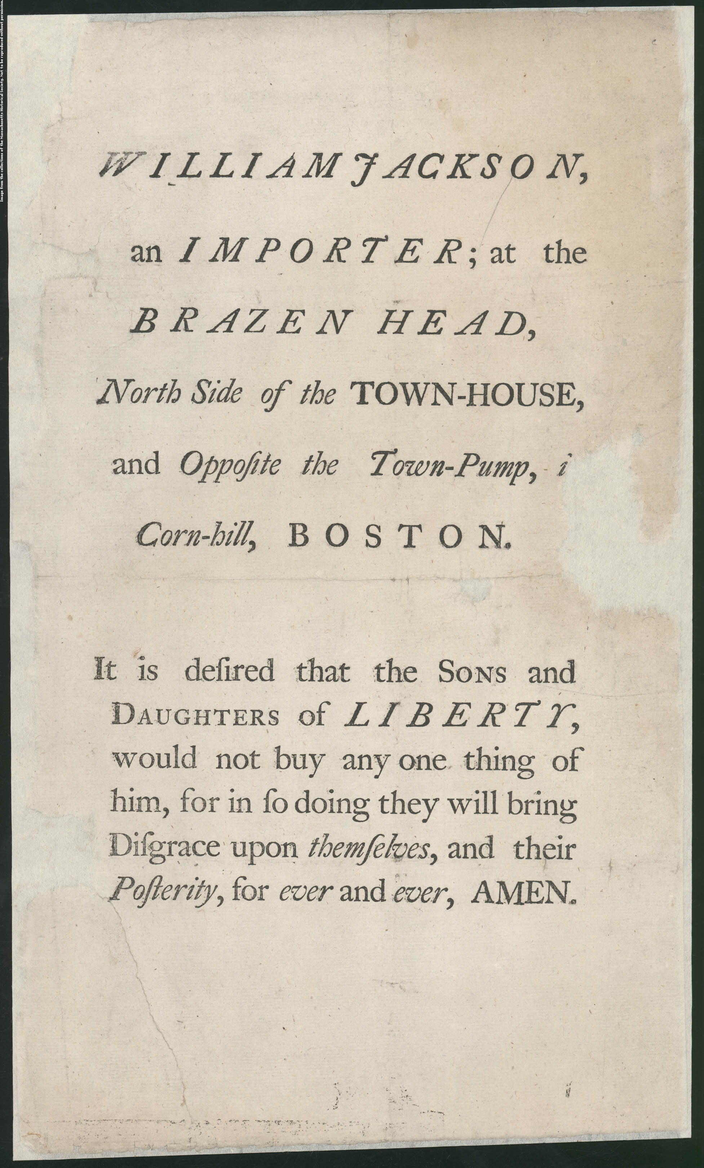Transcript:

WILLIAM JACKSON, an IMPORTER; at the BRAZEN HEAD, North Side of the TOWN-HOUSE, and Opposite the Town-Pump, in Cornhill, BOSTON.

It is desired that the SONS and DAUGHTERS of LIBERTY, would not buy any one thing of him, for in so doing they will bring Disgrace upon themselves, and their Posterity, for ever and ever, AMEN.

Source: William Jackson, an Importer; at the Brazen Head, Broadside 39.9 cm x 23.9 cm [Boston, between 1768-1770], Massachusetts Historical Society
Boston Gazette’s List of Importers, 1770
Benjamin Edes, along with his partner John Gill, helped support Patriot protests against the Crown’s tax laws by publishing the names of every merchant who refused to sign the non-importation agreement on the front page of their paper. The list identified 12 merchants, including Theophilus Lillie, as “Enemies of their Country” and described the location of each shop so that townspeople would know which stores to avoid.

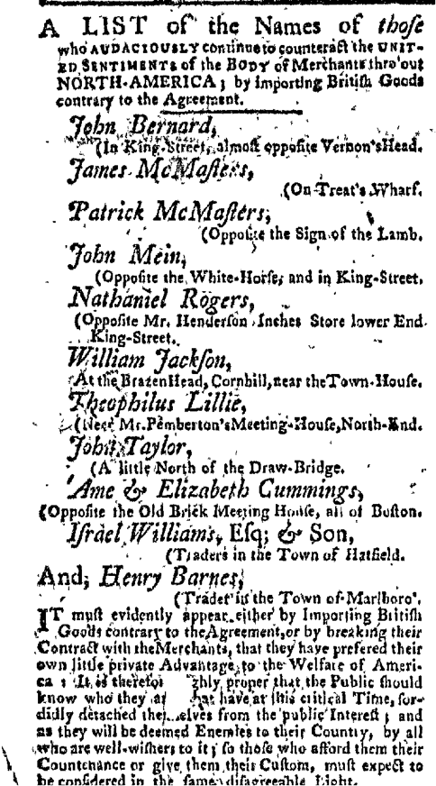

Transcript:
A LIST of the Names of those who AUDCIOUSLY continue to counteract the UNITED SENTIMENTS of the BODY of Merchants thro’ out NORTH-AMERICA; by importing British Goods contrary to the Agreement.
John Bernard,
(in King-Street, almost opposite Vernon’s Head.
James McMasters
(On Treat’s Wharf.
Patrick McMasters
(Opposite the sign of the Lamb.
John Mein,
(Opposite the White-Horse; and in King-Street.
Nathaniel Rogers,
(Opposite Mr. Henderson Inches Store lower End
…King Street.
William Jackson,
(At the Brazen Head, Cornhill near the Town-House.
Theophilus Lillie,
(Near Mr. Pemberton’s Meeting-House, North-End.
John Taylor,
(A little North of the Draw-Bridge.
Anne & Elizabeth Cummings,
(Opposite the Old Brick Meeting House, all of Boston.
Israel Williams, Esq. & Son,
(Traders in the Town of Hatfield.
And, Henry Barnes,
(Trader in the Town of Marlboro.
IT must evidently appear either by Importing British Goods contrary to the Agreement, or by breaking their Contract with the Merchants, that they have prefered their own little private Advantage to the Welfare of America; It is therefore highly proper that the Public should know who they are that at this critical Time, sordidly detached themselves from the public Interest; and as they will be deemed Enemies to their Country, by all who are well-wishers to it; so those who afford them their Countenance or give them their Custom, must expect to be considered in the same disagreeable light.

Source: Boston Gazette, February 12, 1770
Boston Gazette, Ladies’ Agreement against Drinking Foreign Tea, 1770
Edes & Gill’s Gazette regularly printed notices, such as this one, announcing a pledge by the ladies of Boston against drinking foreign (British) tea. For women, who could not vote or hold office, non-consumption campaigns were a way to participate in colonial politics; many calling themselves “Daughters of Liberty” publicly gave up drinking tea and began spinning their own yarn to avoid buying goods imported from Britain.

The following is a Copy of the Agreement of the young Ladies of this Town, against drinking foreign TEA.
Boston, February 12, 1770.
We the Daughters of those Patriots who have and now do appear for the public Interest; and in that principally for us their Posterity, We as such do with Pleasure engage with them in denying ourselves the drinking of Foreign Tea, in hopes to frustrate a Plan that tends to deprive the whole Community of their all that is valuable in Life.
To the above Agreement 126 young Ladies have already signed.
In addition to the List of the Mistresses of Families who sign’d the Agreement against drinking foreign Tea, inserted in our last, 110 have been added the Week past.

Source: Boston Gazette, February 19, 1770

Boston Gazette Advertisements, February 19, 1770-March 12, 1770
Advertisements were the chief source of income for colonial printers. As was true of other newspapers, advertisements in the Boston Gazette sometimes took up more column space than the local news articles and political essays. Because of their frequency, variety, and high degree of detail, these early newspaper advertisements provide a valuable snapshot of social and economic life in communities across the Thirteen Colonies.

Choice Capers and Anchovys, by the Keg or single Pound TO BE SOLD BY Archibald Cunningham At His Shop near the Draw-Bridge, Fore-street, Boston ALSO New Raisins and Turkey Figgs by the Cask, CURRANTS, Citron, Mace, Cloves, Cinnamon, Rice, Oatmeal Piemento per Hundred weight, Pepper, Almonds, Salt-Petre, Indigo, Starch, Pipes, Lyn-Shoes, Wine Glasses by the Groce, Allum, Ginger, Copperas per cask, Redwood and Logwood per 100, Kippen’s Snuff per Dozen, Kippen’s Tobacco, Bohea Tea per Doz. or less Quantity, Chocolate, Loaf and brown Sugar, Crown Soap, Mustard per pound or in Bottles, long-handled Hearth Brushes, Florence Oyl per Chest or single Plask. With a good Assortment of Glass, Stone, and Cream colour’d Ware, Delph Bowls from half a Pint to three Quarts by the Dozen of single.
N.B. A Quantity of NUTMEGS to be sold cheap at said Shop.

Stray’d or Stolen, a red-and-white Spaniel Dog, named Spring, with long Ears, and short bushy Tail. Any Person who finds said Dog, and brings him to the Printers, shall receive a Guinea Reward.

To be Sold for Want of Employ, A stout, strong, healthy Negro Boy, 18 Years of Age, fit for Town or Country. Enquire of the Printers.

RAN-AWAY from his Master John Langdon, the 20th of this Instant February, an Indented Servant Lad of 14 Years of Age, named EBENEZER BLANCHER. He had on when he went away, a Frock and Trousers, over a dark striped Homespun Jacket and Breeches, a striped cotton and linnen Shirt. Shoes almost worn out, a Pair Brass figured Buckles, this Country make. He is a smart ready Boy, and will tell a good plausible Story. Whoever will take him up and bring him to his Master, shall be rewarded for his Trouble. All Matters of Vessels and others, are warned against carrying off, concealing or entertaining the said Boy [to] avoid the utmost Penalty of Law.

Source: Boston Gazette, February 19, February 26, March 12, 1770
Boston Gazette’s Article on the Murder of Christopher Seider
Christopher Seider (here called Snider) was an eleven-year old boy who was part of a mob demonstrating at the home of Ebenezer Richardson, a known Boston loyalist. After the mob broke down Richardson’s front door, he fired a musket into the crowd, killing Seider. The event caused outrage among Boston patriots, and contributed to an atmosphere of tension and hostility in the days leading up to the Boston Massacre two weeks later.

- On Thursday last in the Forenoon, a barbarous Murder
- extended with many aggravating Circumstances, was
- committed on the Body of a young lad of about eleven
- Years of Age, Son to Mr. ___ Snider of this Town. A
- Number of Boys had been diverting themselves with
- the Exhibition of a Piece of Pageantry near the House
- of Theopolis Lillie who perhaps at this Juncture of
- Affairs may with the most Propriety be described by
- the Name of an IMPORTER — This exhibition naturally
- occasioned Numbers to assemble, and in a very little
- Time there was a great Concourse of Persons,
- especially the younger sort. — One Ebenezer
- Richardson, who has been many years employed as an
- under Officer of the Customs, long known by the
- Name of an INFORMER, and consequently a Person of
- a most abandoned Character, it seems, took Umbrage
- at the supposed Indignity offered to the Importer,
- and soon became a Party to the Affair-- He first
- attempted to demolish the Pageantry, and failing in the
- attempt, he retired to his House, which was but a few Rods
- from the Exhibition. Several Persons passing by the House,
- Richardson, who seemed determined to take this Occasion to
- make a Disturbance, without the least Provocation, gave
- them the most opprobrious Language, charging them with
- Perjury, &c., which raised a Dispute between them—This, it
- is supposed, occasioned the boys to gather nearer
- Richardson’s House, and he, thinking he had now a good
- Colouring to perpetuate the Villainy, threatened to fire upon
- them, and Swore by GOD that he would make the Place too
- hot for some of them before Night, and that he would make

- Lane through them if they did not go away. Soon after, a
- Number of Brickbats or Stones were thrown among the
- People from Richardson’s House, but the Witnesses, who
- were sworn before the Magistrates, declared that it did not
- appear to them that till then any Sort of Attack was made
- by the People on the House. This, however, brought on a
- Skirmish, and Richardson discharged his Piece, loaded with
- Swan Shot, at the Multitude, by which the unhappy young
- Person above-mentioned was mortally wounded, having since
- died of his Wounds — A Youth, Son to Captain John Gore,
- was also wounded in one of his Hands and in both his Thighs,
- by which his life was endangered, but he is likely to soon
- recover of his Wounds

- ….We are assured that not less than eleven Shot were found in
- the Body of the unfortunate Boy, who was inhumanly murdered
- by the infamous Informer on Thursday last.

- It is hoped the unexpected and melancholy Death of young
- Snider will be a Means for the future of preventing any, but
- more especially the Soldiery, from being too free in the Use
of their Instruments of Death.

Source: Boston Gazette, February 26, 1770
Thomas Hutchinson’s Diary Entry on the Seider Murder, 1770
After the killing of eleven-year-old Christopher Seider by Ebenezer Richardson, the Sons of Liberty led a large funeral procession witnessed by thousands of Bostonians. In this diary entry, Thomas Hutchinson, the Loyalist Governor of Massachusetts, somewhat cynically notes that Seider’s death and funeral made good propaganda for Boston patriots.

…when the boy was killed by Richardson, the sons of liberty in Boston, if it had been in their power to have brought him to life again, would not have done it but would have chosen the grand funeral, which brought many thousands together; and the solemn procession from Liberty Tree, near which the boy’s father lived, to the Town House and back to the burying ground made an inconceivable impression

Source: Cited in Sacvan Bercovitch and Cyrus R. K. Patell, eds., The Cambridge History of American Literature (Cambridge University Press, 1994), 358.

Portrait of Craftsman Paul Revere, c. 1770
Boston silversmith Paul Revere was one of the few colonial craftsmen painted by John Singleton Copley, colonial America’s best-known portrait artist. In this painting, dating from about 1770, Revere poses at his workbench, wearing the artisan’s plain linen shirt and vest and displaying his engraving tools and an unfinished teapot.

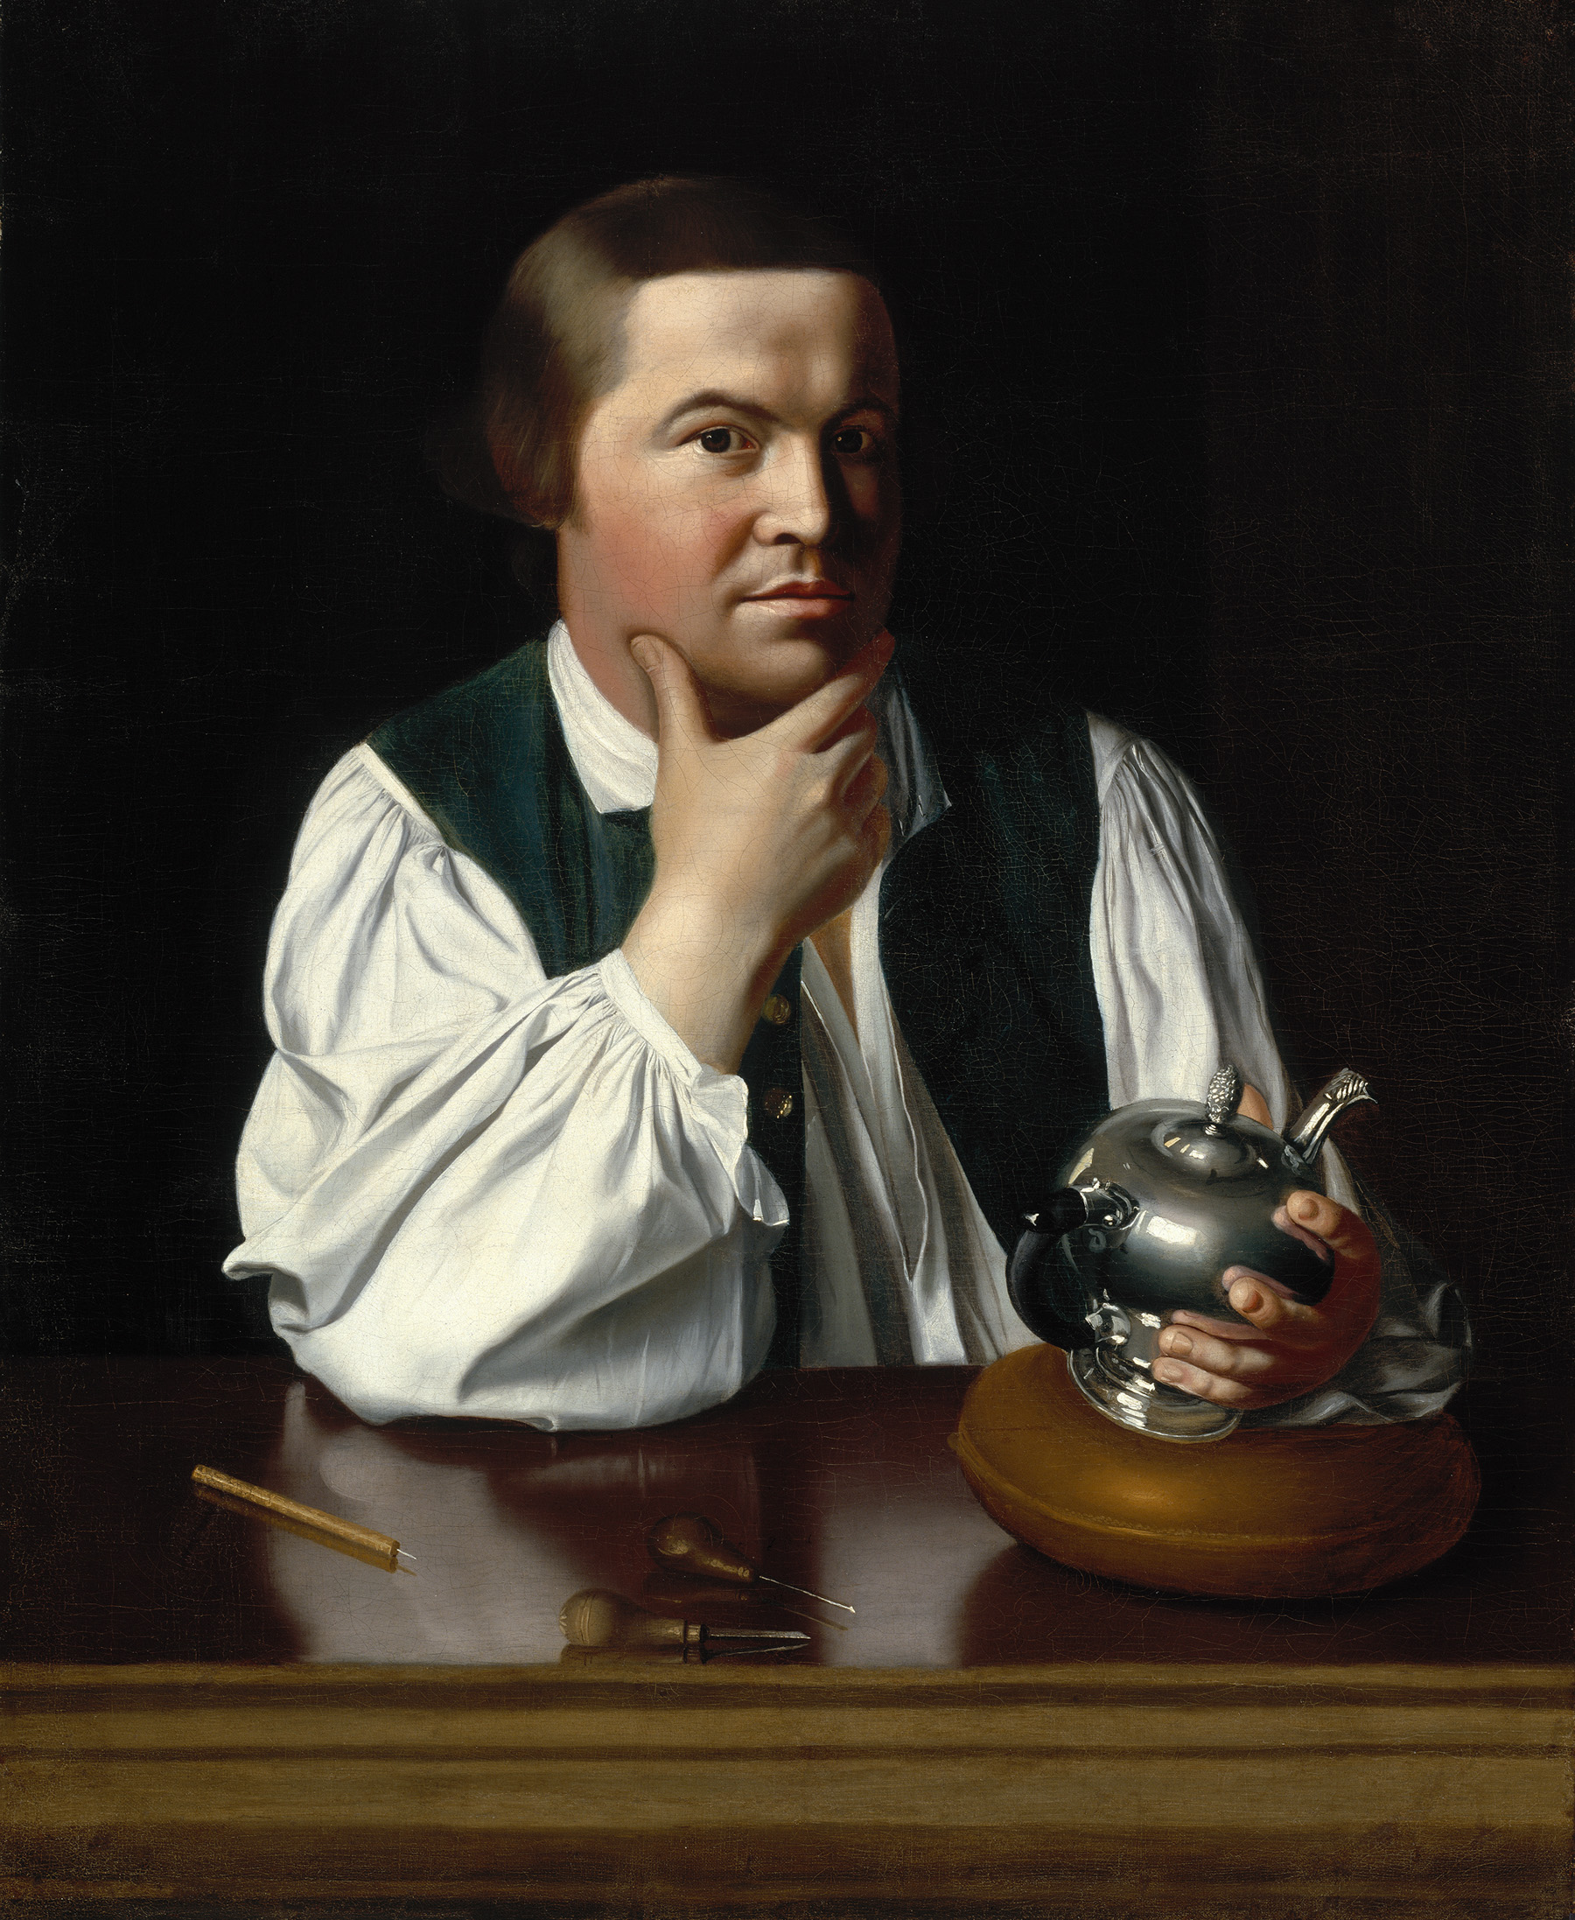
Source: John Singleton Copley, Paul Revere, oil on canvas, 1768-70, 35 X 28 ½ inches – Gift of Joseph W., William B., and Edward H. R. Revere, Museum of Fine Arts, Boston. Photograph © 2010 Museum of Fine Arts Boston.
Letter by Theophilus Lillie Opposing the Non-Importation Agreement, 1770

In this letter, published in the pro-Crown Boston Chronicle, Theophilus Lillie describes his “punishment” at the hands of Patriotic merchants who organized the non-importation movement. Lillie points out that he never consented to the boycott, and is the victim of blatant hypocrisy by those who claim to be defenders of “liberty.”

Upon the whole, I cannot help saying—although I have never entered far into the mysteries of government, having applied myself to my shop and my business—that it always seemed strange to me that people who contend so much for civil and religious liberty should be so ready to deprive others of their natural liberty; that men who are guarding against being subject to laws which they never gave their consent in person or by their representative should at the same time make laws…[to which] I am sure I never gave my consent either in person or by my representative.

But what is still more hard, they are laws made to punish me after I have committed the offence; for when I sent for my goods, I was told nobody would be compelled to subscribe; after they came I was required to store them. This is no degree answered the end of the subscription, which was to distress the manufacturers in England. Now, my storing my goods could never do this; the mischief was done when the goods were bought in England; and it was too late to help it….

If one set of private subjects may at any time take upon themselves to punish another set of private subjects just when they please, it’s such a sort of government as I never heard of before; and according to my poor notion of government, this is one of the principal things which government is designed to prevent; and I own I had rather be a slave under one master (for I know who he is I may perhaps be able to please him) than a slave to a hundred or more whom I don’t know where to find, nor what they will expect of me.

Source: Boston Chronicle, January 15, 1770

Eyewitness Accounts from the Boston Massacre, 1770
In the days and weeks following the fateful events of March 5, 1770, over ninety people––from all ranks of colonial society––gave depositions about what they had seen in front of Justices of the Peace gathered at Faneuil Hall. Later that year, townspeople made up the bulk of the witness lists for both the prosecution and defense during the trials of Captain Preston and the other soldiers. Below is a selection of these eyewitness accounts that includes one of the victims of the massacre, Edward Payne (who suffered a non-fatal gunshot wound) and Captain Preston, the officer in charge of the soldiers.

Depositions from the Town:
I, Charles Hobby, of lawful age, testify and say, that…between the hours of nine and ten o’clock, being in my master’s house, was alarmed with the cry of fire, I ran down as far as the town-house, and then heard that the soldiers and the inhabitants were fighting in the alley….I then left them and went to King street. I then saw a party of soldiers loading their muskets about the Custom-house door, after which they all shouldered. I heard some of the inhabitants cry out, “heave no snow balls,” others cried “they dare not fire.” Capt. Preston was then standing by the soldiers, when a snow ball struck a grenadier, who immediately fired, Capt. Preston standing close by him. The Captain then spoke distinctly, “Fire, Fire!” I was then within four feet of Capt. Preston, and know him well; the soldiers fired as fast as they could one after another. I saw the mulatto fall, and Mr. Samuel Gray went to look at him, one of the soldiers, at a distance of about four or five yards, pointed his piece directly for the said Gray’s head and fired. Mr. Gray, after struggling, turned himself right round upon his heel and fell dead.

Edward Payne, of Boston, merchant testifies that on the evening of the fifth instant, on hearing the bells ring, he supposed there was fire, but on going out he was informed there was not any fire, but a riot….the people round the sentinel were then crying out “Fire, fire, damn you, why don’t you fire,” soon after, he perceived a number of soldiers coming down towards the sentinel, with their arms in a horizontal posture, and their bayonets fixed, who turned the people from before the Custom-house, and drew up before the door, the people, who still remained in the street and about the soldiers, continued calling out to them to fire. In this situation they remained some minutes, when he heard a gun snap, and presently a single gun fired and soon after several others went off, one after another…at which time, a ball passed through the deponents right arm, upon which he immediately retired to the house.

Daniel Usher…testifies and says, that…he saw several persons, mostly young folks, gathered between the Town House and Coffee House, some of whom were talking to the sentinel at the Commissioners’ or Custom-house; after some time, the boys at a distance began to throw light snow-balls at him, which he seemed much enraged at, and…appeared to have charged his gun, giving it a heavy stamp

upon the door step, as if to force down the lead; and then swore to the boys if they came near him he would blow their brains out. About ten minutes after this, the deponent saw Capt. Preston leading seven or eight men from towards the Town House, and placed them between the Custom-house door, and the sentinel box. About four or five minutes after they were posted, the snowballs now and them coming towards the soldiers, the Capt. commanded them to fire. Upon this, one gun quickly went off; and afterwards he said “Fire by all means!” others succeeding, and the deponent being utterly unarmed, to avoid further danger, went up round the Town House till the fray was over.

Captain Preston’s Deposition from March 12, 1770:
The mob still increased and were outrageous, striking their clubs or bludgeons one against another, and calling out, come on you rascals, you bloody backs, you lobster scoundrels, fire if you dare, G-d damn you, fire and be damned, we know you dare not, and much more such language was used. At this time I was between the soldiers and the mob, parleying with, and endeavoring all in my power to persuade them to retire peaceably, but to no purpose. They advanced to the points of the bayonets, struck some of them and even the muzzles of the pieces, and seemed to be endeavoring to close with the soldiers. On which some well behaved persons asked me if the guns were charged. I replied yes. They then asked me if I intended to order the men to fire. I answered no, by no means, observing to them that I was advanced before the muzzles of the men's pieces, and must fall a sacrifice if they fired; that the soldiers were upon the half cock and charged bayonets, and my giving the word fire under those circumstances would prove me to be no officer. While I was thus speaking, one of the soldiers having received a severe blow with a stick, stepped a little to one side and instantly fired.... On this a general attack was made on the men by a great number of heavy clubs and snowballs being thrown at them, by which all our lives were in imminent danger, some persons at the same time from behind calling out, damn your bloods-why don't you fire. Instantly three or four of the soldiers fired.... On my asking the soldiers why they fired without orders, they said they heard the word fire and supposed it came from me. This might be the case as many of the mob called out fire, fire, but I assured the men that I gave no such order; that my words were, don't fire, stop your firing. . . .

Testimony from the Trial:
William Sawyer: The people kept huzzaing. Damn'em. Daring'em to fire. Threw Snow balls. I think they hit 'em. As soon as the Snow balls were thrown and a club a Soldier fired. I heard the Club strike upon the Gun and the corner man next the lane said fire and immediately fired. This was the first Gun. As soon as he had fired he said Damn you fire. I am so sure that I thought it was he that spoke. That next Gun fired and so they fired through pretty quick.

Newton Prince (an African-American member of the South Church): Heard the Bell ring. Ran out. Came to the Chapel. Was told there was no fire but something better, there was going to be a fight. Some had buckets and bags and some Clubs. I went to the west end of the Town House where [there] were a number of people. I saw some Soldiers coming out of the Guard house with their Guns and running down one after another to the Custom house. Some of the people said let's attack the Main Guard, or the Centinel who is gone to King street. Some said for Gods sake don't lets touch the main Guard. I went down. Saw the Soldiers planted by the Custom house two deep. The People were calling them Lobsters, daring'em to fire saying damn you why don't you fire. I saw Capt. Preston out from behind the Soldiers. In the front at the right. He spoke to some people. The Capt. stood between the Soldiers and the Gutter about two yards from the Gutter. I saw two or three strike with sticks on the Guns. I was going off to the west of the Soldiers and heard the Guns fire and saw the dead carried off. Soon after the Guard Drums beat to arms. The People whilst striking on the Guns cried fire, damn you fire. I have heard no Orders given to fire, only the people in general cried fire.

Daniel Cornwall: Capt. Preston was within 2 yards of me and before the Men and nearest to the right and facing the Street. I was looking at him. Did not hear any order. He faced me. I think I should have heard him. I directly heard a voice say Damn you why do you fire. Don't fire. I thought it was the Captain's then. I now believe it. .

Source: A Short Narrative of the Horrid Massacre in Boston (reprint; New York: John Dogget, 1849), 63, 74, 86; Hiller B. Zobel, ed., The Legal Papers of John Adams, Vol. III (Cambridge, Mass.: Belknap Press of Harvard University Press, 1965), 46-98; Publications of the Colonial Society of Massachusetts (1905), Vol. VII, 8-9.
Paul Revere’s Engraving Depicting the Boston Massacre, 1770
This sensationalized depiction of the Boston Massacre was done as an engraving by Paul Revere shortly after the event took place. Although Revere is thought to have been present at the scene of the Massacre, he based his engraving on a drawing by artist Henry Pelham, and he exaggerates or omits certain details, for instance showing Captain Preston giving the order to fire. Widely reproduced, the engraving became an effective instrument of anti-British propaganda in the days after the Massacre.

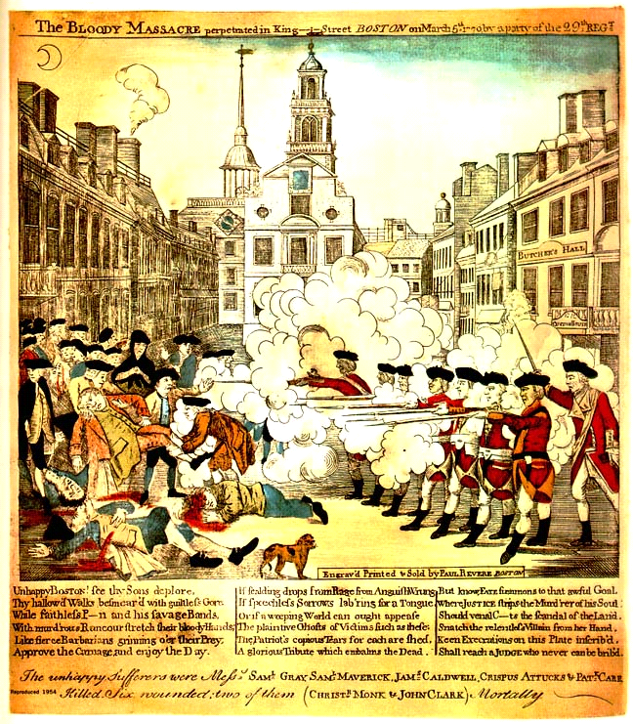

Transcript:

THE BLOODY MASSACRE perpetrated in King Street BOSTON on March 5th, 1770 by a party of the 29th Regt.

Unhappy Boston! Unhappy BOSTON ! see thy Sons deplore,
Thy hallowed Walks besmear d with guiltless Gore :
With faithless P—n and his savage Bands,
With murd’rous Rancour stretch their bloody Hands ;
Like fierce Barbarians grinning o’er their Pay.
Approve the Carnage and enjoy the Day.

If scalding drops from Rage and Anguish Wrung,
If speechless Sorrows lab’ring for a Tongue,
Or if a weeping World can aught appease
The plaintive Ghosts of Victims such as these,
The Patriot’s copious Tears for each are shed,
A glorious Tribute which embalms the Dead.

But know, FATE summons to that sordid Goal
Where JUSTICE strips the murd’rer of his Soul.
Should venal C—ts the scandal of the Land,
Snatch the relentless Villain from her Hand,
Keen Execrations on this Plate inscrib’d,
Shall reach a JUDGE who never can be brib’d.

Source: Paul Revere, based on a design by Henry Pelham, The bloody massacre perpetrated in King Street Boston on March 5th 1770 by a party of the 29th Regt., engraving, on or about March 28th, 1770; from The Library of Congress Online, Prints and Photographs Division, http://www.loc.gov.

Phillis Wheatley, "To the Right Honourable William, Earl of Dartmouth," 1773
In this stanza from one of Wheatley’s best known poems, Wheatley describes the human costs of the slave trade and links her own captivity from Africa to her support for liberty in America. Despite her acknowledged prowess as a writer, the accompanying illustration still describes Wheatley as a “Negro Servant,” or slave.

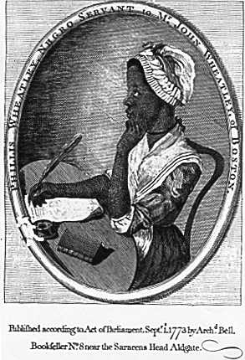
Should you, my lord, while you peruse my song,
Wonder from whence my love of Freedom sprung,
Whence flow these wishes for the common good,
By feeling hearts alone best understood,
I, young in life, by seeming cruel fate
Was snatch'd from Afric's fancy'd happy seat:
What pangs excruciating must molest,
What sorrows labour in my parent's breast?
Steel'd was that soul and by no misery mov'd
That from a father seiz'd his babe belov'd:
Such, such my case. And can I then but pray
Others may never feel tyrannic sway?

Image Source: The Library of Congress Online, Prints and Photographs Division, http://www.loc.gov.
Text Source: John C. Shields, ed., The Collected Works of Phillis Wheatley (New York: Oxford, 1988), 73.
Slaves Petition the Massachusetts Legislature, 1777
This petition to the Massachusetts legislature was drafted by Prince Hall, a free African American who fought at the Battle of Bunker Hill, on behalf of the state’s enslaved people. Throughout the revolutionary era, scores of slaves signed petitions that linked their demands for freedom with the cause of American independence.

To the Honorable Counsel & House of Representatives for the State of Massachusetts in General Court Assembled, January 13, 1777:

The petition of a great number of blacks detained in a state of slavery in the bowels of a free & Christian country humbly show that your petitioners [state] that
they have in common with all other men a natural and inalienable right to that freedom which the Great Parent of the Universe has bestowed equally on
all mankind and which they have never forfeited by any compact or agreement whatever. They were unjustly dragged by the hand of cruel power from their
dearest friends and some of them even torn from the embraces of their tender parents -- from a populous, pleasant, and plentiful country, and in violation of
laws of nature and of nations, and in defiance of all the tender feelings of humanity brought here to be sold like beasts of burden and like them condemned to slavery for life….

Every principle from which America has acted in the course of their unhappy difficulties with Great Britain pleads stronger than a thousand arguments in favor of
your petitioners, and they, therefore humbly beseech that your
honors give this petition its due weight and consideration and cause an act of the Legislature to be passed whereby they may be restored to the enjoyments of that
which is the natural right of all men -- and their children who were born in this land of liberty –– not be held as slaves.

Source: Collection of the Massachusetts Historical Society.
Thomas Paine, Common Sense, 1776
In these excerpts from Common Sense, Thomas Paine makes the case for independence from Britain. The alleged benefits of British rule, Paine asserts, are actually liabilities; he cites unfair trade policies and American entanglement in Britain’s foreign wars. Published anonymously on January 10, 1776, the work spread quickly through the colonies (120,000 were said to have been distributed within three months), and went on to become one of the most famous documents of the American Revolution.

In the following pages I offer nothing more than simple facts, plain arguments, and common sense. . .
I have heard it asserted by some, that as America has flourished under her former connection with Great-Britain, the same connection is necessary towards her future happiness, and will always have the same effect. Nothing can be more fallacious than this kind of argument. We may as well assert that because a child has thrived upon milk, that is never to have meat, or that the first twenty years of our lives is to become a precedent for the next twenty….

But she has protected us, say some. . . . We have boasted the protection of Great Britain, without considering, that her motive was interest not attachment. . . . This new World hath been the asylum for the persecuted lovers of civil and religious liberty from every part of Europe. . . . As Europe is our market for trade, we ought to form no partial connection with any part of it….Europe is too thickly planted with Kingdoms to be long at peace, and whenever a war breaks out between England and any foreign power, the trade of America goes to ruin, because of her connection with Britain. . . . There is something absurd, in supposing a Continent to be perpetually governed by an island. . . .

No man was a warmer wisher for a reconciliation than myself, before the fatal nineteenth of April, 1775 [the day of the battles of Lexington and Concord], but the moment the event of that day was made known, I rejected the hardened, sullen-tempered Pharaoh of England for ever….

A government of our own is our natural right. . . . Ye that oppose independence now, ye know not what ye do: ye are opening the door to eternal tyranny. . . .

O! ye that love mankind! Ye that dare oppose not only the tyranny but the tyrant, stand forth! Every spot of the old world is overrun with oppression. Freedom hath been hunted round the Globe. Asia and Africa have long expelled her. Europe regards her like a stranger, and England hath given her warning to depart. O! receive the fugitive, and prepare in time an asylum for mankind.

Source: Thomas Paine, Common Sense (Philadelphia: W & T Bradford, 1776).

