A NOTE TO THE EDUCATOR:

On the following pages, you will find “flashcards” with terms and definitions (both combined and separate) that your students may encounter while playing Part 1 of “For Crown or Colony?” These terms and definitions can be introduced and practiced before or during the time students see or hear them in the context of Mission US or in their American history study. The discussion questions and writing prompts will provide further opportunities for students to have more practice with the words and terms.

Divide your students into small groups of four or five, and ask each group to review the terms and definitions.

After your students have had a chance to review and discuss the terms and definitions, distribute the letter from Nat to his parents back home in Uxbridge. Review the directions with your students, and ask them to complete the letter using the terms they studied.

Here are the terms which should be inserted into each paragraph of Nat’s letter:
Paragraph 1- contract, master, apprentice
Paragraph 2- Seven Year’s War, journeyman, master
Paragraph 3- redcoats
Paragraph 4- artisans, printer, freedman, slave, slavery
Paragraph 5- Patriot, merchant

Apprentice  An apprentice is somebody who is being trained by a skilled professional in an art, a craft, or a trade. In colonial trades, this person learned from, and worked for, the master. | Master  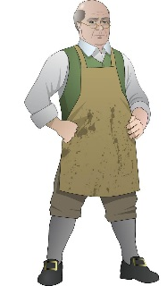  The master, in this case, could mean two things: first, a master craftsman is someone at the highest level of skill in a trade or occupation. In colonial trades, this person was most often the owner of the business. The master is also the person with whom an indenture contract is made.
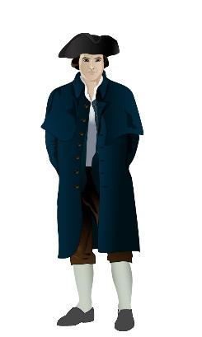  Patriot  In colonial times, a Patriot was a proud supporter of the American cause: at first, this meant freedom from what were considered unfair British laws. Later on, it also meant a person who was in favor of American independence from the British Empire. | Contract  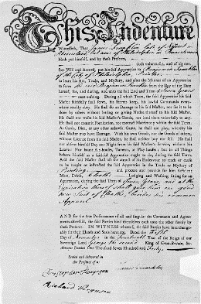  A contract is a formal, usually legal agreement. It can also be a more general term for an indenture, a work agreement with strict terms, usually lasting seven to ten years. In exchange for room and board and instruction in a trade, the servant was at the mercy of the master. Servants often worked long hours and suffered harsh treatment and conditions.
Merchant  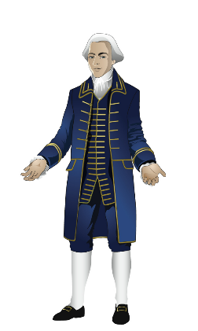  A merchant is someone who buys and sells goods, especially in large quantities. These people shipped goods to and from other colonies, to England and to Europe and Africa. They were often among the wealthiest and most respected colonists. | Redcoat  “Redcoat” was a nickname for a British soldier serving in America, so named because of the color of the coat he wore. It was not as insulting as two other nicknames, “bloodyback” and “lobster.” It was similar to the modern nickname “cops” for police officers, so-named because of the copper buttons on their uniforms.

Artisan  An artisan is a skilled craftsperson, who makes tools, decorative objects, books, or clothing by hand.  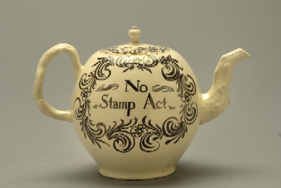 | Journeyman  A journeyman is an artisan who has completed an apprenticeship and is fully trained and qualified, but who still works for an employer or master craftsman.  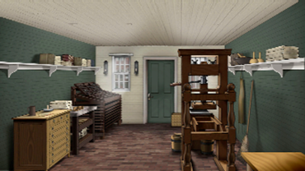
Slave  A slave is somebody who is forced to work for somebody else. Since this person was regarded as property, he or she received no payment for their work. | Freedman  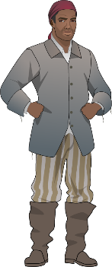  A freedman is a person who has been freed from slavery. In colonial America and before the Civil War, these people were required to carry papers that proved they were free. Many were kidnapped back into slavery.
Slavery  Slavery is a system based on using enforced labor and regarding those laborers as property. This institution has existed in many different societies and time periods. In the British colonies and later the U.S. these enslaved workers faced harsh treatment and no rights. | 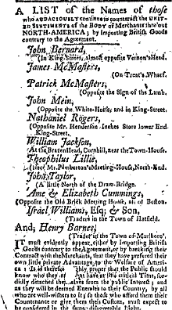  Printer  A person who presses type and ink onto paper. In colonial shops this person often wrote, edited, and published newspapers and pamphlets.

Seven Years’ War

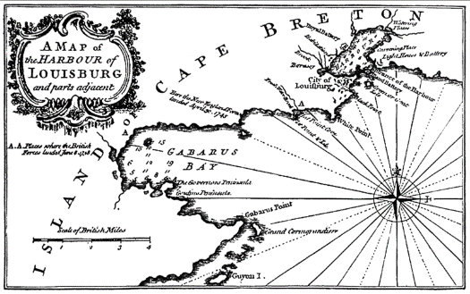
This was a bloody costly war (1756-1763) between England and France. Part of the war was fought in North America, where both countries claimed land. The fighting occurred on the northern and western frontiers (the parts of the English territory that bordered or overlapped the French territory). In North America, the war became known as the French and Indian War.

Apprentice | Master  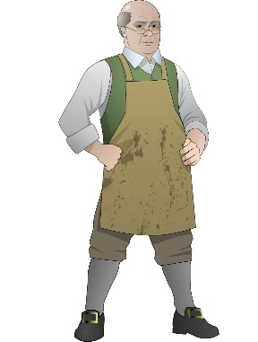
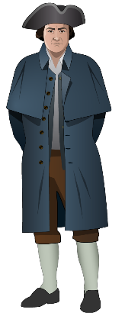  Patriot | Contract  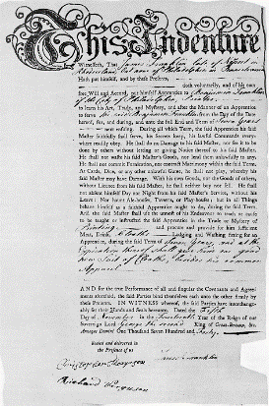
Merchant  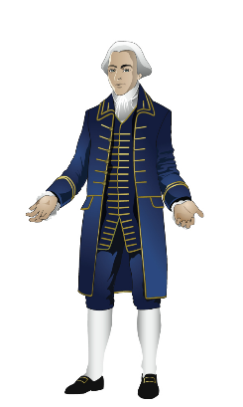 | 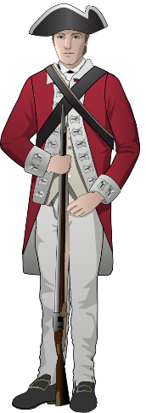  Redcoat

Artisan  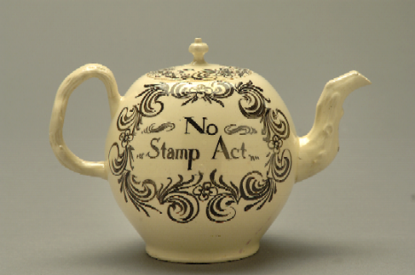 | Journeyman  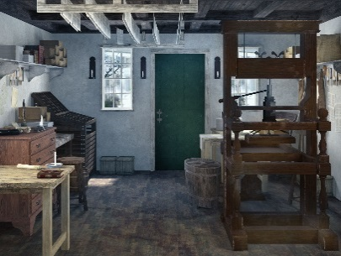
Slave  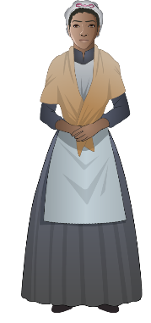 | 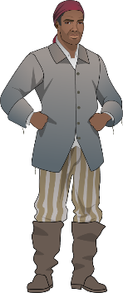  Freedman
Slavery  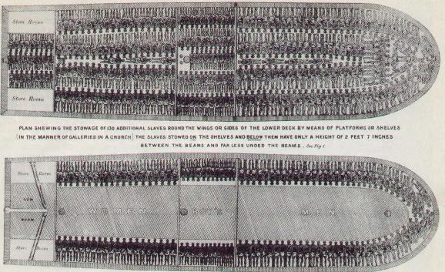 | Printer

Seven Years’ War

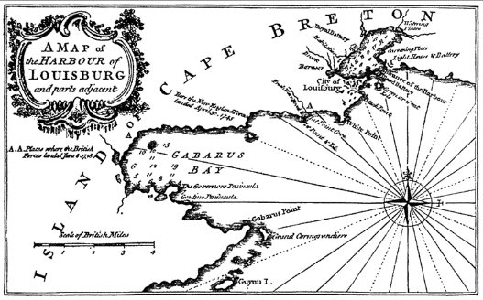

Somebody who is being trained by a skilled professional in an art, a craft, or a trade. In colonial trades, this person learned from, and worked for, the master. | This craftsman is someone at the highest level of skill in a trade or occupation. In colonial trades, this person was most often the owner of the business. This is also the person with whom an indenture contract is made.
In colonial times, this was a person who was a proud supporter of the American cause: at first, this meant freedom from what were considered unfair British laws. Later on, it also meant a person who was in favor of American independence from the British Empire. | A formal, usually legal agreement. It can also be a more general term for an indenture, a work agreement with strict terms, usually lasting seven to ten years. In exchange for room and board and instruction in a trade, the servant was at the mercy of the master. Servants often worked long hours and suffered harsh treatment and conditions.
Someone who buys and sells goods, especially in large quantities. These people shipped goods to and from other colonies, to England and to Europe and Africa. They were often among the wealthiest and most respected colonists. | This was a nickname for a British soldier serving in America, so named because of the color of the coat he wore. It was not as insulting as two other nicknames, “bloodyback” and “lobster.” It was similar to the modern nickname “cops” for police officers, so-named because of the copper buttons on their uniforms.

A skilled craftsperson who makes tools, decorative objects, books, or clothing by hand. | An artisan who has completed an apprenticeship and is fully trained and qualified, but who still works for an employer or master craftsman.
Somebody who was forced to work for somebody else. Since this person was regarded as property, he or she received no payment for their work. | A person who has been freed from slavery. In colonial America and before the Civil War, these people were required to carry papers that proved they were free. Many were kidnapped back into slavery..
A system based on using enforced labor and regarding those laborers as property. This institution has existed in many different societies and time periods. In the British colonies and later the U.S. these enslaved workers faced harsh treatment and no rights. | A person who presses type and ink onto paper. In colonial shops this person often wrote, edited, and published newspapers and pamphlets.

This was a bloody costly war (1756-1763) between England and France. Part of the war was fought in North America, where both countries claimed land. The fighting occurred on the northern and western frontiers (the parts of the English territory that bordered or overlapped the French territory). In North America, the war became known as the French and Indian War.
Name: Date:

Activity: After reading and talking about the words or terms on the flash cards, read this letter Nat Wheeler sent to his parents back in Uxbridge after his first day in Boston. Use the cards and your memory to help you fill in the missing words and terms.

slavery  freedman  slave  artisan | journeyman  redcoat  merchant  apprentice | master  patriot  contract | printer  Seven Year’s War

My dear Mother and Father,
I thank you for signing the __________________ with Mr. Edes. While he does not strike me as the kindest of men, so far he has been a very fair __________________ to me, and I hope he will decide to take me on here as his __________________.
Of course, I understand that there wasn’t much future for me in Uxbridge. Even though Christopher went off to fight in the __________________ against the French, Samuel will stay on with you, and so it makes good sense for me to he here in Boston learning a trade rather than to have remained at home. Perhaps I will someday become a _______________ printer at Mr. Edes’s shop, and when you come to visit me, I will announce it in the newspaper. Maybe some day, I will have a shop of my own and be a ______________!
Boston is a rather puzzling place compared to Uxbridge. You know, Mother and Father, many of the citizens of Boston look unfavorably on the British soldiers here. They call them ______________ or lobsters!
On my first day, I was to sell some advertisements for the newspaper. I wandered up and down the streets, which are filled with the shops of various _________________, cabinetmakers, blacksmiths, chandlers, coopers, potters, leathersmiths and more. It’s a busier and more interesting city than ever I imagined. I met a girl who had lost her dog, Thimble. I told her I worked for the ________________ and that she might take out an ad announcing that fact. She said she would. At the harbor, I met yet another man, named Solomon. He was a black man, but he was a _______________ and not a ______________. He seemed as good a man as any white man I have ever met. Yet there might be an advertisement for a runaway dog next to one for a runaway slave! I don’t really understand __________________, truth be told. A person is not a horse or a table. How can good people presume to own another person?
I met a ___________________ named Paul Revere who made no secret that he opposes Americans importing goods from England. And then I met yet another man, a ______________ named Mr. Lillie, who feels importation of goods from England is a normal and necessary part of trade.
There is a lot to do, and a lot to think about. I will write you often about my progress. I pray you and Samuel are well.
Your grateful and loving son,
Nat

