

Nathaniel “Nat” Wheeler

Royce Dillingham

Solomon Fortune

Martha Edes

Phillis Wheatley

Paul Revere

Hugh White

Constance Lillie

Benjamin Edes

Mr. Wheeler

Nathaniel “Nat” Wheeler

Royce Dillingham

Solomon Fortune

Mrs. Martha Edes

Phillis Wheatley

Paul Revere

Hugh White

Constance Lillie

Mr. Benjamin Edes

Mr. Wheeler

Theophilus Lillie



**EDES ATTIC**

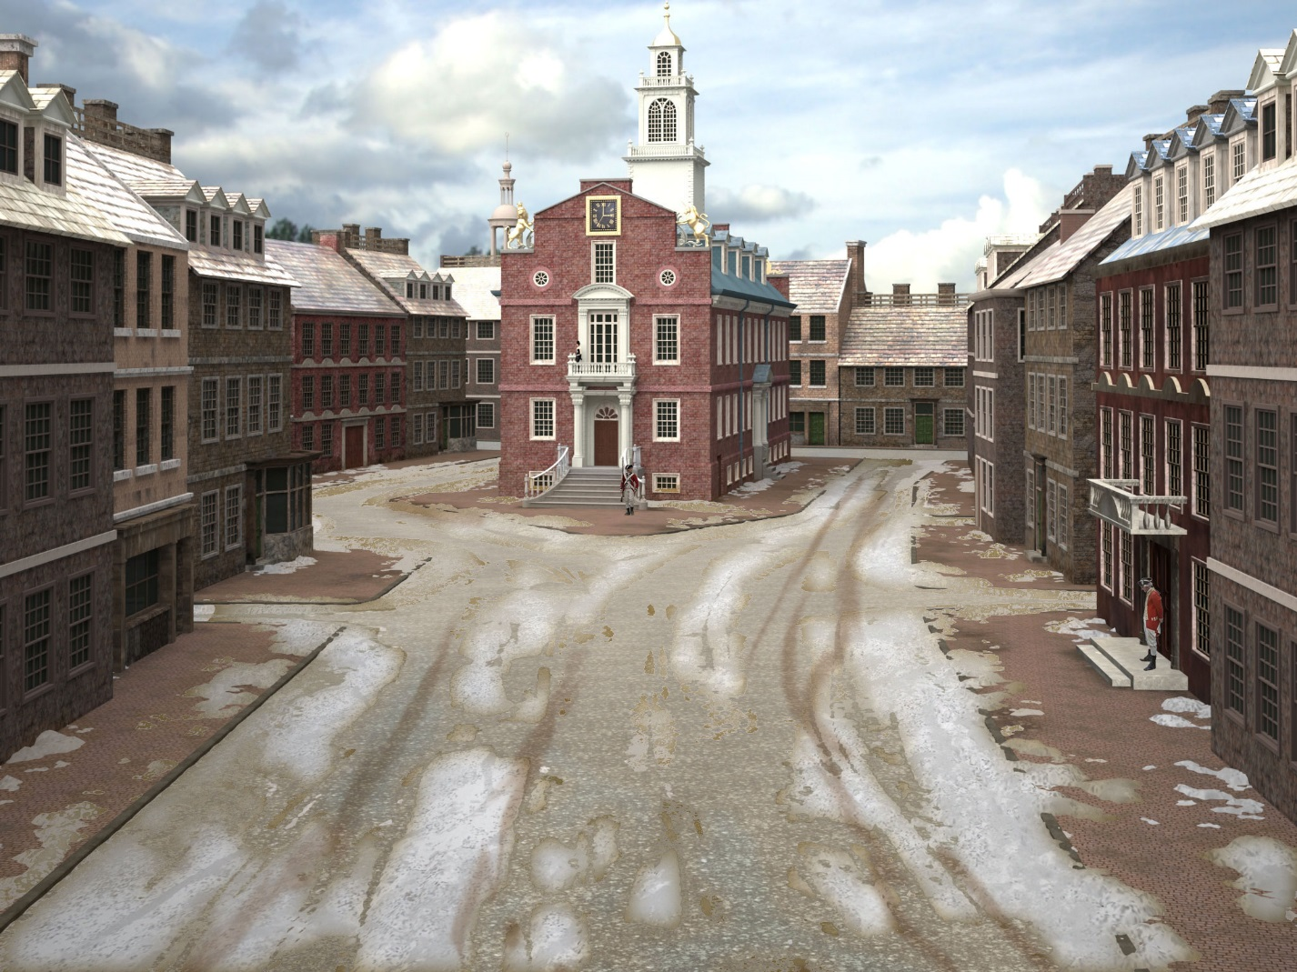

**KING STREET**

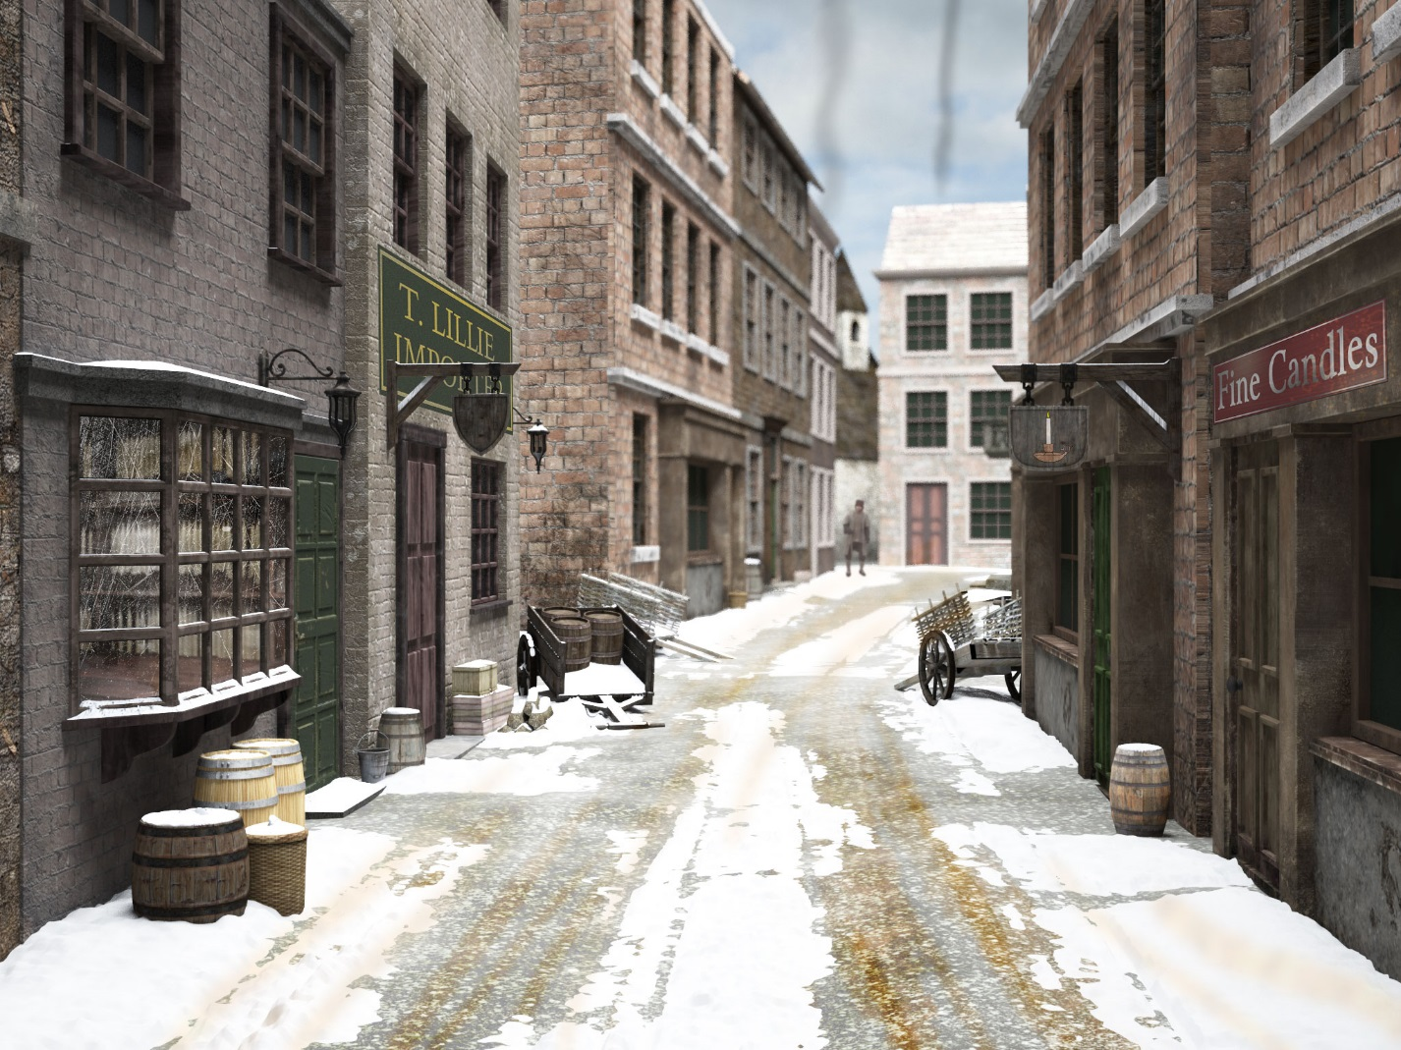

**NORTHEND**

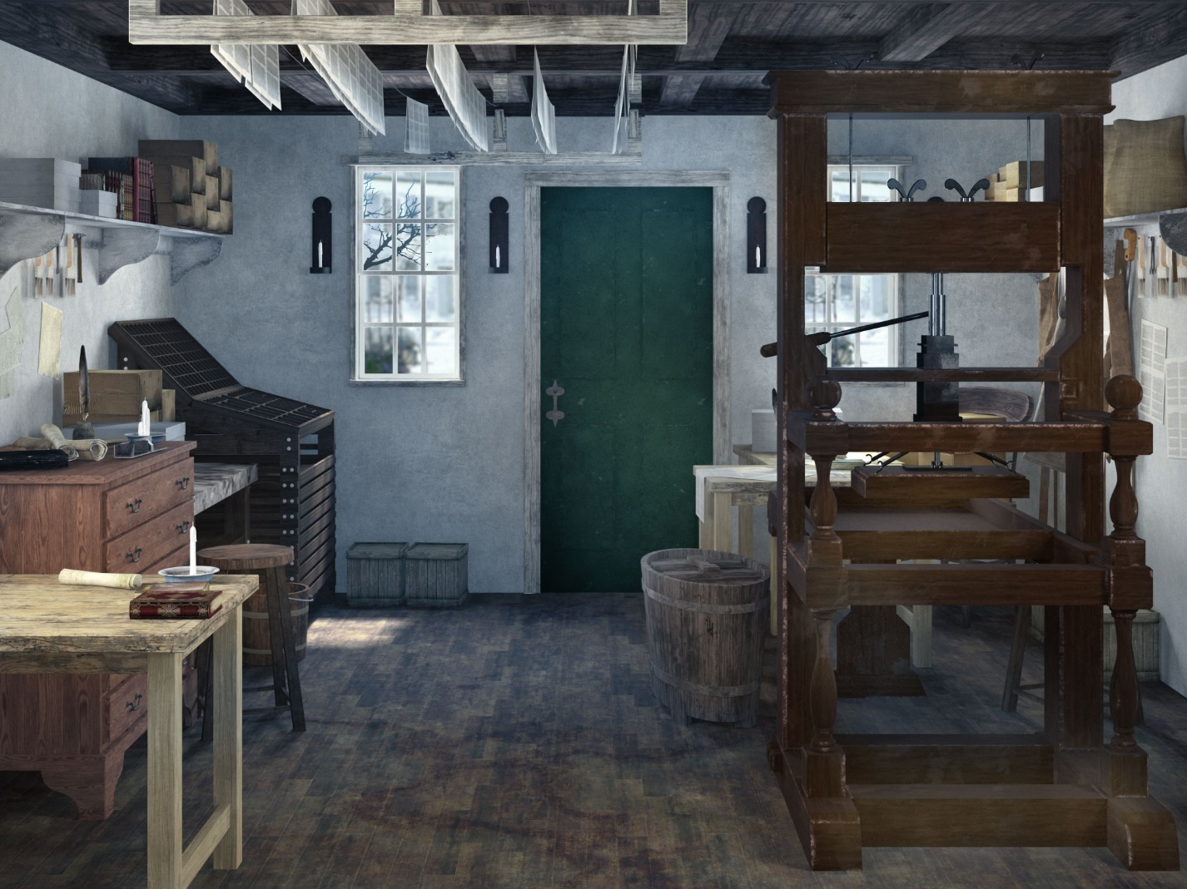

**PRINTSHOP**

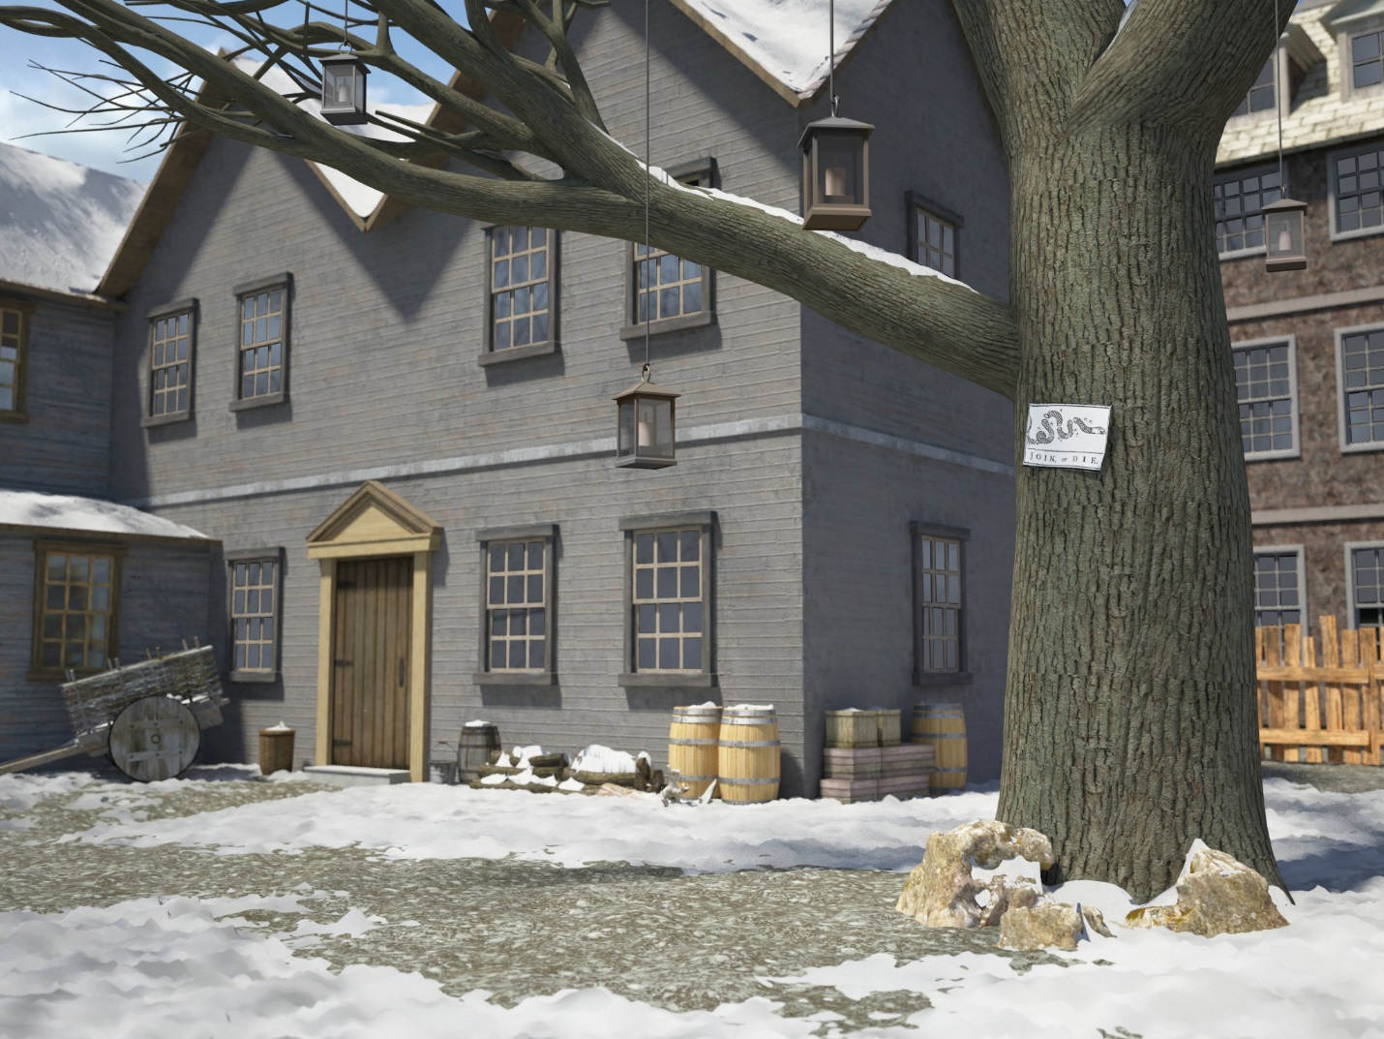

**EDES KITCHEN**

**LIBERTY TREE**



**WHEELER FARMHOUSE**

**GRIFFIN’S WHARF**

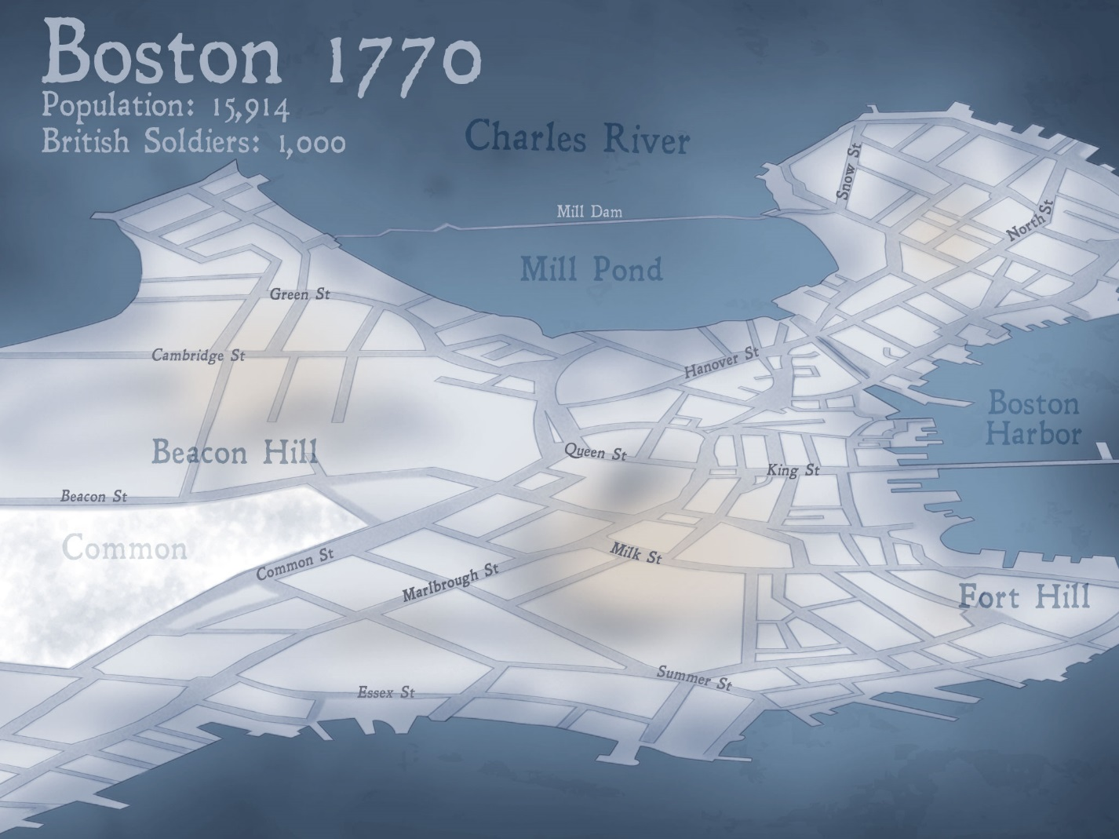

**MAP OF BOSTON, MASSACHUSETTS**