Godey’s Lady Book (1848)

Godey’s Lady Book was one of the country’s most popular magazines in this era. It advised middle-class white women on domestic matters, including how to maintain a beautiful home, raise healthy and well-behaved children, and dress in the latest European styles.
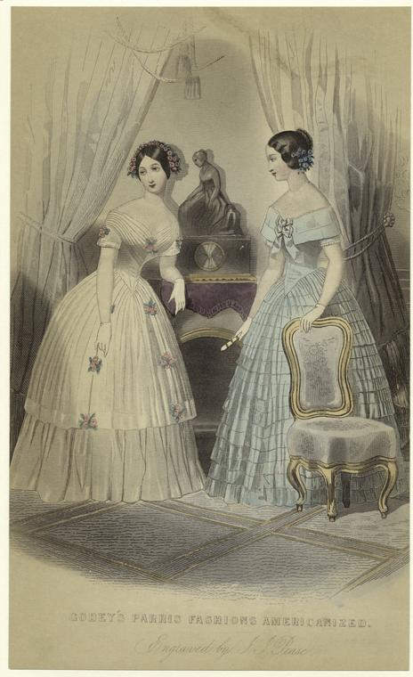
Source: Godey’s Paris Fashions Americanized, engraved by Joseph Pease, 1848, from New York Public Library’s Digital Gallery, http://digitalgallery.nypl.org/nypldigital/id?802276

