“Sale of Slaves and Stock” Poster (1852)

Slaves were considered property by their owners and by law and could be sold with no regard for family ties. The 1850s witnessed one of the nation’s largest geographic shifts in its slave population as the internal slave market sold thousands of enslaved African Americans from the upper south to the lower south. The death of a slave owner could result in the break up of numerous families.
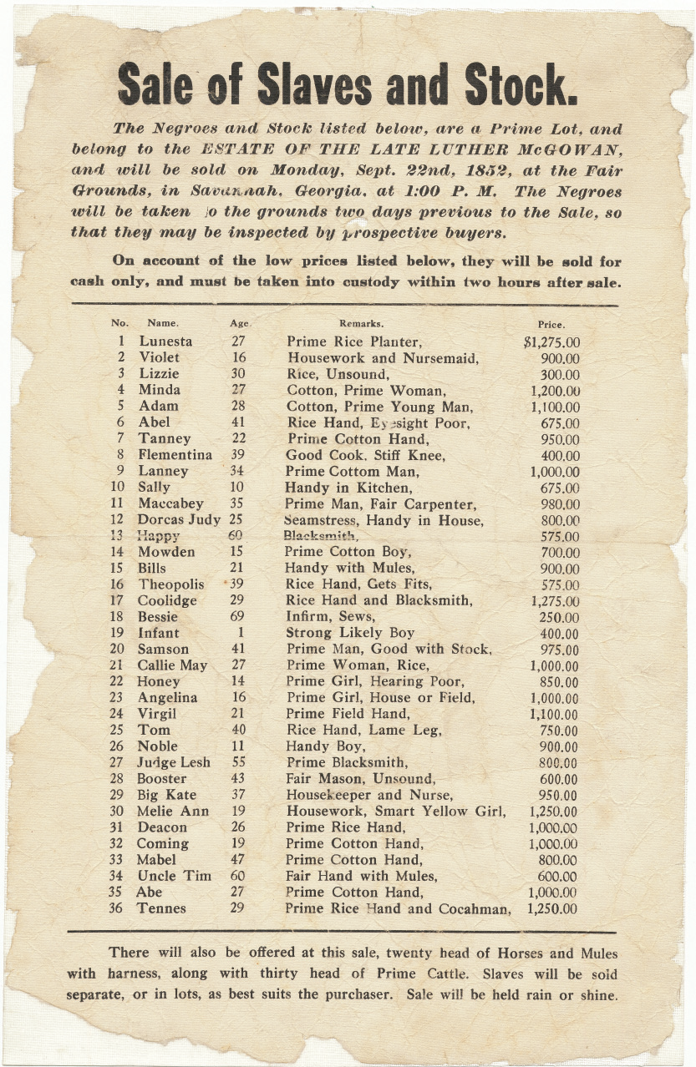
Source: Chicago History Museum

