“$1200 to $1250 Dollars! For Negroes!!” Poster (1853)

After 1807, slaves could no longer be imported into the United States from Africa or the Caribbean. Plantation owners were dependent on the domestic slave trade and the natural increase of slaves for their labor. By the 1850s, the western expansion of cotton meant that the demand for slaves exceeded the supply in certain regions. Slave traders used advertising, as seen here, to encourage slave owners in the Upper South---where demand for labor was decreasing—to sell their slave property to masters in the Deep South where the demand for labor was highest.

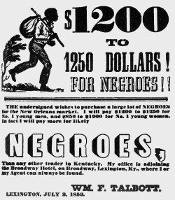

Text:
$1200 to $1250 Dollars! For Negroes!!
The undersigned wishes to purchase a large lot of NEGROES for the New Orleans market. I will pay $1200 to $1250 for No. 1 young men, and $850 to $1000 for No. 1 young women. In fact I will pay more for likely NEGROES, Than any other trader in Kentucky. My office is adjoining the Broadway Hotel. on Broadway, Lexington, Ky., where I or my Agent can always be found.
WM. F. Talbott

LEXINGTON, JULY 2, 1853
Source: Coleman Collection, University of Kentucky Special Collections, printed in Marion B. Lucas, A History of Blacks in Kentucky: From Slavery to Segregation, 1760-1891 (2003), 91.

