“Plantation Police” in Mississippi, 1863

This scene of white patrollers examining “Negro passes” in Mississippi illustrates the constraints placed on all African Americans in the slave South. This news illustration captured a scene during the Civil War, when slave owners in Mississippi feared that large numbers of slaves would escape to freedom behind Union lines and organized patrols to closely monitor the movements of slaves.

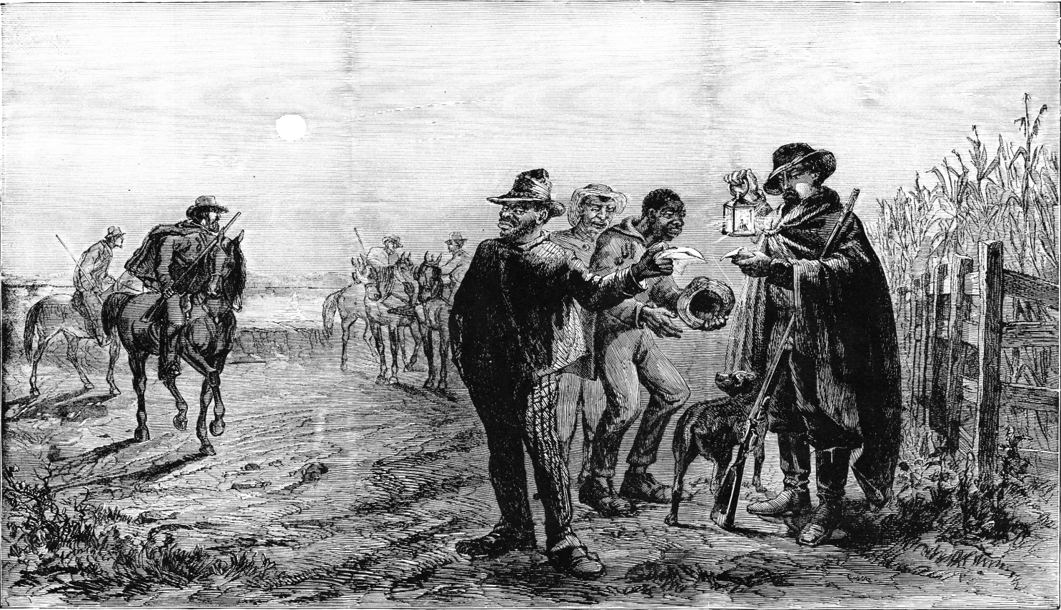

Source: Frank B. Schell, “Plantation Police, Vicksburg, Miss.,” Frank Leslie’s Illustrated Newspaper, 11 July 1863.

