“Caution!! Colored People of Boston” Anti-Slavery Poster (1851)

After the passage of the Fugitive Slave Law, abolitionists tried to warn fugitives in the North about the new dangers to their safety. This poster was created by Boston abolitionist Theodore Parker.
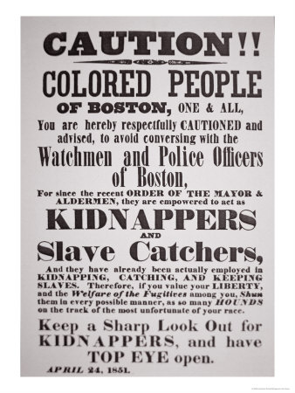
Source: Boston Public Library

