Life in Manzanar Prison Camp | In the Eye of the Beholder: Dorothea Lange and Ansel Adams

Instructions

A NOTE TO THE EDUCATOR: This activity is best used after students have played the Prologue and Part 1 of the game.
During World War II, artists Dorothea Lange and Ansel Adams photographed life in Manzanar Prison Camp. Lange’s images represented more of the harsh conditions in the camp, while Adams’ presented a more optimistic view. While both photographers were commissioned to document the camp conditions in the prison by the US government, Lange’s photographs were not released to the public until after the war.
Working in small groups, students learn about Dorothea Lange and Ansel Adams and view their work documenting life in Manzanar. After examining a selection of curated images, students will record their observations about how each artist documented life in Manzanar and use a Venn diagram to compare and contrast the collection of each artist. A culminating activity asks students to write a creative response about the camp from the perspective of Lange or Adams.
Steps to Complete:
- Students complete Prologue and Part 1 of “Prisoner in My Homeland.” Briefly discuss what they experienced to ensure that they understand the major points introduced.
- Distribute the Dorothea Lange and Ansel Adams packets to students divided into groups of 2-3.
- Instruct students to complete each packet.
- Complete the Venn Diagram.
- Then, students should complete the Culminating Activity individually.
- Debrief the activity as a class by discussing the groups’ responses to the questions, Venn Diagram, and Culminating Activity.

Dorothea Lange Photographs of Manzanar
Directions: Read the text below and examine the Dorothea Lange photographs documenting life in Manzanar Prison Camp, along with the descriptive captions Lange wrote to accompany each image.
Dorothea Lange (1895-1965) is widely considered one of the greatest documentary photographers of the 20th century. Her images of the Great Depression, taken while she was employed by the Farm Security Administration (FSA), are iconic.
While working on assignment for the War Relocation Authority (WRA) during World War II, Lange photographed the forced removal and incarceration of Japanese Americans in camps. Her photos captured life in the prison camps and the often raw emotions displayed by the people who were uprooted from their homes and forced to live in the camps.
Analyzing Photographs of Dorothea Lange
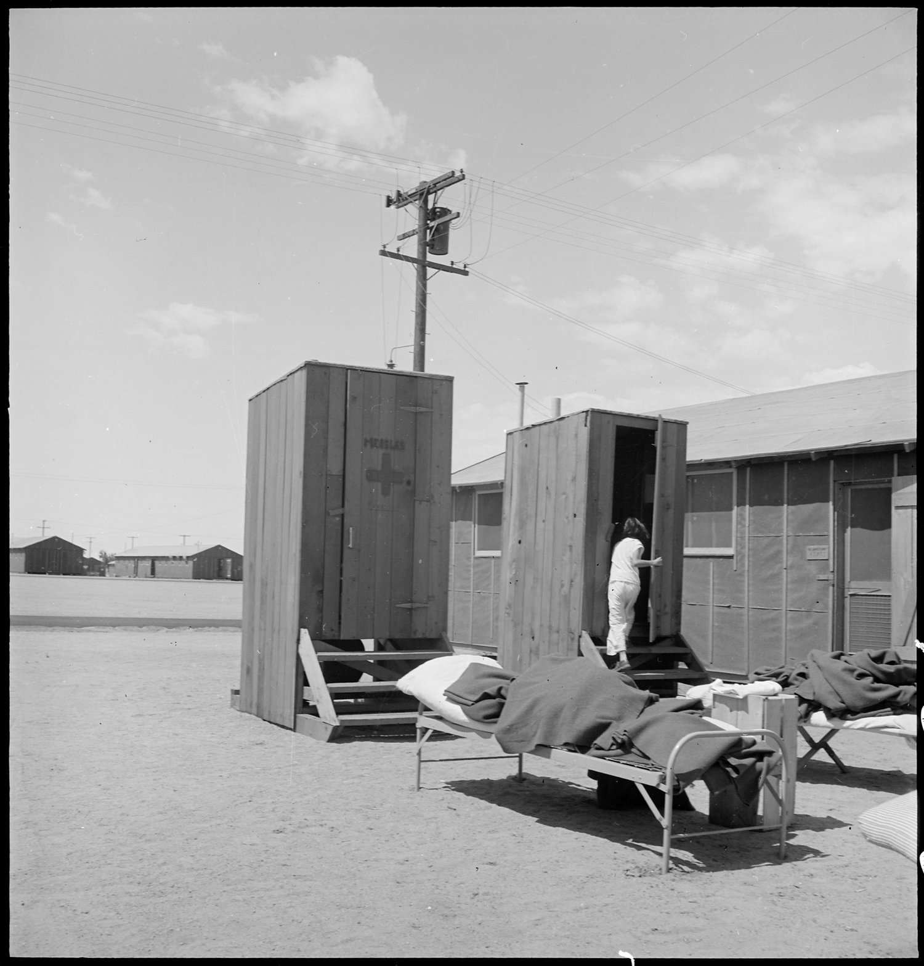
Lange’s Caption: Manzanar Relocation Center, Manzanar, California. Hospital latrines, for patients, between the barracks, which serve temporarily as wards. For the first three months of occupancy medical facilities have been meager but the new hospital fully equipped, is almost ready for occupancy.
7/1942
https://catalog.archives.gov/id/538149

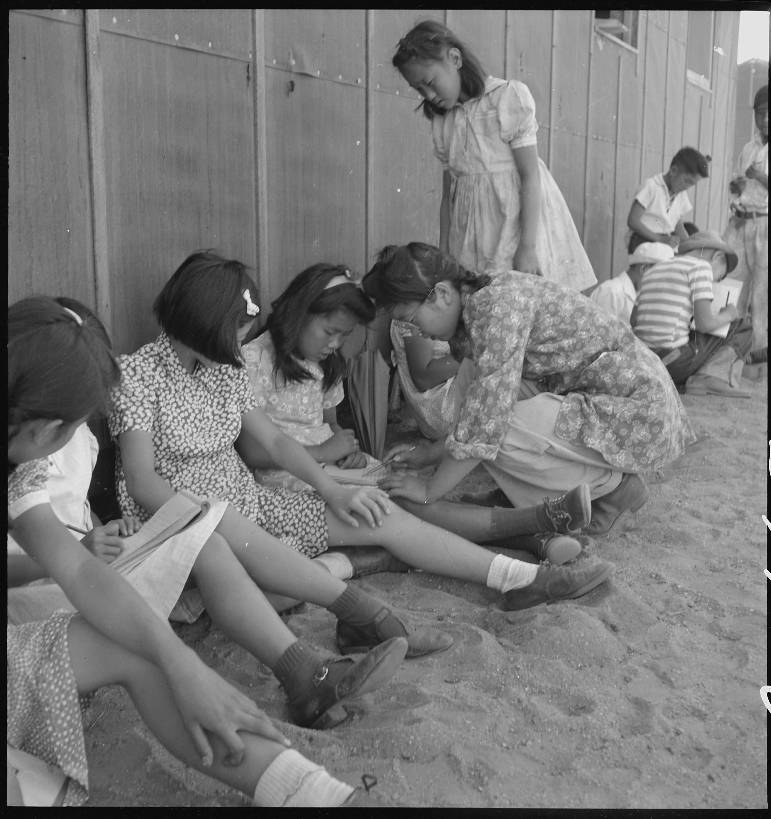
Lange’s Caption: Manzanar Relocation Center, Manzanar, California. An elementary school with voluntary attendance has been established with volunteer evacuee teachers, most of whom are college graduates. No school equipment is as yet obtainable and available tables and benches are used. However, classes are often held in the shade of the barrack building at this War Relocation Authority center. 1942.
https://catalog.archives.gov/id/537962

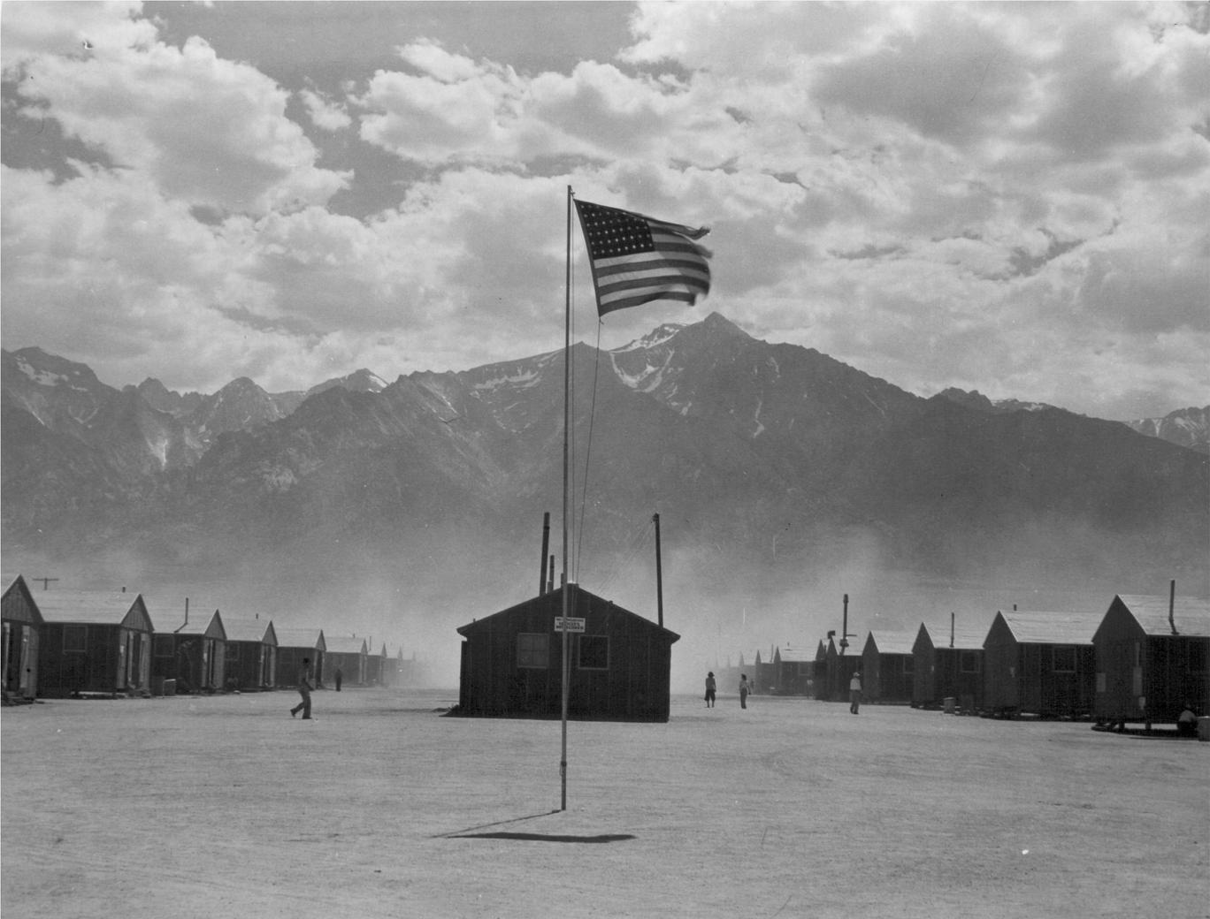
Lange’s Caption: Manzanar, California. Dust storm at this War Relocation Authority center where evacuees of Japanese ancestry are spending the duration.
https://catalog.archives.gov/id/539961

Directions: While thinking about the Dorothea Lange photographs, also think about the parts of “Prisoner in My Homeland” you have already played. Record your observations about life in Manzanar Prison Camp in the chart. You may record more than one observation in each box.

Dorothea Lange | What does the source reveal about life in Manzanar? [Hint: In the photos, consider the artist’s perspective, the framing of the image, the featured subject or activity, the tone of the image, the movement of people, people’s expressions, caption text, etc.]
Medical Care
School in Prison
View of the Buildings and Surrounding Environment

Review the photographs and your recorded observations. What do you think Dorothea Lange was trying to record with her photographs? What was her goal?
Ansel Adams Photographs of Manzanar

Directions: Read the text below and examine the Ansel Adams photographs documenting life in Manzanar Prison Camp.
Ansel Adams (1902-1984), America's most well-known photographer, documented the Manzanar War Relocation Center in California and the Japanese-Americans imprisoned there during World War II.
Adams' Manzanar work is a departure from his signature style landscape photography. Although a majority of the more than 200 photographs are portraits, the images also include views of daily life, agricultural scenes, and sports and leisure activities. When offering the collection to the Library of Congress in 1965, Adams said in a letter, "The purpose of my work was to show how these people, suffering under a great injustice, and loss of property, businesses and professions, had overcome the sense of defeat and dispair [sic] by building for themselves a vital community in an arid (but magnificent) environment....All in all, I think this Manzanar Collection is an important historical document, and I trust it can be put to good use."
Analyzing Photographs of Ansel Adams
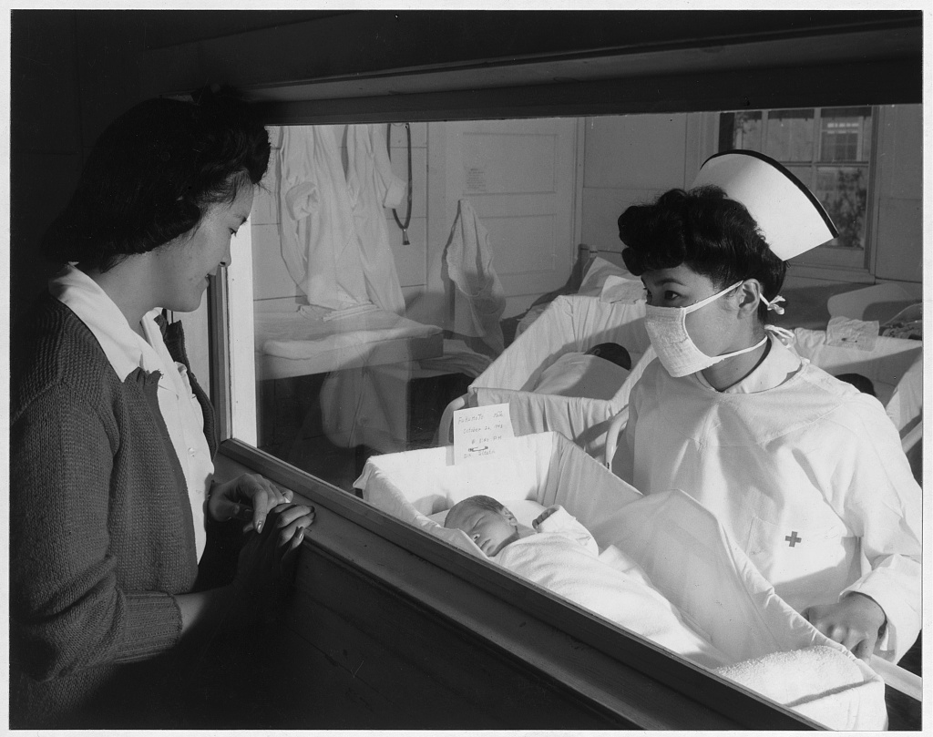
Nurse Aiko Hamaguchi, mother Frances Yokoyama, baby Fukomoto, Manzanar Relocation Center, California / photograph by Ansel Adams. 1943. https://www.loc.gov/resource/ppprs.00343/
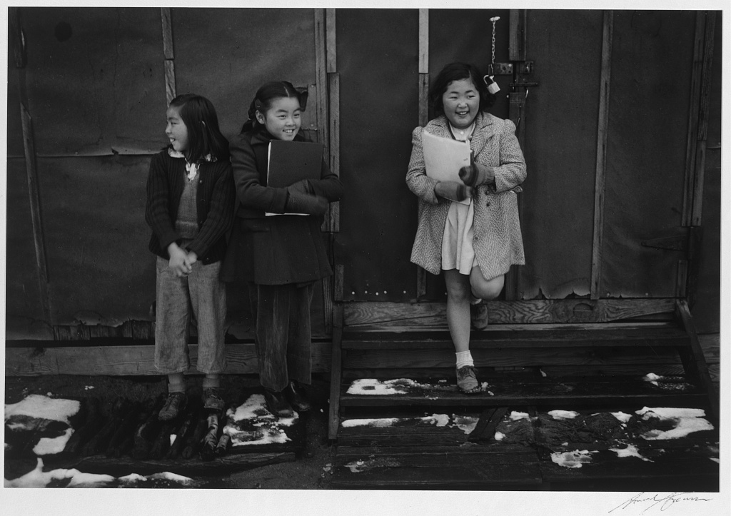
School children, Manzanar Relocation Center, California / photograph by Ansel Adams, 1943
https://www.loc.gov/resource/ppprs.00357/

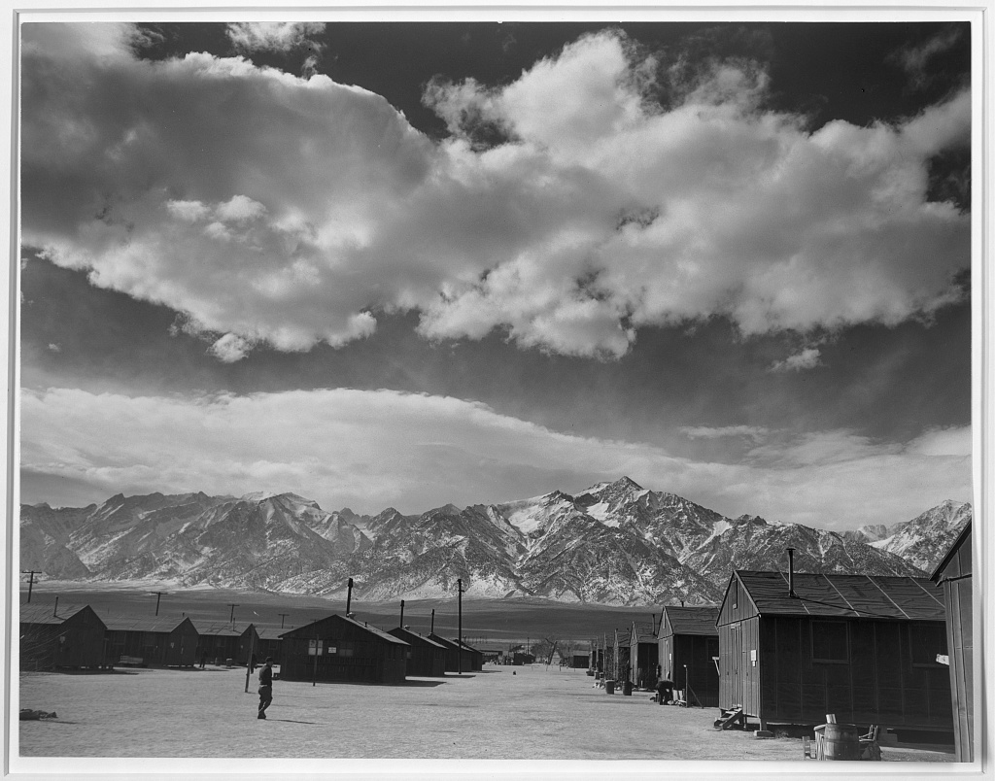

Manzanar street scene, clouds, Manzanar Relocation Center, California / photograph by Ansel Adams, 1943.
https://lccn.loc.gov/2002695966

Directions: While thinking about the Ansel Adams photographs, also think about the parts of “Prisoner in My Homeland” you have already played. Record your observations about life in Manzanar Prison Camp in the chart. You may record more than one observation in each box.
Ansel Adams | What does the source reveal about life in Manzanar from the perspective of an outsider (Adams) documenting life in a prison camp? [Hint: In the images, consider the artist’s perspective, featured subjects or activities, the tone of the images, the movement of people, people’s expressions, caption text, etc.]
Medical Care
School in Prison
View of the Buildings and Surrounding Environment

Review the photographs and your recorded observations. What do you think Ansel Adams was trying to record with his photographs? What was his goal?

Compare and Contrast
Directions: Review the information you recorded in your Dorothea Lange and Ansel Adams charts. Use the Venn diagram to list the similarities and differences between the way the two artists documented Manzanar.
Culminating Questions:
- What are the differences you see in the set of photos?
- Dorothea Lange and Ansel Adams were both commissioned by the United States government to photograph the living conditions of Manzanar Prison Camp. Lange’s photographs were not released until World War II ended. Why do you think the government did this?

Extension Activity:
Write a short story from the perspective of Henry Tanaka that he might tell his grandchildren (born after WWII) about life at Manzanar. How would he describe arriving there? How would he describe the living conditions, daily life, and how it felt to be imprisoned?

