A NOTE TO THE EDUCATOR:
On the following pages, you will find “flashcards” with terms and definitions (both combined and separate) that your students may encounter while playing “Prisoner in My Homeland.” These terms and definitions can be introduced and practiced before or during the time students see or hear them in the context of Mission US or in their American history study. The discussion questions and writing prompts will provide further opportunities for students to have more practice with the words and terms.

Divide your students into small groups of four or five, and ask each group to review the terms and definitions. After your students have had a chance to review and discuss the terms and definitions, distribute the excerpt from an imagined talk between Maya Tanaka and a class of middle school American history students.

Review the directions with your students, and ask them to complete the text using the terms they studied. Here is the order in which the vocabulary terms should be inserted into the blanks within Maya’s talk with students:

mochi
sugoi
General DeWitt
questionnaire
Selective Service System
WAAC
unqualified allegiance

General DeWitt  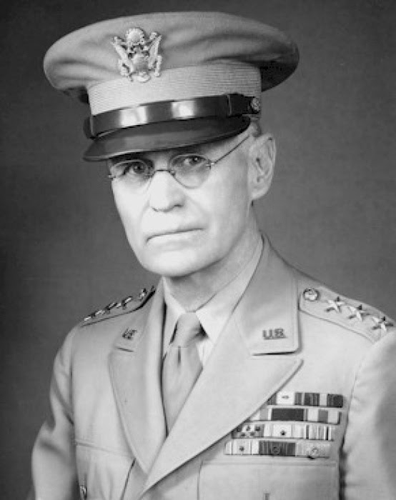  U.S. wartime general overseeing the defense of the Pacific Coast. DeWitt opposed allowing Japanese Americans to resettle on the West Coast on the grounds that it was "impossible to determine their loyalty." | mochi  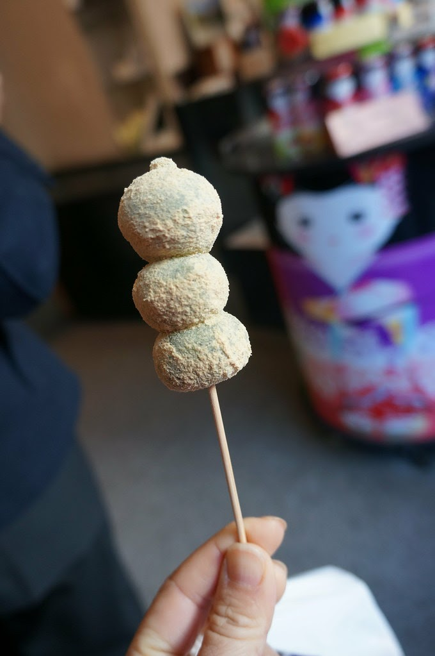  Traditional small cakes made of sweet steamed rice paste.
Questionnaire  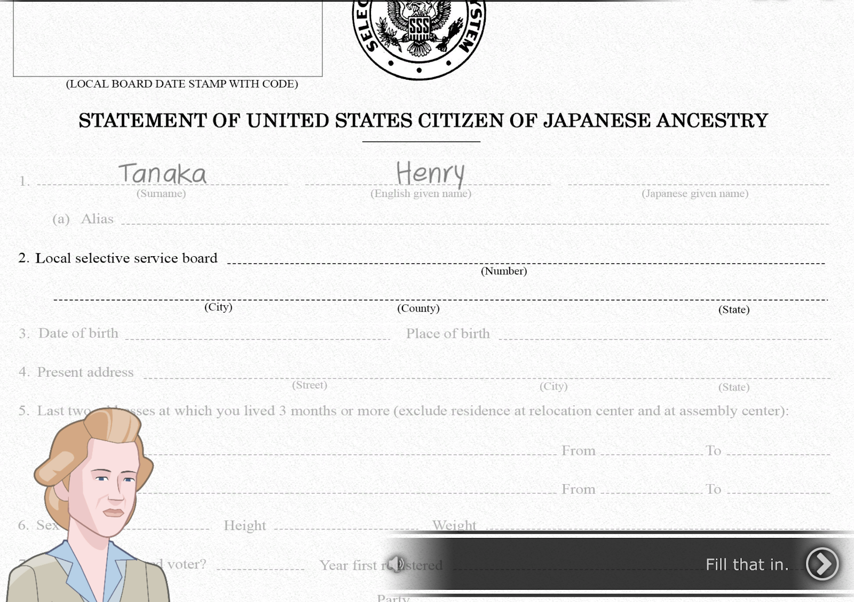  A form designed by the U.S. military to determine whether Nisei being considered for military service would be loyal to the United States or to Japan. | Selective Service System    U.S. government agency responsible for maintaining information on persons who may be required to serve in the military.
sugoi  Amazing or “wow.”   | unqualified allegiance  loyalty or dedication to a person, country, or belief without exceptions or reservations  
WAAC
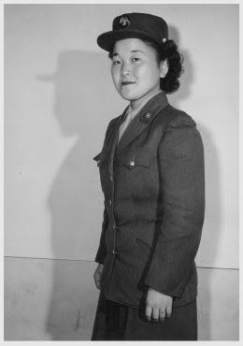
The Women's Army Auxiliary Corps, an all-female volunteer unit of the U.S. Army formed in 1942.

General DeWitt | mochi
Questionnaire | Selective Service System
sugoi | unqualified allegiance
WAAC

U.S. wartime general overseeing the defense of the Pacific Coast. DeWitt opposed allowing Japanese Americans to resettle on the West Coast on the grounds that it was "impossible to determine their loyalty." | Traditional small cakes made of sweet steamed rice paste.
A form designed by the U.S. military to determine whether Nisei being considered for military service would be loyal to the United States or to Japan. | U.S. government agency responsible for maintaining information on persons who may be required to serve in the military.
Amazing or “wow.” | loyalty or dedication to a person, country, or belief without exceptions or reservations
The Women's Army Auxiliary Corps, an all-female volunteer unit of the U.S. Army formed in 1942.

Name: _______________________ Date:_________________________

Activity: More than seventy-five years after the events of “Prisoner In My Homeland,” Maya Tanaka, Henry Tanaka’s present-day 20-something granddaughter, is invited to give a talk to a local middle school history class. Maya is telling the class about a controversial decision made by the U.S. government in the World War II-era Japanese incarceration camps. The following is a portion of her interactions with the students.

After reading and discussing the words and terms on the flashcards, read this excerpt from her talk with the students, and use your memory to fill in the missing words and terms.

WAAC | sugoi | unqualified allegiance
General DeWitt | Selective Service System | mochi
questionnaire

Maya Tanaka: Hello class! I’m back to speak with you about my family’s history in the World War II-era Japanese American incarceration camps. Today, I’m going to share with you about a time that my grandfather, Henry Tanaka, faced a tough decision in the camps. It was near the New Year of 1943. That must seem like a long time ago to you!

Student: What did people do to celebrate the new year in the camps?

Maya Tanaka: From reading my grandfather’s diary, I learned that people would make _________ in the camps. Do you know that is?

Student: Yes! I’ve had the ice cream. It’s like a rice dessert.

Maya Tanaka: That’s right. I’m pretty surprised you know! We might say, _________ in Japanese. Though, I guess a lot of people today may have eaten that kind of ice cream. It’s sticky cakes, pounded from cooked rice. It can be both sweet or savory. This food is an important part of Japanese and Japanese American tradition, especially for celebrating the new year.

Student: Why do you bring mochi up?

Maya Tanaka: People like my grandfather would make mochi in the camps as a way of carrying their cultural traditions forward while in prison. It was a difficult time, the year of 1943. ___________________ was the person in charge of many of the decisions about what happened in these prisons. Along with many other government officials, he decided to hand out a ________________.

Student: Like a test?

Maya Tanaka: Yes, sort of like a test. It was a way that the government decided to determine who might be willing to serve in the military. The official term the government agency that establishes eligibility for the draft is __________________.

Student: What about women in the camps? How would they respond to a question about military service in 1943?

Maya Tanaka: That’s a great question. In this document, the government asked women if they were willing to sign up for the __________________. Women could serve as translators, medical professionals, or administrative roles. These roles were pretty complicated. Sometimes, their families did not like them serving in these roles. Some became translators for military documents.

Student: It seems like a lot was figured out in a very short time period!

Maya Tanaka: That’s right. The Japanese Americans in the prisons during World War II had to make big decisions. The government wanted to assess their “______________________” to the United States on a paper questionnaire. You’ll find out more about what happened soon. I’ll be back to talk about the consequences of these answers on the questionnaire.

