The Buffalo and the Cheyenne

A NOTE TO THE EDUCATOR:
The following activity consists of two parts and a summary activity. First, students consider the central role the buffalo played in Northern Cheyenne society, examining sources that demonstrate the buffalo’s use as food, clothing, shelter, trade, and its importance in cultural practices. Second, students consider the challenges to this way of life presented by the decimation of the buffalo herds that occurred after the Civil War.

Students should work in small groups. First, they should examine the sources in Part I, complete the chart, and answer the question. Then, they should examine the sources in Part II, complete the chart, and answer the question. Finally, students should complete the Summary Activity.

Steps to Complete:

- Students complete Part 2 of “A Cheyenne Odyssey.” Briefly discuss what they experienced to ensure that they understand the major points introduced.
- Distribute the source packets to students divided into groups of 3-4.
- Instruct students to complete Part I before moving on to Part II.
- Once students have completed Parts I and II, they should complete the Summary Activity in their groups.
- Debrief the activity as a class by discussing the groups’ responses to the questions and to the Summary Activity.

The Buffalo and the Cheyenne
Background Information and Instructions

As you already know from playing Parts 1 and 2 of “A Cheyenne Odyssey,” buffalo played a central role in the Northern Cheyenne way of life. Buffalo were more than just the primary food source for the Cheyenne; buffalo hides were the foundation of trade with white settlers and buffalo products were part of almost every item used by the Cheyenne in their everyday lives. Because the buffalo was so central to the lives of Plains Indians like the Northern Cheyenne, these Indian tribes are often referred to as Buffalo Societies. In this activity, you will explore the role played by the buffalo in Northern Cheyenne society, and the challenges presented by the destruction of the buffalo herds after the Civil War.

In Part I of this activity, you will examine several sources that illustrate the importance of the buffalo to the Northern Cheyenne. Using this information and the information you have gathered by playing the game, complete the chart to get a better understanding of how important the buffalo was in Northern Cheyenne society. Then, answer the question in a paragraph.

In Part II of this activity, you will examine several sources that address the reasons behind the decline of the buffalo herds, and the effect that this decimation had on the Northern Cheyenne and other Plains Indians. Complete the chart and answer the question using the information you recorded in the chart.

In the Summary Activity, you will examine the role played by the buffalo in Northern Cheyenne society, and the challenges presented by the decimation of the buffalo from the perspective of Little Fox.

Part I: The Role of the Buffalo in Northern Cheyenne Society

Source 1: Excerpt from Wooden Leg: A Warrior Who Fought Custer
Wooden Leg was a Northern Cheyenne warrior who lived during the nineteenth century. He witnessed the transition from traditional life on the plains to life on reservations. He participated in several famous battles, including the Battle of the Little Bighorn. In this excerpt, he describes the role played by the buffalo and buffalo products in Northern Cheyenne society.

“We could get food, clothing, and shelter from the buffalo only. Saddles and harness, halters and bridles were made by using their rawhide. Stout thongs for all purposes were cut from them. For a rawhide lariat rope, long strands were cut by following around the outside of a buffalo rawhide. Three or four of these strands were plaited together. Buffalo hair, particularly from the neck of the bull, was also spun into long strands and plaited to make a lariat. The buffalo then, was very important to us in our mode of life. When any man went out specially hunting them he usually led two or three pack horses to bring in his gathered supply of food and skins. . . .
Buffalo robes from adult animals served as overcoats for men or women. Buffalo calf or deer robes were used for children. Buffalo hair sometimes was stuffed into the moccasins to keep feet warm….”

Marquis, Thomas B. Wooden Leg: A Warrior Who Fought Custer. Lincoln: University of Nebraska Press, 1957. [Originally published as A Warrior Who Fought Custer in 1931.]

Source 2: Buffalo Hunt

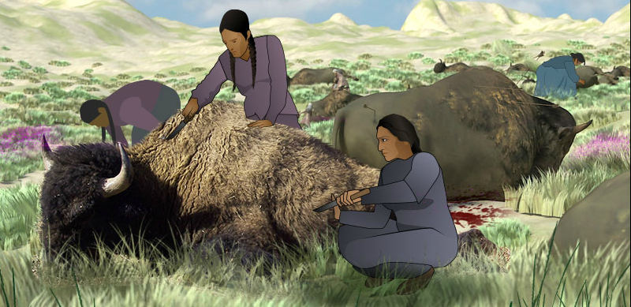

Hunting buffalo was the main source of food for the Northern Cheyenne. As efficient nomadic hunters, the Northern Cheyenne utilized every part of the buffalo carcass that could be used. Therefore, a successful hunt not only meant that the tribe would have plenty to eat, but that they would have hides for trade, for tipis, and for clothing. They also used sinew for weapons and household items, and hair for insulation and decoration.

Source 3: Backrest
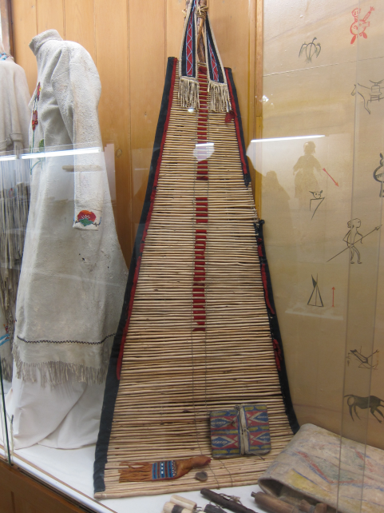

Backrests, made from willow shoots and buffalo sinew, were a highly portable form of seating. They were often painted and decorated with beads. A leather loop made from buffalo hide at the top attached the rolled up backrest to a tripod made out of wooden poles for easy transport.
(From the Yellowstone County Museum, http://www.yellowstonecountymuseum.org/.)
Source 4: War Club
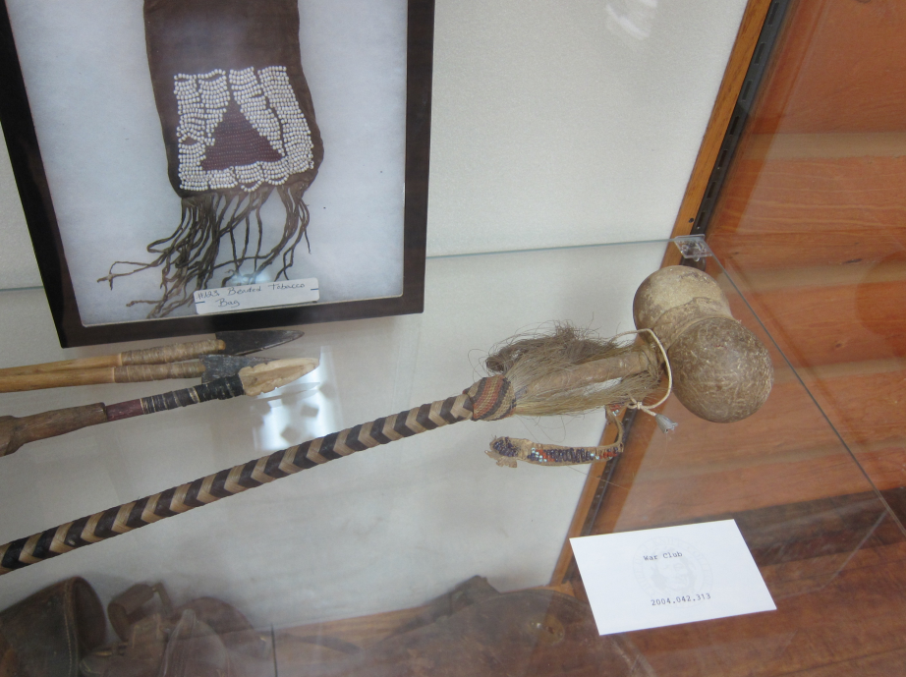

Great Plains Indians such as the Northern Cheyenne often fought with other tribes over hunting rights and territory. War clubs, consisting of a stone head and attached by braided buffalo hair, were commonly used in battle.
(From the collection of Chief Dull Knife College, http://www.cdkc.edu/.)
Source 5: Northern Cheyenne Camp and Tipi Interior
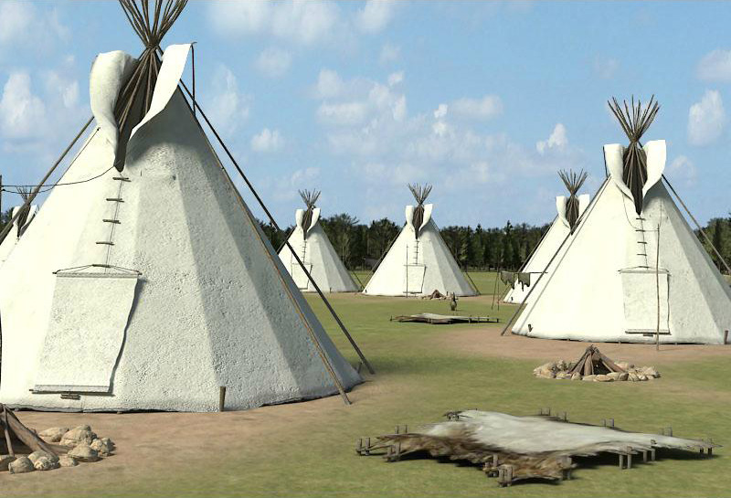
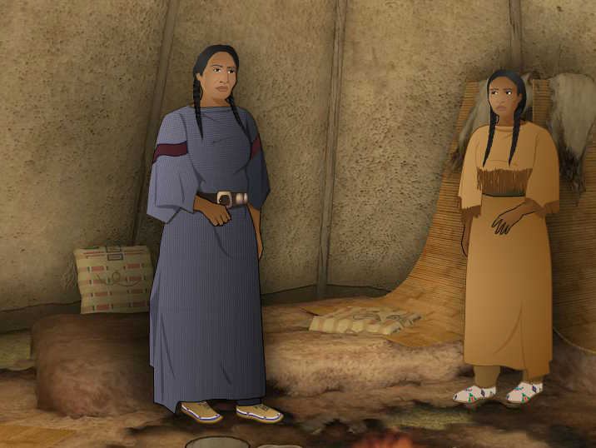

The presence of the buffalo was pervasive in any Plains Indian camp. Buffalo products were used to provide shelter, clothing, and many items used in ever day life. Northern Cheyenne such as Little Fox and his family were surrounded by constant reminders of how important the buffalo was in their lives.

Source 6: Trading Post Interior

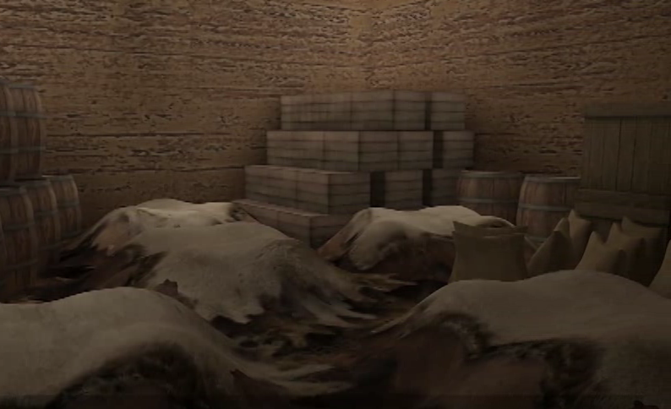

Buffalo hides and robes were always an important item of trade with white settlers, but as the nineteenth century progressed, white Americans and Europeans became more and more enamored with buffalo products. Buffalo hides and robes became stylish in the world of fashion. Machine belts made of buffalo hide lasted longer than those made of cowhide. The buffalo played a crucial role in industrializing the United States.
Source 7: Origins of the Massaum Ceremony

The Massaum Ceremony is one of the communal rituals performed by the Northern Cheyenne. It is sometimes called the Buffalo Dance or the Animal Dance, and is performed by men wearing buffalo head masks. Such dances are an important part of the Cheyenne’s ceremonial, spiritual, and social life. In 1911, Black Horse provided the following description of the origins of the Massaum Ceremony to George Bird Grinnell:

“One morning, many generations back, our great-great-grandfather was out hunting, looking for deer, which in those days were our food, for then there was no buffalo. He saw three deer run up on a hill, and then pass on over a wide level prairie. He followed them, hoping he might kill one. As he went on, suddenly he saw five buffalo coming over a hill from the west. They went down to a stream and stopped and lay down. He could see the steam coming from their nostrils as they breathed. It looked as if they had been running hard. As he looked at them, he thought, ‘Well, here are buffalo.’

Presently he raised his head and looked about, and saw four buffalo coming toward him from the north and running down to the first ones; they stopped there, and lay down with them. Not long after that, three buffalo came from the south, and later two from the east. All of them stopped with the first buffalo.
Soon after those, great herds of buffalo began to come from all directions, and after that the people had always plenty of buffalo. At the same place animals of all kinds gathered, and in commemoration of this gathering the people instituted this Massaum ceremony . . .”

Source: Grinnell, George Bird. The Cheyenne Indians: Their History and Ways of Life, Vol. II. Lincoln: University of Nebraska Press, 1972.

Directions: While thinking about these sources, also think about the parts of “A Cheyenne Odyssey” you have already played. Record your observations about the importance of buffalo in Northern Cheyenne society in the chart. You may record more than one observation in each box. When you have completed the chart, answer the question.

Source | What does the source tell me about the centrality of the buffalo in Northern Cheyenne life? [Hint: In the images, consider what objects are made of and how important they maybe to Cheyenne life.]
Source 1

Source 2

Source 3

Source 4

Source 5

Source 6

Source 7

Do you think the term “buffalo society” appropriately describes Plains Indians such as the Northern Cheyenne? Why or why not?

Part II: The Decimation of the Buffalo
As you examine the sources in Part II of this activity, complete the chart that accompanies them.

Source 1: White Society and the Buffalo
“In the 1870s, buffalo robes became fashionable, and industrialists discovered that buffalo hides could be used for machine belts. The destruction of the bison gathered speed, as dealers used the nation's expanding railroads to transport the hides to market. Railroad companies were particularly interested in disposing of bison; the enormous herds delayed trains, and frequently destroyed huge sections of track. Several railroads offered ‘hunting specials’ across the Plains to their customers; passengers were welcome to shoot as many bison as they possibly could from the comfort of their train car. After a particularly good summer of ‘hunting specials’ in the 1870s, several railroads had to cancel the excursions for a time because the smell from the rotting carcasses on either side of the tracks was so nauseating to passengers.”
(From the website for the PBS series Frontier House, http://www.pbs.org/wnet/frontierhouse/frontierlife/essay8_3.html)

Source 2: Buffalo Skulls

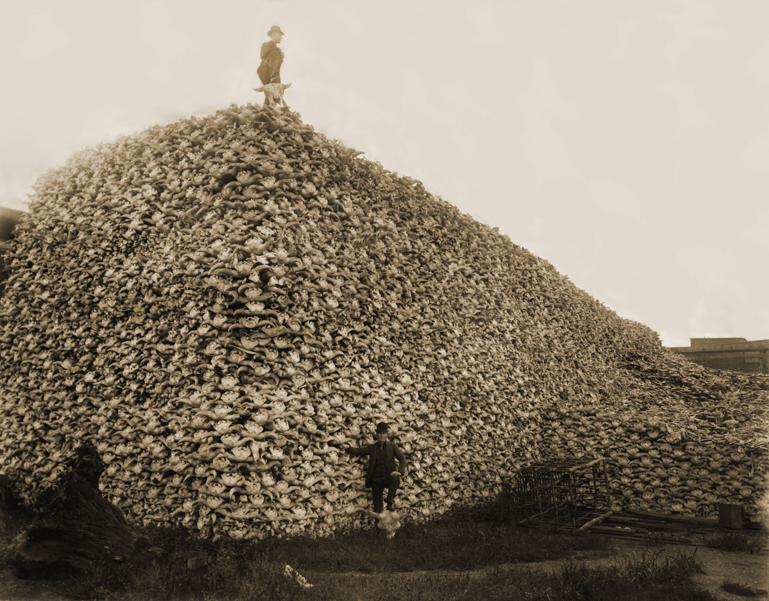

(From: http://upload.wikimedia.org/wikipedia/commons/5/5a/Bison_skull_pile-restored.jpg)

Source 3: Buffalo Hides

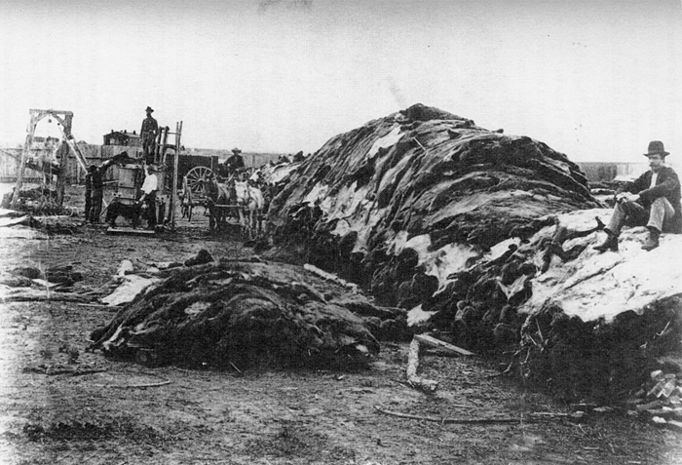

(From http://www.tombstone1880.com/archives/buffalo_hides.jpg)

Source 4: Mounted buffalo heads at a railroad station
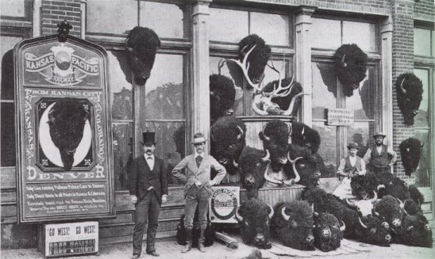
(From http://www.univie.ac.at/Anglistik/easyrider/data/emptying_the_great_plains.htm)

Source 5: North American Bison Population, Estimated 1865-1889

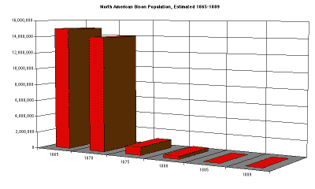

(From http://pbln.imsa.edu/model/tutorials/buffalo/documents/socialmath.html)

Source 6: The Buffalo and the “Indian Problem”
“While the Federal government never officially sanctioned a policy regarding deliberate destruction of buffalo, there were many who noted that the elimination of the buffalo would also lead to the elimination of the "Indian problem." In 1874, the Secretary of the Interior stated, ‘The buffalo are disappearing rapidly, but not faster than I desire. I regard the destruction of such game as Indians subsist upon as facilitating the policy of the government, of destroying their hunting habits, coercing them on reservations, and compelling them to begin to adopt the habits of civilization.’
Similarly, in 1876, Senator James Throckmorton of Texas reasoned, ‘It would be a great step forward in the civilization of the Indians and the preservation of peace on the [frontier] if there was not a buffalo in existence.’"

(From the website for the PBS series Frontier House, http://www.pbs.org/wnet/frontierhouse/frontierlife/essay8_3.html)

Directions: Analyze the information presented in the sources in Part II, and then answer the question.

Source | What does the source tell me about the decimation of the buffalo after the Civil War? [Hint: In the photographs, consider what is happening and who is portrayed.]
Source 1

Source 2

Source 3

Source 4

Source 5

Source 6

What factors caused the drastic decline in the buffalo population illustrated in the chart in Source 5?

Part III: Summary Activity

Northern Cheyenne like Little Fox witnessed the decline of buffalo herds and their willful destruction by white men. They reacted in many ways. How do you think Little Fox would have reacted?

Write a short story that Little Fox may have told his children and his grandchildren about life on the Plains during the latter part of the nineteenth century. How would he explain the importance of the buffalo in the lives of the Northern Cheyenne? How would he describe the destruction of the buffalo and what it meant to him as a Northern Cheyenne?

