A NOTE TO THE EDUCATOR:

On the following pages, you will find “flashcards” with terms and definitions (both combined and separate) that your students may encounter while playing Part 5 of “A Cheyenne Odyssey.” These terms and definitions can be introduced and practiced before or during the time students see or hear them in the context of Mission US, or in their American history study. The discussion questions and writing prompts will provide further opportunities for students to have more practice with the words and terms.

Divide your students into small groups of four or five, and ask each group to review the flashcards containing the combined terms and definitions. Then, have students use the flashcards that have the meanings separated from the images and ask them to match each word/image to its corresponding meaning.

After your students have had a chance to review and discuss the terms and definitions, distribute the excerpt from Little Fox featured at the end of this document. Review the directions with your students and ask them to complete the text using the terms they studied.

Here are the terms that should be inserted into each paragraph of Little Fox’s story:
Paragraph 1 – reservation, banks
Paragraph 2 – earth pigments, scout, ravine, crest, ford
Paragraph 3 – articles

articles  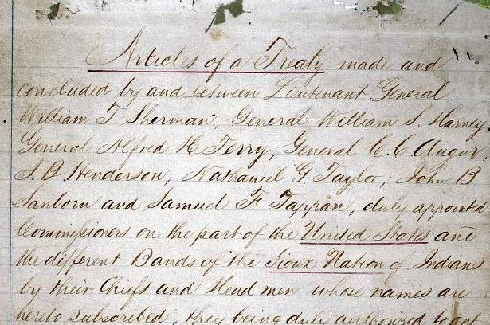  parts of a treaty or other legal document that address specific issues or subjects | banks  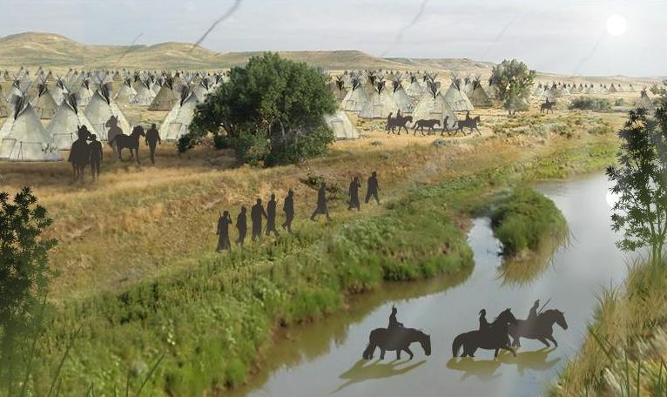  the raised ground beside a river
crest  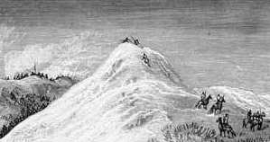  to reach the top of a hill or mountain | earth pigments  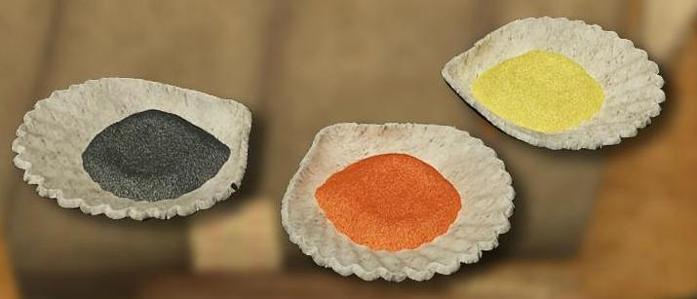  naturally occurring minerals used to paint
ford  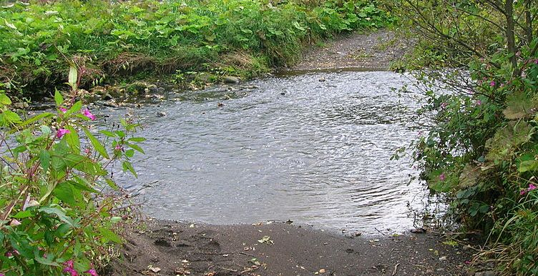  part of a stream, river or other body of water, that is shallow enough to walk across | ravine  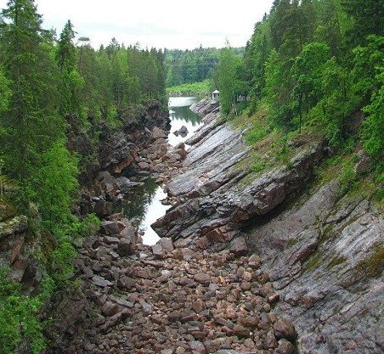  a small, narrow valley with steep sides, carved by running water; it is smaller than a canyon and larger than a gully
reservation  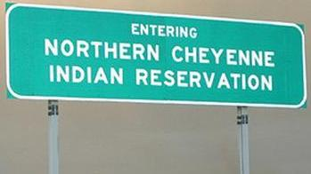  an area of land in the US set aside as a place for Indians to live | scout  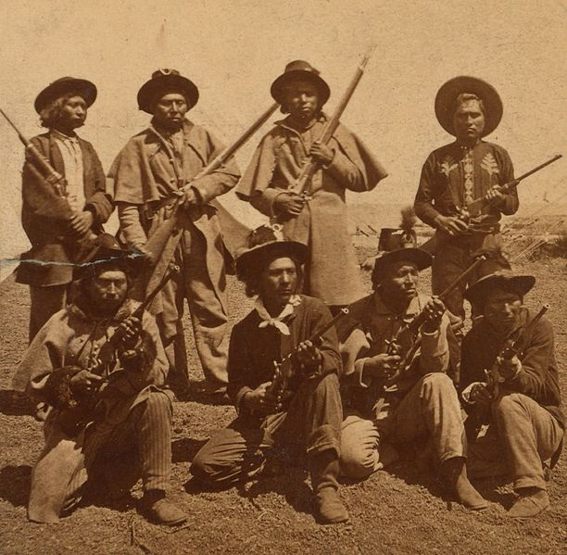  an individual hired to get information  about an enemy; in 1866, the US Army  began hiring Indians as scouts

articles | banks
crest | earth pigments
ford | ravine
reservation | scout

an individual hired to get information about an enemy;  in 1866, the US Army  began hiring Indians as scouts | naturally occurring minerals  used to paint
to reach the top of a hill or mountain | a small, narrow valley with steep sides, carved by running water; it is smaller than a canyon and larger than a gully
an area of land in the US set aside as a place for Indians to live | the raised ground next to a river
part of a stream, river or other body of water, that is shallow enough  to walk across | parts a treaty or other legal document that address specific issues or subjects

Name: Date:

After Little Fox grew up and had children and grandchildren of his own, he continued the Northern Cheyenne tradition of passing along family history through storytelling. This activity imagines Little Fox sitting around a fire as an old man, telling his grandchildren about his life and adventures growing up.

Instructions: After reading and talking about the words and terms on the flash cards, read the excerpt below from Little Fox’s story, describing what his life was like when he was growing up. Use the cards and your memory to help you fill in the missing words and terms.

articles  banks  crest | earth pigments  ford  ravine | reservation  scout

“Our people have fought many battles in my lifetime. Our greatest victory was the Battle of the Greasy Grass. Sadly, some of our warriors, including Many Horses, were killed during the battle, but many more white soldiers died that day, including their chief. The soldiers called their chief General Custer. Today, some people call that event the Battle of the Little Bighorn, or Custer’s Last Stand. I remember the day well. Before the battle, our band had been camping with the Lakota on their _______________________________, a portion of land set aside for them. We then left that area and camped along the ______________________ of the Little Bighorn River, with the Cheyenne and Lakota chiefs and thousands of others. That is where we were on the day of the battle.

The morning of the battle, we could hear a lot of noise nearby. We knew that something big was happening. I put on my war face, using colorful _______________________________. I got on my horse and headed out to see how I could help. It was a scene of chaos, with gunshots and war cries filling the air. Hundreds of warriors were on horseback. While I was riding, I saw a
Crow ____________________ who had been hired by the white soldiers. I quickly rode away from him. During that day, I rode through a _________________________ on horseback, but my horse didn’t mind as he was very good at moving through water. I also rode through a narrow ________________________ and then went to _________________________ a hill, riding all the way to the top, where I came upon the scene of the battle.

After the battle, things were peaceful for a few months. Then, things got worse for us. Soldiers came to our camp and destroyed our things, burned our tipis, and took our horses. We decided to go to the Lakota reservation to live. However, though certain ______________________ of the treaty our people had signed with the white men said we could live there, we were forced to move far to the south. We had to walk for four whole months!

We ended up at Darlington Agency, where we stayed for a year. Life was very hard for us there. There was a lot of sickness. We decided to leave, but the journey was not easy. With the help of the Creator and the strength of our people, Blue Feather and I managed to survive. Our people have been on a long journey--an odyssey--but we continue to survive and carry on the traditions of our ancestors with pride.

