A NOTE TO THE EDUCATOR:

On the following pages, you will find “flashcards” with terms and definitions (both combined and separate) that your students may encounter while playing Part 3 of “City of Immigrants.” These terms and definitions can be introduced and practiced before or during the time students see or hear them in the context of MISSION US or in their American history study. The discussion questions and writing prompts will provide further opportunities for students to have more practice with the words and terms.

Divide your students into small groups of four or five, and ask each group to review the terms and definitions.

After your students have had a chance to review and discuss the terms and definitions, distribute the excerpt from the reporter’s interview with Lena. Review the directions with your students and ask them to complete the text using the terms they studied.

Here are the terms which should be inserted into each paragraph of Lena’s life story:
Paragraph 1- sweatshop, yente
Paragraph 2- balabusta, bubeleh
Paragraph 3- bodice, suffrage, chutzpa
Paragraph 4- inquisition

Photography Credits
Inquisition: Dejan Miladinovic

inquisition  Harsh and intensive questioning or investigation.  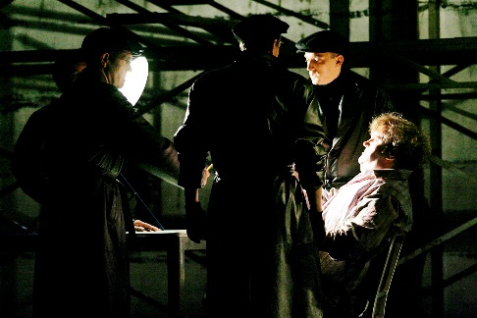 | bodice  The part of a dress (excluding sleeves) that is above the waist.  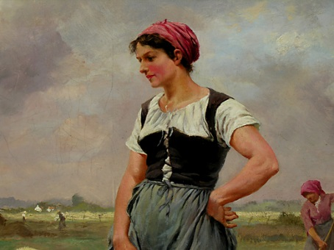
balabusta  Yiddish for mistress of the house or a good homemaker.  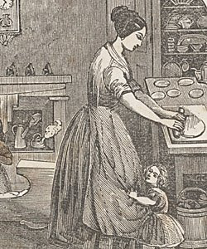 | bubaleh  Yiddish term of endearment, similar to calling someone “sweetie.”  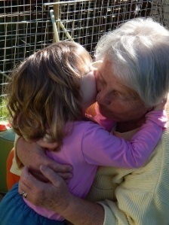
chutzpah  Yiddish word meaning bravery or self-confidence that borders on rudeness.   | sweatshop  A clothing workshop at the turn of the twentieth century in which workers work long hours in poor conditions for little pay.  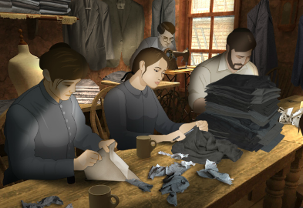
suffrage  The right to vote in political elections.  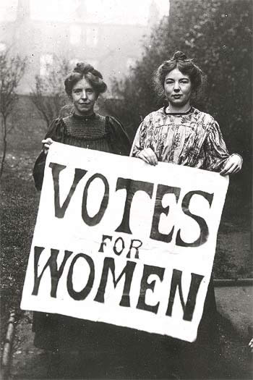 | yente  Yiddish word for a person who likes to gossip or interfere.  

inquisition | bodice
balabusta | bubaleh  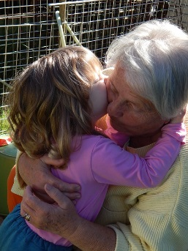
chutzpah | sweatshop  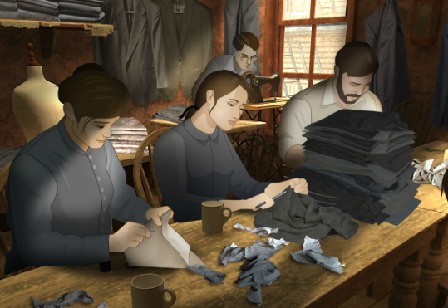
suffrage | yente

Harsh and intensive questioning or investigation. | The part of a dress (excluding sleeves) that is above the waist.
Yiddish for mistress of the house or a good homemaker. | Yiddish term of endearment, similar to calling someone “sweetie.”
Yiddish word meaning bravery or self-confidence that borders on rudeness. | A clothing workshop at the turn of the twentieth century in which workers work long hours in poor conditions for little pay
The right to vote in political elections. | Yiddish word for a person who likes to gossip or interfere.

Name: Date:

This activity imagines Lena is making a speech to New York City students and community residents in 1982, seventy years after the events in “City of Immigrants.” Lena is discussing what life was like on the Lower East Side in the early twentieth century.

Instructions: After reading and talking about the words and terms on the flash cards, read this excerpt from Lena’s speech. Use the cards and your memory to help fill in the missing words and terms. Some words may be used more than once.

balabusta  bodice | bubeleh  chutzpa | inquisition  sweatshop | suffrage  yente

“My first job was in the __________________ that was in our building. I spent many hours sewing clothes for low wages. Most of the people who worked there lived nearby. The lady who sat next to me was a real __________________. She was always talking about the other workers and the boss when he wasn’t there.

One day I had to take Isaac’s place and take the pushcart. Isaac had the pushcart stocked with housewares, so I would look for a nice __________________ who might need something for her kitchen. Some of the customers thought I was too young to be a peddler. They’d say, “__________________, what are you doing out here all alone?”

I often went to the Henry Street Settlement House to practice English and to learn other skills. There were many different things you could do there. You could be in a play. Or you could practice your sewing and learn how to make a __________________. Some of the people were even working to try to pass women’s __________________. I heard some people say that it took __________________ to fight for the right of women to vote.

When I had some free time, I would try to do something fun. I had to ask Isaac and Sonya first. They’d ask so many questions that I’d wonder if it was an __________________. But I know they just wanted to make sure I was safe.

