A NOTE TO THE EDUCATOR:

On the following pages, you will find “flashcards” with terms and definitions (both combined and separate) that your students may encounter while playing Part 5 of “City of Immigrants.” These terms and definitions can be introduced and practiced before or during the time students see or hear them in the context of MISSION US or in their American history study. The discussion questions and writing prompts will provide further opportunities for students to have more practice with the words and terms.

Divide your students into small groups of four or five, and ask each group to review the terms and definitions.

After your students have had a chance to review and discuss the terms and definitions, distribute the excerpt from the reporter’s interview with Lena. Review the directions with your students and ask them to complete the text using the terms they studied.

Here are the terms which should be inserted into each paragraph of Lena’s life story:
Paragraph 2- picketing, goys
Paragraph 3- socialites, muckrakers
Paragraph 4- toughs
Paragraph 5- scabs, vigilant, magistrate

Photography Credits
Socialites: New York Times

goy  Yiddish word meaning a person who is not Jewish.   | magistrate  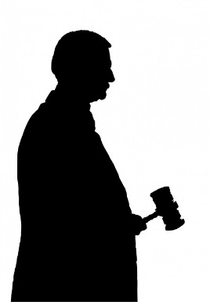  A judge who may conduct trials and impose penalties for minor criminal offenses.
muckrakers  American journalists at the turn of the century who searched for and exposed problems or other unpleasant facts in order to make them public.  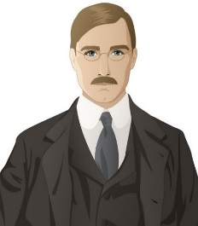 |   picketing  Standing outside a location (e.g., a factory) and attempting to persuade others not to enter the location for a specific reason, such as a strike.
scabs  A disparaging (negative) word for workers who refuse to strike or who help company management during a strike. Also referred to as “strike breakers.”  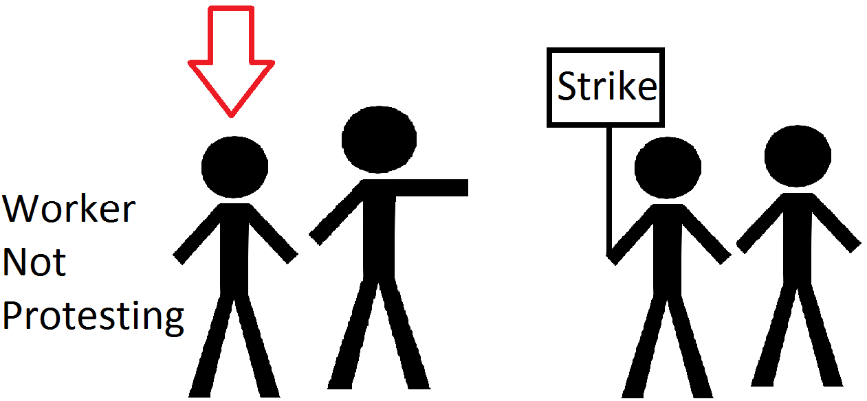 | socialites  Persons in upper-class society who are well-known for hosting or participating in social events such as parties and fundraisers.  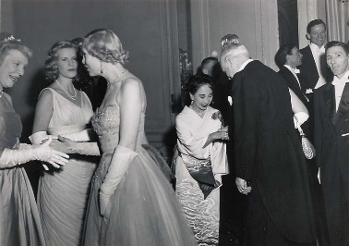
toughs  Groups of men hired by company management to assist scabs and physically intimidate or restrain picketers. Also referred to as “thugs” or “scab chaperones.”  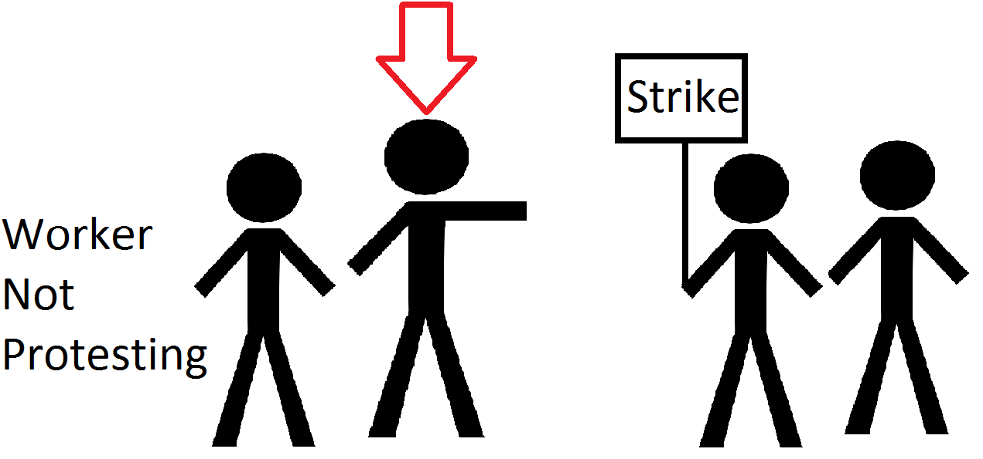 | vigilant  Keeping careful watch for possible danger or difficulties.  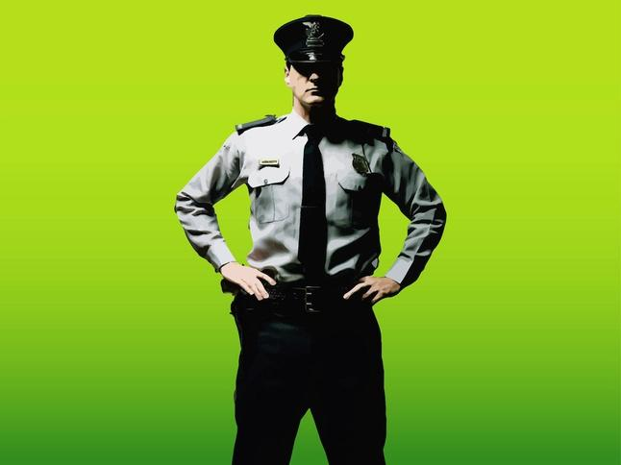

goy | magistrate  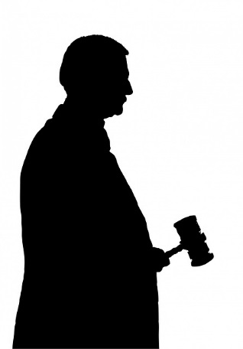
muckrakers  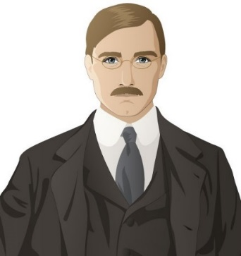 | picketing
scabs | socialites  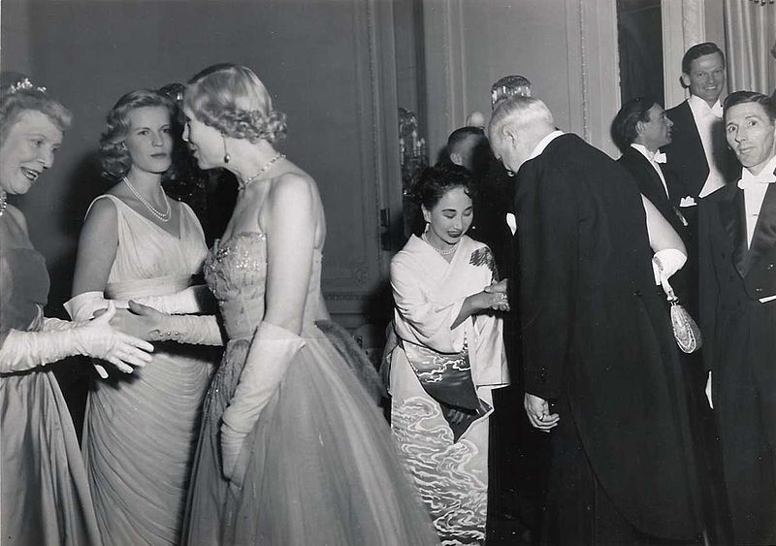
toughs | vigilant

Yiddish word meaning a person who is not Jewish. | A judge who may conduct trials and impose penalties for minor criminal offenses.
American journalists at the turn of the century who searched for and exposed problems or other unpleasant facts in order to make them public. | Standing outside a location (e.g., a factory) and attempting to persuade others not to enter the location for a specific reason, such as a strike.
A disparaging (negative) word for workers who refuse to strike or who help company management during a strike. Also referred to as “strike breakers.” | Persons in upper-class society who are well-known for hosting or participating in social events such as parties and fundraisers.
Groups of men hired by company management to assist scabs and physically intimidate or restrain picketers. Also referred to as “thugs” or “scab chaperones.” | Keeping careful watch for possible danger or difficulties.

Name: Date:

This activity imagines Lena is making a speech to New York City students and community residents in 1982, seventy years after the events in “City of Immigrants.” Lena is discussing what life was like on the Lower East Side in the early 20th century.

Instructions: After reading and talking about the words and terms on the flash cards, read this excerpt from Lena’s speech. Use the cards and your memory to help fill in the missing words and terms. Some words may be used more than once.

goys  magistrate | muckrakers  picketing | scabs  socialites | toughs  vigilant

“One day I woke up and learned that the ILGWU had voted to go on strike. At first I wasn’t sure what to do. My family needed me to work. At the same time, maybe the strike would make things better at the factory.

When I got to the factory, I saw that some people had signs and were __________________. The strike made all types of women join together. Both Jews and __________________ stood on the picket lines.

It wasn’t just workers, either. Some wealthy __________________ were there supporting the strike. A few __________________ were trying to find out information for the newspapers.

Not all the workers had joined the strike, however. I saw some people go into the factory to work. The factory had hired __________________ to make sure they got into the factory. You had to be careful.

I learned not to call the people still working __________________. If a policeman heard you do that you could get arrested. You could also get in trouble if you weren’t __________________ and if you accidently touched a worker. If you got arrested you’d be sent to jail and you’d have to appear in front of the __________________. It was difficult deciding the right things to do!”

