1. There was a long history of anti-Asian discrimination in the United States before
World War II.
For decades before World War II, Japanese Americans and other Asian Americans were subjected to harassment and racist laws and regulations in the U.S. For example, in 1882 Congress passed the Chinese Exclusion Act, which kept most Chinese people––who had been immigrating to the West Coast to work as miners, railroad laborers, and small business owners––from entering the United States. After 1882, U.S. companies sought Japanese workers to do back-breaking, poorly-paid work in fields and factories. Some Japanese immigrants also started their own businesses, operating laundries, cafes, or other shops. But even though Americans relied on their labor, many politicians, scholars, and members of the general public -- even labor unions whose members feared losing jobs to Japanese workers -- described Japanese immigrants as people from an “undesirable race” and attempted to limit Japanese American influence and restrict their rights. The Naturalization Act of 1790 already barred nonwhite immigrants from becoming citizens. The California Alien Land Law of 1913, and similar laws in other states, for instance, prohibited “aliens ineligible for citizenship” from buying or owning land.

2. Japanese immigrants and other Japanese Americans established strong
communities all along the West Coast.
Even though they faced discrimination, Japanese Americans developed strong communities throughout the western United States. Issei (Japanese immigrants) formed cultural and financial hubs known as “Little Tokyos” or Nihonmachi (Japantowns) in Seattle, San Francisco, and Los Angeles. Outside of cities, they also created churches, business clubs, and social centers dedicated to fostering cultural pride and traditions they could pass on to the next generation. Political organizations further advanced Japanese American interests throughout the country. For example, the Japanese American Citizen League, founded in 1929, focused on protecting the rights of Japanese American people. And with the help of Japanese American newspapers like Rafu Shimpo, both Issei and their American-born children (Nisei) could retain and advance their interests beyond the limits of their immediate community.

3. Antagonism between Japan and the United States grew prior to World War II.
The Empire of Japan had become an extremely powerful nation-state that held significant political and military influence in Asia and the Pacific. Beginning in 1868 with the Meiji Restoration, Japan’s emperors promoted rapid expansion of manufacturing and the military. These campaigns quickly threatened the political independence of nearby countries, and sparked conflicts throughout the region. In the 1930s, the Empire of Japan expanded even further when it invaded mainland China and its military occupied strategic islands in the Pacific. Soon it threatened areas where the U.S., British, and French had a significant imperial presence. In 1940, Japan signed The Tripartite Pact with Germany and Italy, siding with two countries at war with allies of the United States. These actions further increased Americans’ antagonism toward Japan. The U.S. declared war on Japan after the attack on the U.S. naval base at Pearl Harbor, Hawai’i in 1941.

4. U.S. wartime actions treated Japanese Americans differently from German and
Italian Americans.
World War II was fought between two large groups of nations: the Allied powers (United States, Great Britain, and the Soviet Union) and the Axis powers (Germany, Italy, and Japan). Because many immigrants and foreign nationals from all three of the Axis nations lived in the U.S., some Americans questioned the loyalty of German Americans, Italian Americans, and Japanese Americans. In response, the U.S. government established incarceration camps, and the military detained and imprisoned a small fraction of German and Italian Americans: less than .1% of the total population of these communities. But Japanese Americans living on the West Coast were singled out for more extreme treatment. Thousands were forced to leave their homes and sent to prison camps for the duration of the war after President Roosevelt signed Executive Order 9066. The Order did not specify a particular race or ethnicity. But wartime propaganda portrayed Japanese people as subhuman and monstrous (such as the navy poster below that depicts the Empire of Japan as a rat), leading the general public to support the American government’s policy to treat Japanese Americans differently from their German and Italian American counterparts.

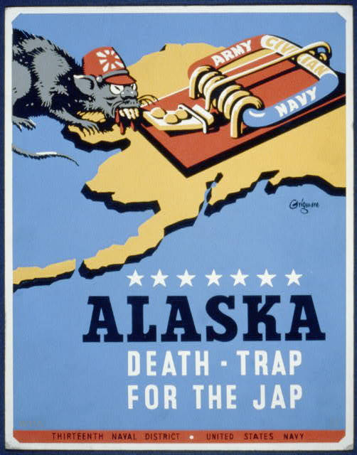
Source: Edward Thomas Grigware, “Alaska - Death-Trap for the Jap,” poster, 1941. Library of Congress Prints and Photographs Division, https://www.loc.gov/pictures/item/98510121/.

5. There were several types of incarceration camps created to detain Japanese
Americans.
Because of Executive Order 9066, approximately 120,000 Japanese Americans were incarcerated in camps during World War II. Most of these facilities were hastily built and often conditions were harsh. Race tracks and fairgrounds were at times used as temporary assembly centers, where thousands of Japanese Americans lived in hastily-constructed barracks -- some even in horse stalls -- for months while the Army built more permanent prison camps euphemistically called “relocation centers” away from the coast. In order to accommodate so many people, the War Relocation Authority created ten prison camps in California, Arizona, Idaho, Utah, Wyoming, Colorado, and as far east as Arkansas. In addition to these larger encampments, the Department of Justice and the U.S. Army created detention centers for thousands of Japanese Americans they considered especially dangerous. Although the government did not call these prisons, they really were: people were held against their will in facilities that were surrounded by barbed wire and their movements were monitored by guards. They could not leave the camps for jobs or other reasons without permission. And although people were not forced into cells, the conditions in living barracks were rough, with many people in crowded quarters that were poorly heated and impossible to keep clean or comfortable.

