Dorothea Lange Photo: Elementary School

Dorothea Lange had photographed the plight of migrant families for the Farm Security Administration during the Great Depression in the 1930s. She was hired again in the early 1940s by the War Relocation Authority to document the forced removal of Japanese Americans from the West Coast. Many of Lange’s photographs exposed the difficulties and harsh conditions in the camps, and were censored by the government during the war. The following image shows an incarceree teaching children in a makeshift outdoor classroom.

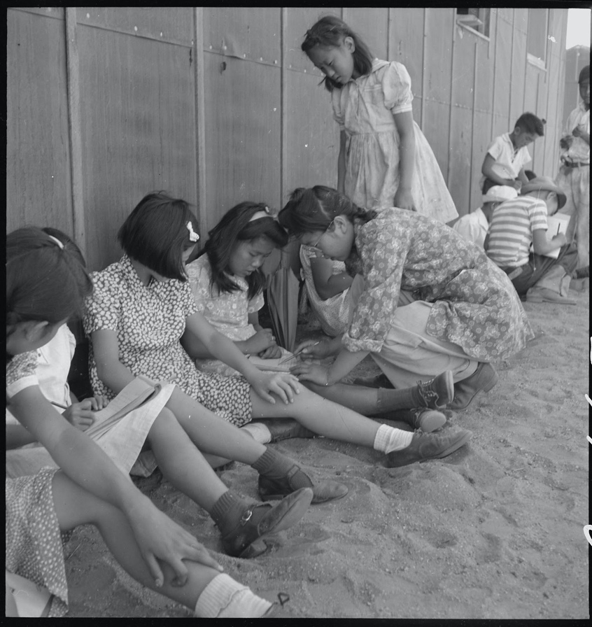

Caption: Manzanar Relocation Center, Manzanar, California. An elementary school with voluntary attendance has been established with volunteer evacuee teachers, most of whom are college graduates. No school equipment is as yet obtainable and available tables and benches are used. However, classes are often held in the shade of the barrack building at this War Relocation Authority center. 1942.

Source: National Archives: Record Group 210: Records of the War Relocation Authority, 1941 - 1989 Series: Central Photographic File of the War Relocation Authority, 1942 - 1945 https://catalog.archives.gov/id/5379

