The WRA Application for Leave Clearance

The following form was developed by the War Relocation Authority (WRA) and given to incarcerated Japanese Americans. The WRA created the questionnaire to serve a similar purpose as the U.S. army’s questionnaire for draft-age Nisei and many of the questions are identical, including the controversial question 28. However, the WRA’s intention was to determine whether incarcerees could be trusted to leave the camps. As with the army’s questionnaire, there was widespread fear and confusion as to the form’s purpose and how it would be used.

Full Form

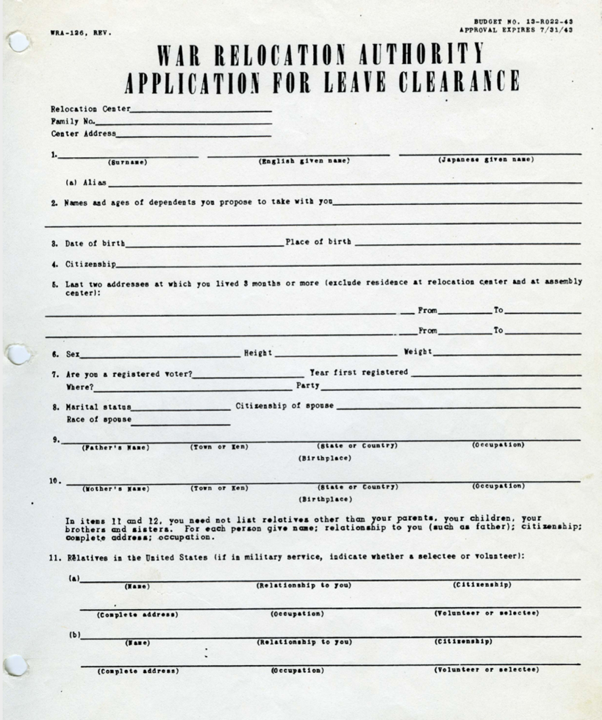

Source: WRA, “Application for Leave Clearance,” 1943, Courtesy of K. Morgan Yamanaka, Densho Digital Repository, ddr-densho-188-5. https://ddr.densho.org/ddr-densho-188-5/

