Presidential Apology Letter

The passage of the Civil Liberties Act in 1988 granted financial compensation and a formal apology by the President of the United States to all Japanese Americans who were incarcerated during World War II. However, two years passed before the funds were distributed as the following apology letter by President George HW Bush (dated October 1990) shows. When completed, 82,219 people received an apology and compensation for the “serious injustices” done to them or their heirs during the war.

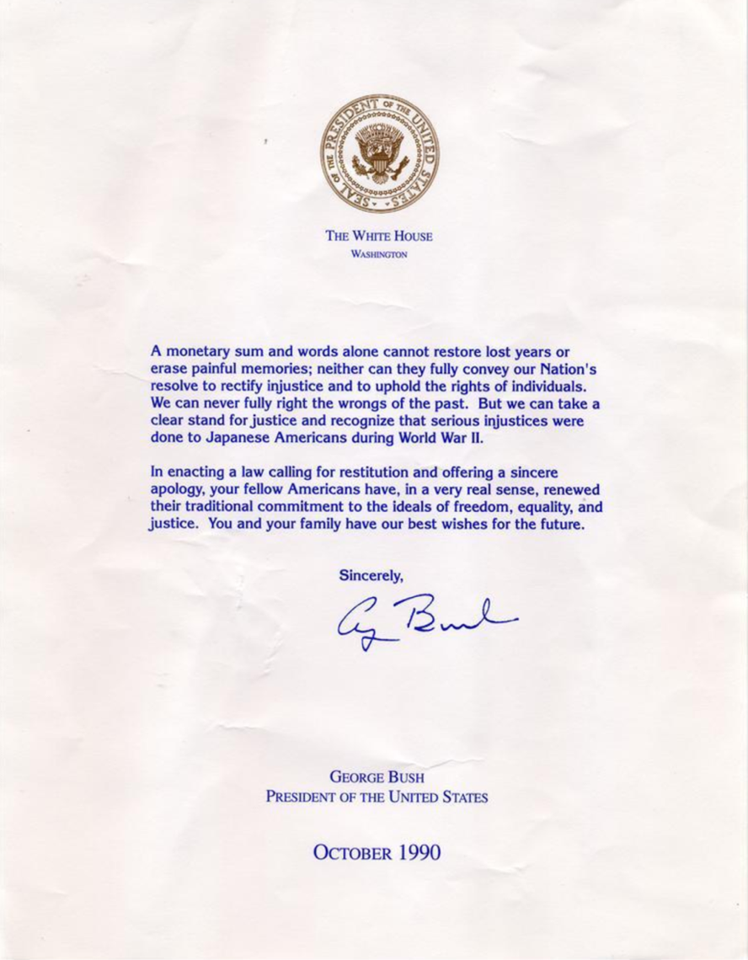

Source: George Bush, Presidential Apology Letter, 1990. Densho Digital Repository, ddr-densho-153-20. Courtesy of Majorie Matsushita. http://ddr.densho.org/ddr-densho-153-20/

