Looking for Work after the Camps

After incarceration ended, some Japanese Americans were unable to return to their pre-war lives: they had lost their homes, their jobs, their savings, and their property while imprisoned. Facing difficult employment opportunities and prejudice, one-third of former incarcerees were forced to move to a different state. In response, the War Relocation Authority (WRA) created a resettlement program for those Japanese Americans. In the following photograph from 1945, three former incarcerees of the Heart Mountain camp in Wyoming look over a bulletin board of possible job opportunities at the WRA headquarters in Philadelphia, Pennsylvania.

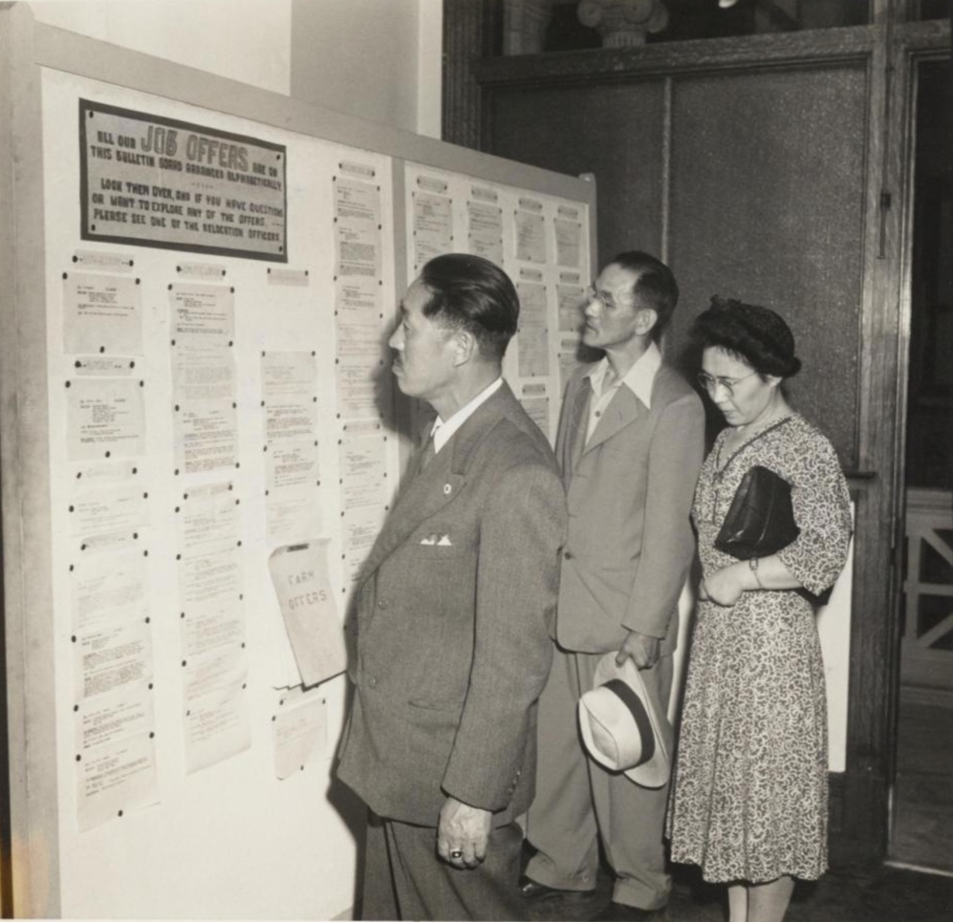

Source: Gretchen Van Tassel, “Mr. and Mrs. Tomatsu Gorai and Mr. Ushimatsu Kubota looking over the job bulletin board in the Philadelphia WRA office,” photograph, July, 1945. WRA no. G-932, War Relocation Authority Photographs of Japanese-American Evacuation and Resettlement, Bancroft Library, UC Berkeley. https://oac.cdlib.org/ark:/13030/ft4779n99z/?order=3&brand=oac4

