Instructions to all Persons of Japanese Ancestry

These instructions for the removal of Japanese Americans living in Seattle, Washington were posted throughout Japanese American neighborhoods. In addition to these instructions, military troops posted flyers informing Japanese Americans of their imminent removal. These orders followed Executive Order 9066, which gave the Western Defense Command of the Department of War the authority to exclude anybody from what it deemed strategic areas.

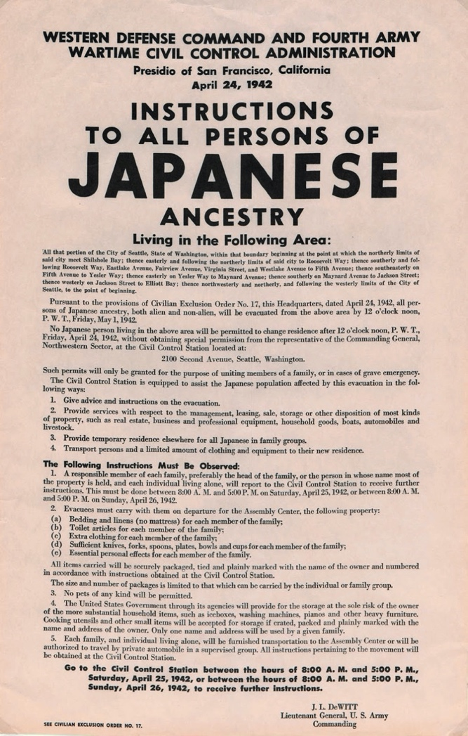
Source: Western Defense Command and Fourth Army Wartime Civil Control Administration, “Instructions to all persons of Japanese ancestry,” Washington State University, Digital Exhibits, accessed April 17, 2020, http://digitalexhibits.wsulibs.wsu.edu/items/show/4407.

WESTERN DEFENSE COMMAND AND FOURTH ARMY
WARTIME CIVIL CONTROL ADMINISTRATION

Presidio of San Francisco, California
April 24, 1942

INSTRUCTIONS
TO ALL PERSONS OF
JAPANESE
ANCESTRY

Living in the Following Area:

All that portion of the City of Seattle, State of Washington, within that boundary beginning at the point at which the northerly limits of said city meet Shilshole Bay; easterly and following the northerly limits of said city to Roosevelt Way; thence southerly and following Roosevelt Way, Eastlake Avenue, Fairview Avenue, Virginia Street, and Westlake Avenue to Fifth Avenue; thence southeasterly on Fifth Avenue to Yesler Way; thence easterly on Yesler Way to Maynard Avenue; thence southerly on Maynard Avenue to Jackson Street; thence westerly on Jackson Street to Elliot Bay; thence northwesterly and northerly, and following the westerly limits of the City of Seattle, to the point of beginning.

Pursuant to the provisions of Civilian Exclusion Order No. 17, this Headquarters, dated April 24, 1942, all persons of Japanese ancestry, both alien and non-alien, will be evacuated from the above area by 12 o'clock noon, P.W.T., Friday, May 1, 1942.

No Japanese person living in the above area will be permitted to change residence after 12 o'clock noon, P.W.T., Friday, April 24, 1942, without obtaining special permission from the representative of the Commanding General, Northwestern Sector, at the Civil Control Station located at:

2100 Second Avenue, Seattle, Washington.

Such permits will only be granted for the purpose of uniting members of a family, or in cases of grave emergency.

The Civil Control Station is equipped to assist the Japanese population affected by this evacuation in the following ways:
1. Give advice and instructions on the evacuation.
2. Provide services with respect to the management, leasing, sale, storage or other disposition of most kinds of property, such as real estate, business and professional equipment, household goods, boats, automobiles and livestock.
3. Provide temporary residence elsewhere for all Japanese in family groups.
4. Transport persons and a limited amount of clothing and equipment to their new residence.

The Following Instructions Must be Observed:

1. A responsible member of each family, preferably the head of the family, or the person in whose name most of the property is held, and each individual living alone, will report to the Civil Control Station to receive further instructions. This must be done between 8:00 A. M. and 5:00 P. M. on Saturday, April 25, 1942, or between 8:00 A. M. and 5:00 P. M. on Sunday, April 26, 1942.

2. Evacuees must carry with them on departure for the Assembly Center, the following property:
(a) Bedding and linens (no mattress) for each member of the family;
(b) Toilet articles for each member of the family;
(c) Extra clothing for each member of the family;
(d) Sufficient knives, forks, spoons, plates, bowls and cups for each member of
the family;
(e) Essential personal effects for each member of the family.

All items carried will be securely packaged, tied and plainly marked with the name of the owner and numbered in accordance with instructions obtained at the Civil Control Station. The size and number of packages is limited to that which can be carried by the individual or family group.

3. No pets of any kind will be permitted.

4. The United States Government through its agencies will provide for the storage at the sole risk of the owner of the more substantial household items, such as iceboxes, washing machines, pianos and other heavy furniture. Cooking utensils and other small items will be accepted for storage if crated, packed and plainly marked with the name and address of the owner. Only one name and address will be used by a given family.

5. Each family, and individual living alone, will be furnished transportation to the Assembly Center or will be authorized to travel by private automobile in a supervised group. All instructions pertaining to the movement will be obtained at the Civil Control Station.

Go to the Civil Control Station between the hours of 8:00 A. M. and 5:00 P. M.,
Saturday, April 25, 1942, or between the hours of 8:00 A. M. and 5:00 P. M.,
Sunday, April 26, 1942, to receive further instructions.

J. L. DEWITT
Lieutenant General, U. S. Army
Commanding

SEE CIVILIAN EXCLUSION ORDER NO. 17.

