I Am An American

Dorothea Lange had photographed the plight of migrant families for the Farm Security Administration during the Great Depression in the 1930s. She was hired again in the early 1940s by the War Relocation Authority to document the forced removal of Japanese Americans from the West Coast. This photo was taken in March 1942 and shows the Wanto Co. store in Oakland, California. The business was owned by the Matsuda family. Tatsuro Matsuda, a University of California graduate, commissioned and installed the "I am an American" sign.

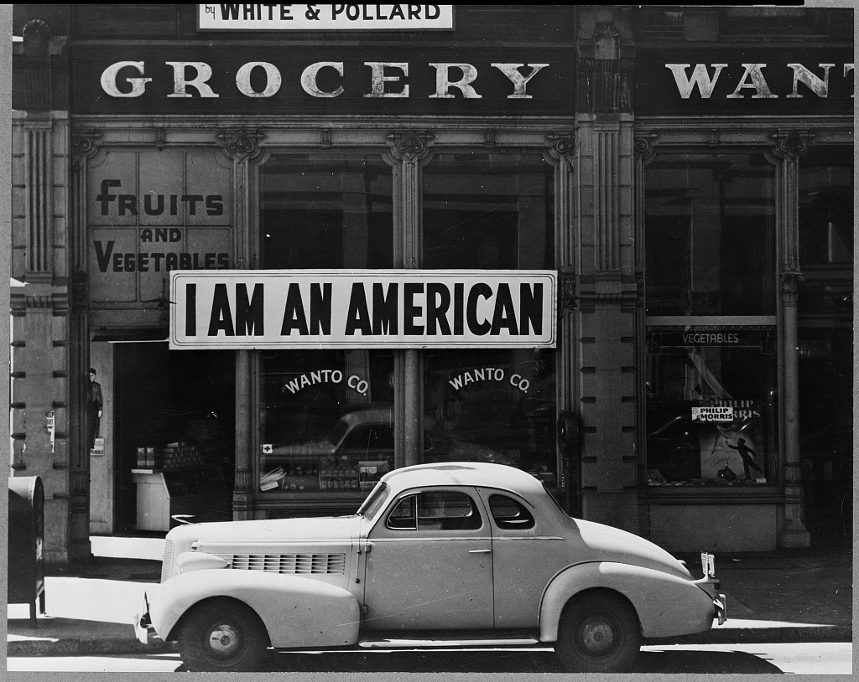

Photographer’s caption: Oakland, Calif., Mar. 1942. A large sign reading "I am an American" placed in the window of a store, at [401 - 403 Eighth] and Franklin streets, on December 8, the day after Pearl Harbor. The store was closed following orders to persons of Japanese descent to evacuate from certain West Coast areas. The owner, a University of California graduate, will be housed with hundreds of evacuees in War Relocation Authority centers for the duration of the war
Source: Library of Congress Prints and Photographs Division, https://www.loc.gov/item/2004665381/

