Photo of the Forced Removal From Bainbridge Island

On March 30, 1942, military troops arrived on Bainbridge Island to force the removal of all Japanese American residents. Mr. and Mrs. Moji (inside truck) and their dog, King were among those removed. Japanese Americans were not allowed to take family pets with them to prison camp, if they were lucky, they could leave the animals with friends or neighbors.

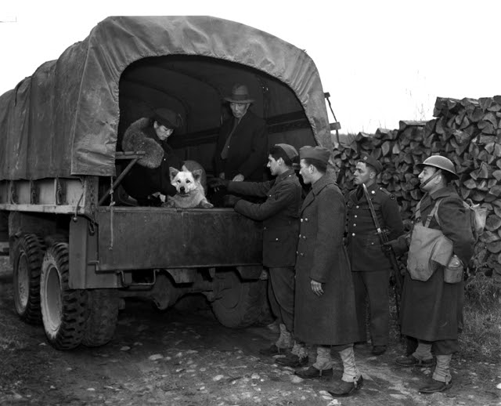

Source: Densho Digital Repository, ddr-densho-36-24 (Legacy UID: denshopd-i36-00024) Courtesy of the Seattle Post-Intelligencer Collection (number PI-28046), Museum of History &

