Dorothea Lange Photo - Hospital Latrines

Dorothea Lange had photographed the plight of migrant families for the Farm Security Administration during the Great Depression in the 1930s. She was hired again in the early 1940s by the War Relocation Authority to document the forced removal of Japanese Americans from the West Coast. Many of Lange’s photographs exposed the difficulties and harsh conditions in the camps, and were censored by the government during the war. The following image––taken in the first months at Manzanar––depicts temporary hospital beds and outdoor latrines (toilets) for patients.

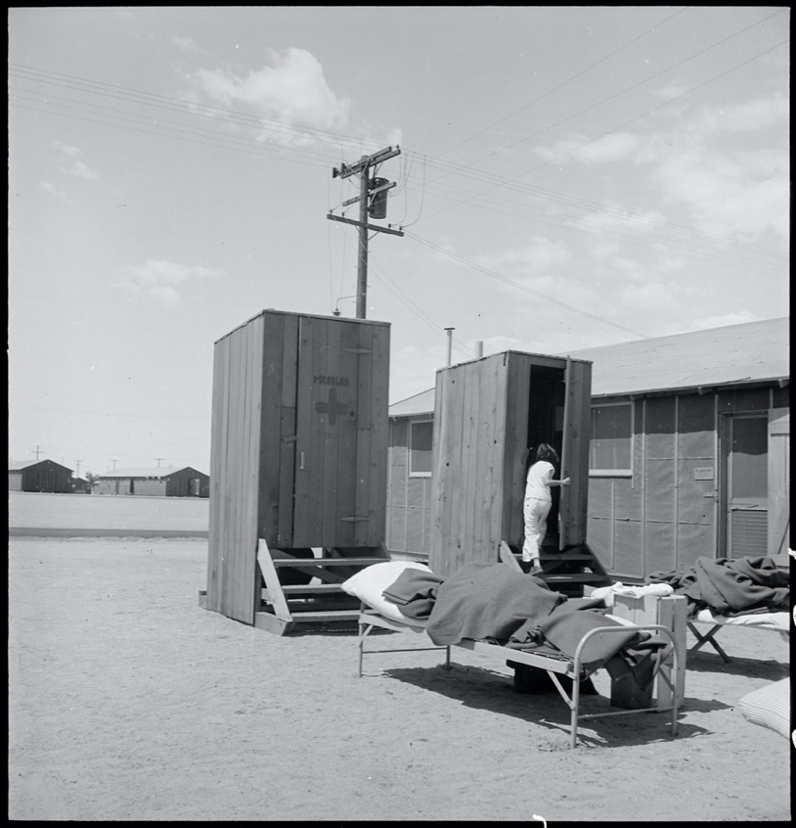

Caption: Manzanar Relocation Center, Manzanar, California. Hospital latrines, for patients, between the barracks, which serve temporarily as wards. For the first three months of occupancy medical facilities have been meager but the new hospital fully equipped, is almost ready for occupancy. 7/1942

Source: National Archives: Record Group 210: Records of the War Relocation Authority, 1941 - 1989 Series: Central Photographic File of the War Relocation Authority, 1942 - 1945 https://catalog.archives.gov/id/538149

