Stanley Hayami Essay: My Viewpoint of the Evacuation

Stanley Kunio Hayami was sixteen in 1942 when his family was forcibly removed from Los Angeles, California and incarcerated at Heart Mountain Wyoming. Throughout his imprisonment at Heart Mountain, Hayami kept a diary filled with pen-and-ink drawings and he reported regularly on his daily activities such as studying for tests, listening to football games on the radio, or going to the movies. He also voiced his views on the incarceration and the military draft, and spoke of the importance of serving his country. As a high school student, he longed to pursue a career as an artist and writer. Stanley Hayami’s experiences and thoughts served as an inspiration for the Henry Tanaka character in A Prisoner in My Homeland.
First page:
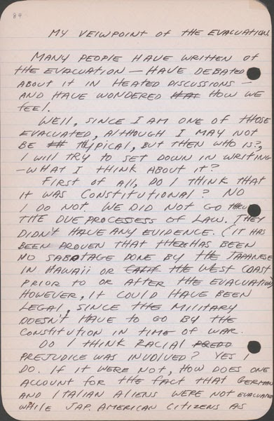
http://www.oac.cdlib.org/ark:/13030/tf6k40056s/?brand=oac4

Second page: http://www.oac.cdlib.org/ark:/13030/tf3489n632/?brand=oac4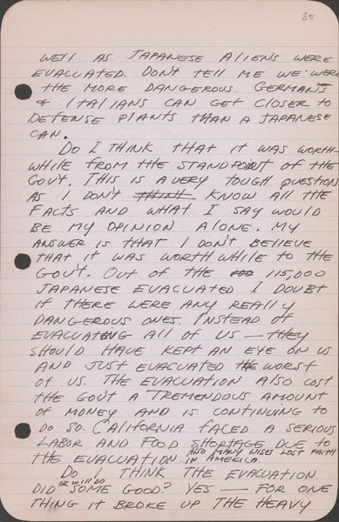

Third page:
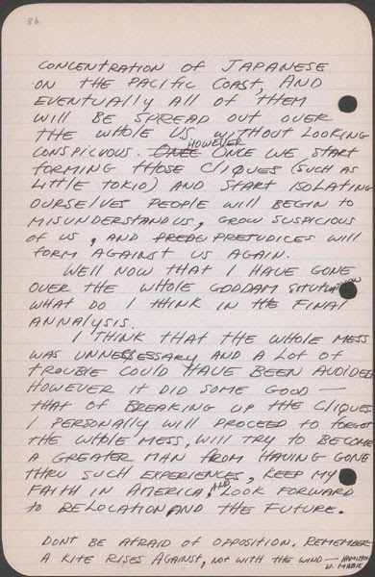
http://www.oac.cdlib.org/ark:/13030/tf2r29n604/?brand=oac4

