“Snow in January 1944” A Kango Takamura Painting

Kango Takamura was an Issei artist who had been a photo retoucher for RKO Studios in Hollywood before being incarcerated at the Manzanar prison camp. He documented his experiences at Manzanar in a series of watercolor paintings and drawings.

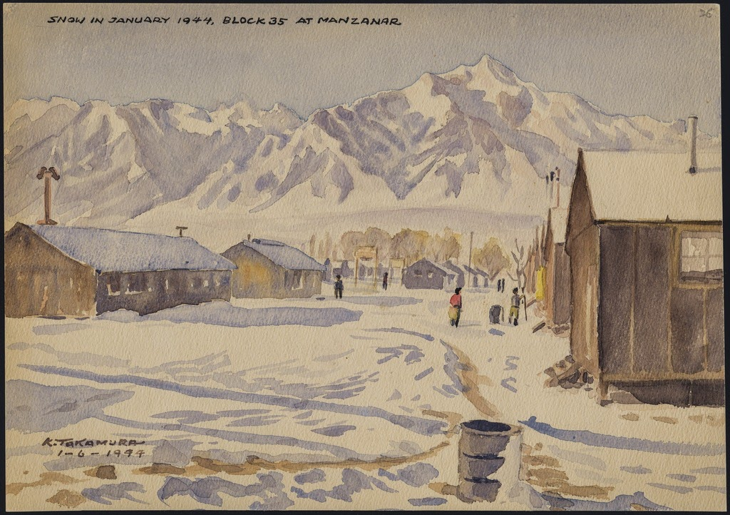

Caption: "Snow in January 1944, block 35 at Manzanar."
Courtesy of Manzanar National Historic Site and the Kango Takamura Collection http://ddr.densho.org/ddr-manz-2-65/
Copyright restricted

