Informed by a generation of new research and writing, Prisoner in My Homeland offers young people a nuanced and illuminating understanding of the choices and challenges faced by Japanese Americans in the WWII era. The game is played from the perspective of Henry Tanaka, a fictional 16-year-old Japanese American boy whose family is forced to leave its home on Bainbridge Island, WA, for a military prison camp in Manzanar, CA. Players must make choices that reflect broader strategies of survival and resistance: will they help their community, focus on family, support the war effort, resist injustice? The game seeks to help correct the image of the incarcerees as passive victims by highlighting instances of resistance, and to place the events within the larger context of Asian immigration to the West Coast and Asian communities’ longer-term struggle to be accepted as American.

“Prisoner in My Homeland” is divided into five parts:
● an interactive prologue that establishes the Tanaka family backstory and historical context of Japanese American immigration and settlement;
● three playable “Parts,” consisting of dialogues, minigames, and other interactions with a variety of historically-based characters, covering 1941 to 1945; and
● an epilogue that reveals the fates of the main characters and summarizes the legacy of Japanese American incarceration for both individuals and the nation.

The prologue establishes the main character’s (Henry Tanaka’s) parents’ journey to America and their life in a small farming community of Bainbridge Island in Washington State before and after the attack on Pearl Harbor. In the wake of the United States’ declaration of war on Japan, President Roosevelt issues Executive Order 9066, and the U.S. military designates Bainbridge Island as the first community to have all inhabitants with Japanese ancestry “excluded." Henry’s father is questioned by the FBI and then arrested. Henry, his mother, and his little sister must leave their farm and dog behind and be escorted by soldiers with bayonets onto a ferry.

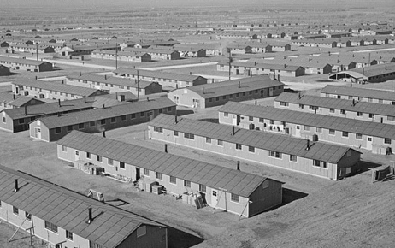
In Part 1, Henry travels to the prison camp at Manzanar, a remote desert wilderness. As he orients himself to his new circumstances, he is required to interact with, and adjust to the presence of, a variety of different Japanese Americans who have been sent to live in close and uncomfortable quarters. In his father’s absence, Henry must help his family adapt in creative ways, such as by finding tin can lids to block holes in the floorboards. Henry can also help his family through taking a job in the camp, which will give him options to improve their barrack furnishings or assist in saving their farm by helping to pay taxes.

In Part 2, school is finally in session, and Henry encounters different ways that young people cope with and resist their displacement, discomfort, and boredom. Henry has the opportunity to deepen relationships with his peers Meiko and Tadashi, and with historical figure Harry Ueno, who is organizing an investigation of missing sugar rations from the mess halls. After his father’s sudden return from detention by the FBI, Henry can help him transition by encouraging him to take up judo again. Tensions sharpen when members of the Japanese American Citizens League (JACL) seek to demonstrate their patriotism by advocating for Nisei to be drafted into the U.S. armed forces, or at least be permitted to serve.
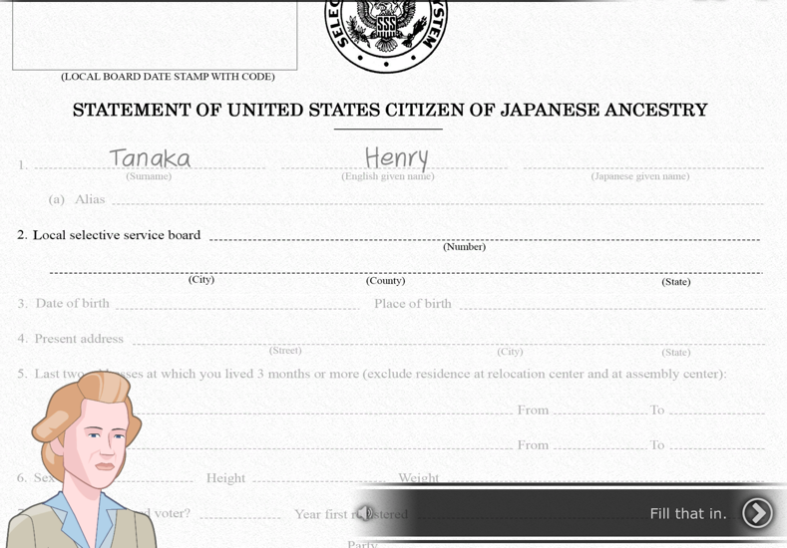
At the start of Part 3, a JACL leader is beaten up by a masked group and Harry Ueno is arrested and jailed for the crime. A large protest of his arrest by incarcerees leads to a military response in which ten people are shot and two killed. A couple of months later, at the age of 17, Henry learns that all incarcerees must complete a “loyalty questionnaire,” and he will have to defend his answers before an army draft board. He grapples with different perspectives on how to answer two questions in particular: one about his willingness to serve in the U.S. armed forces “wherever ordered” and the other swearing unqualified allegiance to the United States and renouncing “allegiance or obedience to the Japanese emperor.”

The player’s choices open up or foreclose different potential paths to be explored in the game’s epilogue. Depending on his response to the questionnaire, Henry transfers with other Bainbridge Islanders to Minidoka or, if he is deemed “disloyal,” is sent to Tule Lake. Subsequent possible paths include enlisting in the U.S. army, attending college in the East, or returning to Bainbridge Island to help his parents resettle. The epilogue also narrates the family’s experiences after incarceration and the history of the decades that followed, including the redress movement and eventual passing of the Civil Liberties Act of 1988.

