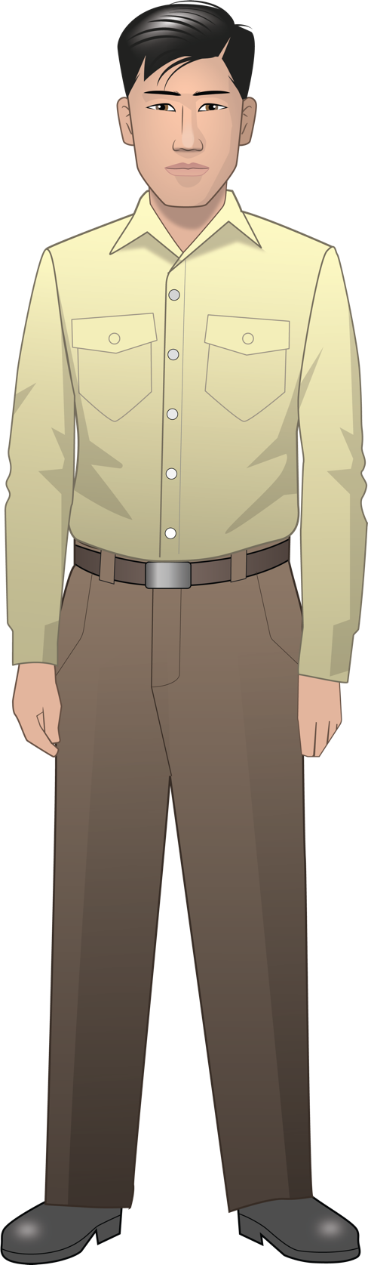
Henry Tanaka
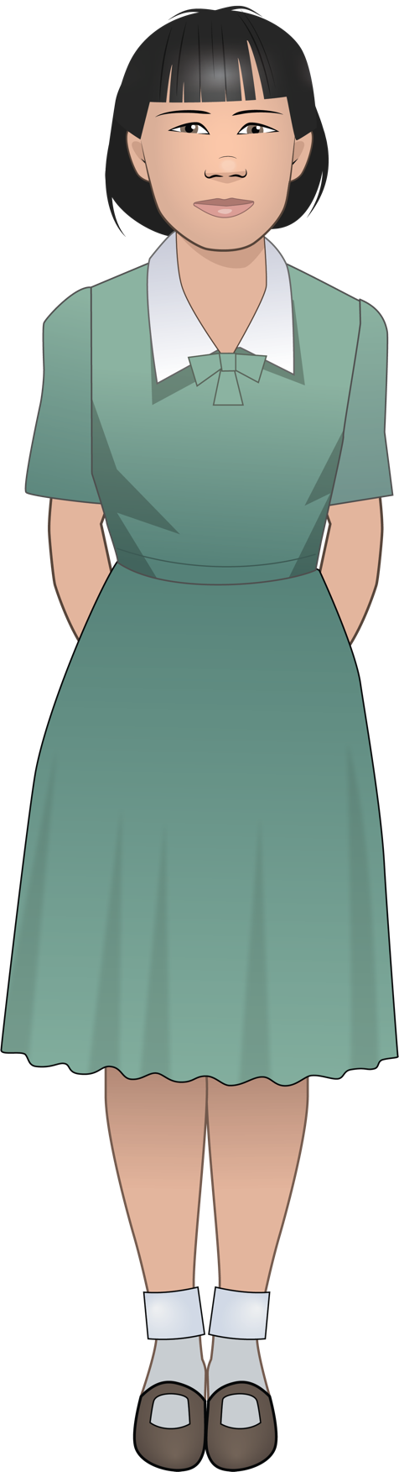
Lily Tanaka
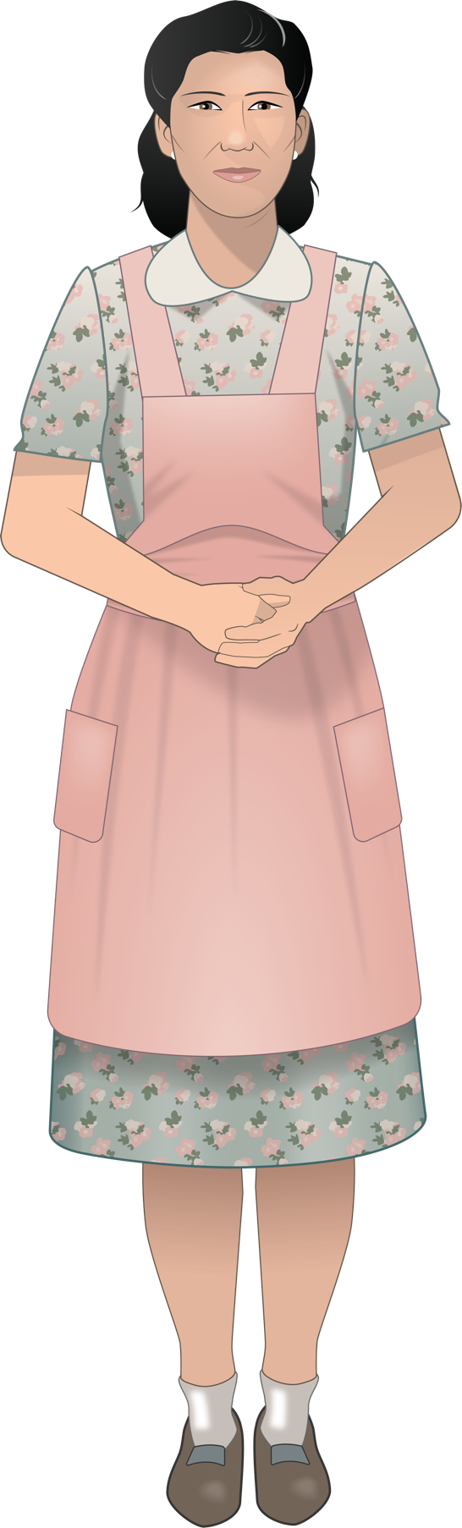
Kiyoko Tanaka

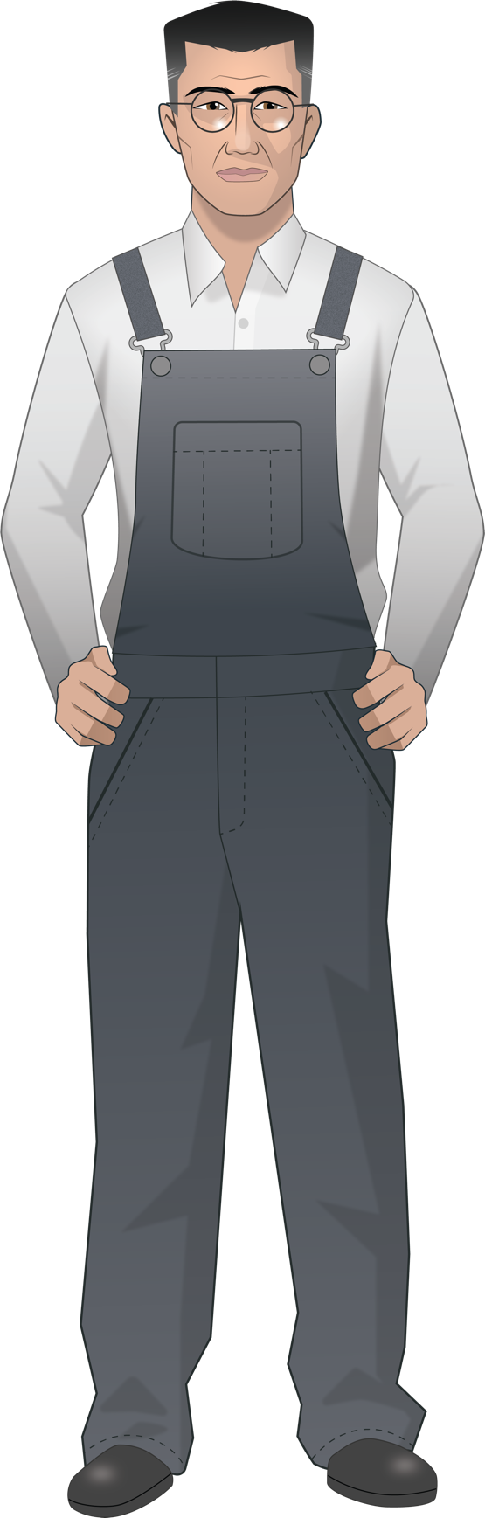
Kinzo Tanaka
Mr. Yamamoto
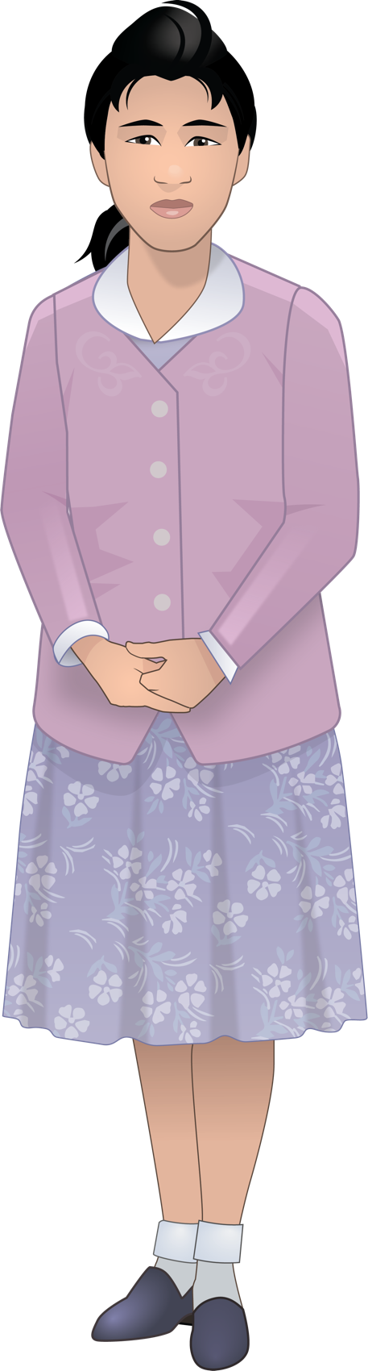
Meiko Yamamoto
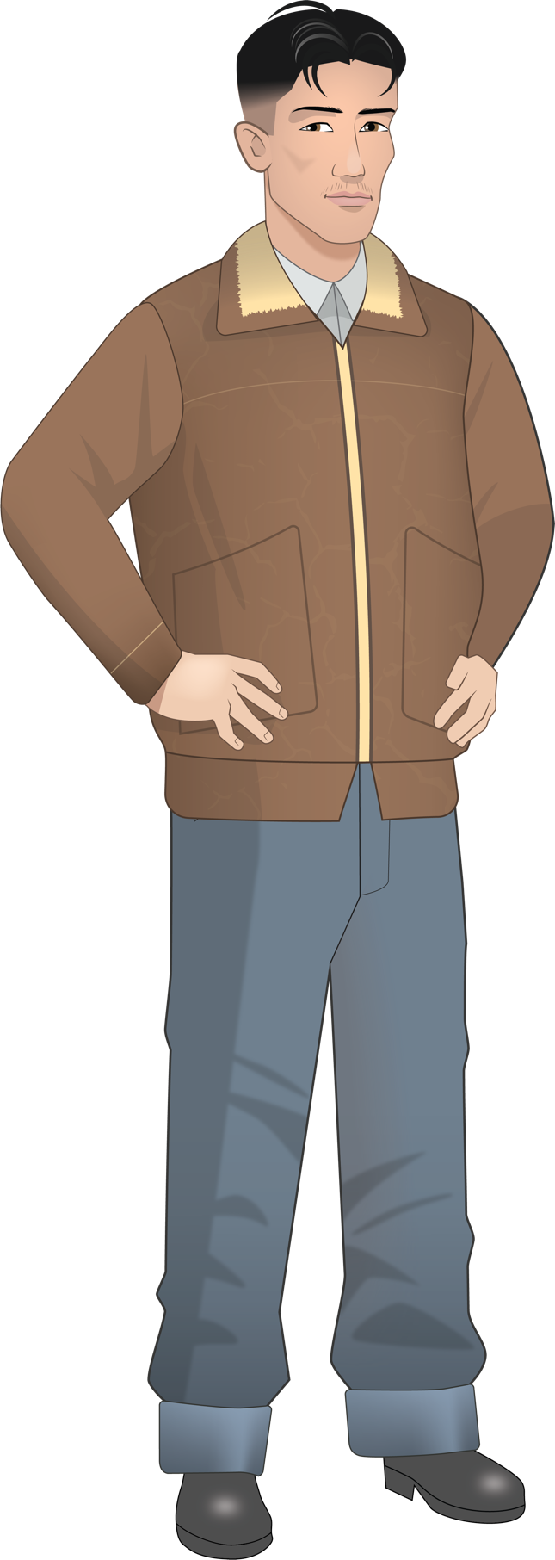
Tadashi
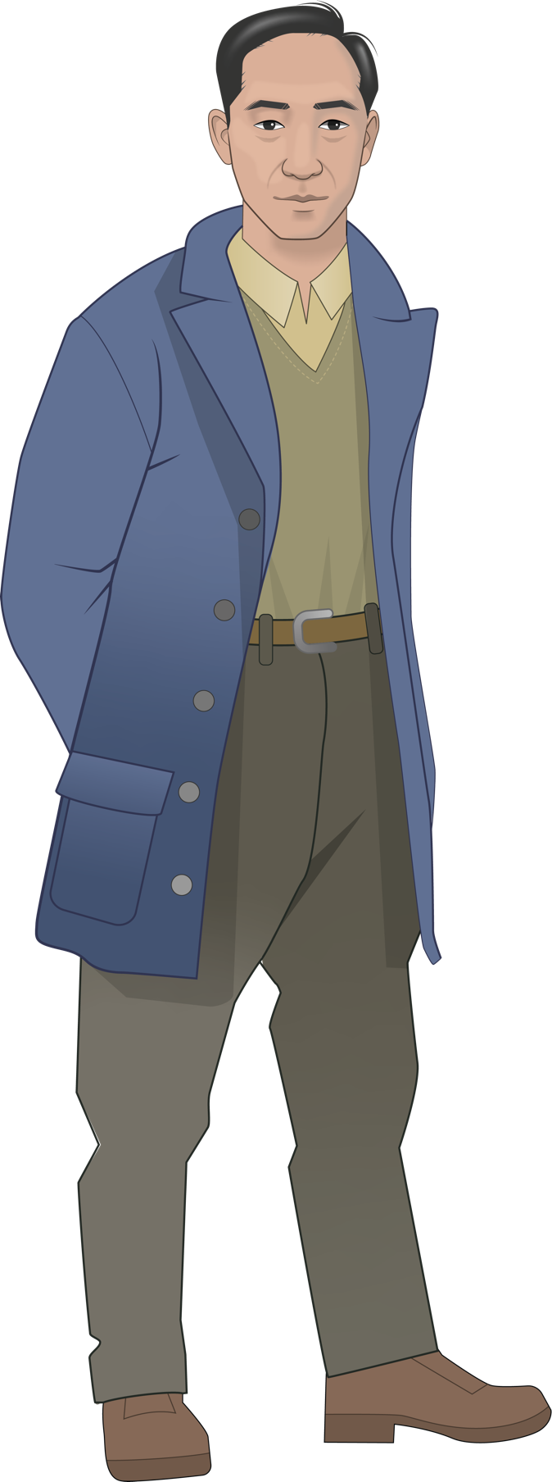
Harry Ueno

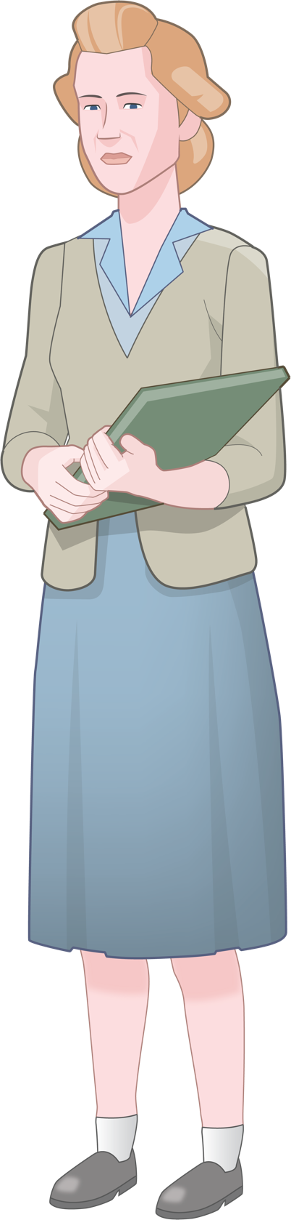
Miss Nelson

