A NOTE TO THE EDUCATOR:
This activity is best used after students have played the Prologue section of the game. The Prologue and the primary sources in this activity illustrate the different points of view on the forced removal of Japanese Americans: the perspective of the U.S. government, a Japanese American community organization, and a Japanese American teenager. You will be assigned one or several of these sources to review. As you review each source, use the provided discussion questions to analyze it. Remember to look closely at the source and think deeply about what it tells you about the divergent views of historical actors.

PRIMARY SOURCE #1: Executive Order 9066

- Prior to having students analyze the primary source documents, instruct students to answer the following question in pairs or small groups based on the Prologue of “Prisoner in My Homeland.” Then conduct a short discussion.
Questions:
- What does it mean to be targeted as the enemy or someone to be feared?
- Remind students that during World War II the U.S. fought against Germany, Italy, and Japan. Why do you think Americans of Japanese descent were targeted in this way?

- Executive Order 9066 Analysis

Project Executive Order 9066 to students and tell them that this is a shortened version of the 3-page document written and ordered by President Franklin D. Roosevelt during World War II. They will analyze key quotes from this document through a “Dialectical Journal” activity.

Pair students up and instruct them to complete the following “Dialectical Journal” handout. A Dialectical Journal is a dual-entry journal that allows students to record their reactions to specific passages and quotes. Review vocabulary words such as those listed below to facilitate student comprehension. Guide students to break up longer quotes into sections to help them understand the passage.

Vocabulary to Review:
- prosecution - the continuation of a course of action with a view to its completion
- espionage - the practice of spying or of using spies, typically by governments to obtain political and military information
- sabotage - the act of damaging something especially for political or military advantage
- designate - to assign or appoint
- prescribe - state as a rule that should be carried out

Dialectical Journal

Directions: Read each quote in the “Direct Quote” column. Then write a response to the quote by completing the sentence prompt in the “Student Response” column.

Direct Quote | Student Response
- ...the successful prosecution of the war requires every possible protection against espionage and against sabotage to national-defense material, national-defense premises, and national-defense utilities | Reading this made me realize...
- Now, therefore, by virtue of the authority vested in me as President of the United States, and Commander in Chief of the Army and Navy, I hereby authorize and direct the Secretary of War, and the Military Commanders whom he may from time to time designate, whenever he or any designated Commander deems such action necessary or desirable, to prescribe military areas in such places and of such extent as he or the appropriate Military Commander may determine, from which any or all persons may be excluded, and with respect to which, the right of any person to enter, remain in, or leave shall be subject to whatever restrictions the Secretary of War or the appropriate Military Commander may impose in his discretion. | This section explains...
- I hereby further authorize and direct the Secretary of War and the said Military Commanders to take such other steps as he or the appropriate Military Commander may deem advisable to enforce compliance with the restrictions applicable to each Military area hereinabove authorized to be designated, including the use of Federal troops and other Federal Agencies | This detail helps me to understand…

- Executive Order 9066 Class Discussion

After students complete the Dialectical Journal, have each group of students share their responses. Then discuss the following questions:

- Why did the President of the U.S. want to create military areas where certain people would be excluded?
- Did the President state what persons of a particular ethnic background to exclude in these military areas? Who did he give the authority to make this type of decision? Why do you think that only Americans of Japanese descent were imprisoned in mass numbers when the U.S. was also fighting against Germany and Italy during World War II?

PRIMARY SOURCE #2: Civilian Exclusion Orders

https://encyclopedia.densho.org/media/encyc-psms/en-denshopd-p25-00049-1.pdf (linked in the instructions below)

Tell students that after Executive Order 9066 was implemented, the U.S. Military Western Defense Command, under the leadership of General John L. DeWitt, carried out President Roosevelt’s order by issuing Civilian Exclusion Orders. These exclusion orders targeted Americans of Japanese descent.

Project or distribute the Civilian Exclusion Order instructions that were posted all throughout neighborhoods of states on the West Coast. Then discuss the following question with students:

Question:
According to the Civilian Exclusion Orders, what were Japanese Americans required to do in order for the government to forcibly remove them from their homes and neighborhoods?

PRIMARY SOURCE #3: JACL Statement

This document is excerpted from a report released by the Japanese American Citizens League (JACL) of Seattle, Washington. Founded in 1929, the JACL served as an advocate for citizenship for Japanese and Asian immigrants. The report, dated February 28, 1942, offers a position on the forced removal of Japanese Americans from Washington State.

STATEMENT BY EMERGENCY DEFENSE COUNCIL, SEATTLE CHAPTER, JAPANESE-AMEERICAN CITIZENS LEAGUE, SEATTLE, WASH.

REPORT PRESENTED TO TOLAN CONGRESSIONAL COMMITTEE, FEBRUARY 28, 1942.

For some time now there has been agitation for the evacuation of Japanese nationals as well as American citizens of Japanese descent from Pacific Coast States. Such evacuation has been proposed in a variety of forms.
We wish to go on record now that the safety and welfare of the United States is, has been, and will continue to be foremost in our minds. We, as American citizens, have a duty to this, our country, and the first tenet of that duty is complete and unshakeable loyalty.
For this very reason, we are opposed to the idea of indiscriminate, en masse evacuation of all citizens and loyal aliens of Japanese extraction. We are wholeheartedly in favor of complete cooperation with the military and other authorities on withdrawal of civilians from the immediate vicinity of defense projects and establishments. But we do not believe that mass evacuation is either desirable or feasible. We believe that the best interests of the United States will be served by other solutions to the problem.
We also desire the privilege of remaining here to fight shoulder to shoulder, and shed our blood, if necessary, in the defense of our country and our home together with patriotic Americans of other national extractions if that time should ever come.

If it is for the greater good that evacuation be decreed, we shall obey to the best of our ability. But we are convinced that here in our homes and in our community is where we belong, where we can lend every ounce of our strength, and every cent of our resources, in creating the sinews of war so necessary to total victory. We are Americans. We want to do our duty where we can serve best.

We believe the so-called Japanese problem is not so serious as certain vocal exponents of mass evacuation profess to believe. We are sure that the benefits to be derived from large-scale evacuation of Japanese from the State of Washington are overwhelmingly overbalanced by the benefits to be derived by keeping them here under the proper supervision.
The Japanese problem is not going to be solved by evacuation. If they are a problem here, they will be a problem wherever they are sent. Since this is so, it is logical that they can be kept under better surveillance where they are now, concentrated as they are well-defined areas and where they can continue to do their bit for the national defense.
Questions:

- President Roosevelt issued Executive Order 9066 on February 19, 1942, which ordered the forced removal of Japanese Americans from the Western U.S. Why do you think the Seattle JACL issued this report on February 28, 1942?
- As you read through this selection from the report, what words stand out to you? Make a list of the most important words in this primary source. Explain your choices.
- What position does the JACL take on the forced removal of Japanese Americans? What do they propose should be done?
- What relationship does the JACL want Japanese Americans to have with the U.S. government? Do you agree or disagree with their opinion?

Making Connections

When you are finished reading Primary Source #2: JACL Statement, consider the meaning of the word “patriotism.” Working alone or with a partner, complete this graphic organizer.

Target Word

PATRIOTISM

From the perspective of the JACL in 1942, the word PATRIOTISM means...

What PATRIOTISM is…. | What PATRIOTISM is not….

The JACL’s perspective on PATRIOTISM reminds me of….(places, events, people, situations)

Why does PATRIOTISM have different meanings for different people?

PRIMARY SOURCE #4: Stanley’s Diary

(For the full diary, visit Online Archive of California).

Diaries are an excellent primary source document to examine firsthand accounts of historical events. Stanley Hyami’s diary provides insight into what he was thinking, feeling, and experiencing while at Heart Mountain prison camp. It’s interesting, engaging to read, and at times heartbreaking. There are weaknesses to this type of primary source, too. Diaries are often not objective because they generally only show one person’s perspective. Thus, it is important to corroborate diaries with other sources to verify facts. In the end, while problematic, diaries are still useful historical sources--especially for learning about the lives of young people. Here’s Stanley’s story.

Stanley Kunio Hayami (1925–45), was born on December 23, 1925, in Los Angeles, California. His family owned the Hayami Nursery in San Gabriel, California, before being forcibly excluded and sent to the Pomona Assembly Center followed by the concentration camp at Heart Mountain in 1942. While there, he served as art editor for the 1944 Tempo yearbook before graduating in June of that year. Throughout his imprisonment at Heart Mountain, Hayami kept a diary filled with pen-and-ink drawings and he reported regularly on his daily activities such as studying for tests, listening to games on the radio, or going to the movies. He also voiced his views on the incarceration and his account of the military draft, and spoke of the importance of serving his country. As a high school student, he longed to pursue a career as an artist and writer, though he felt he didn't have "enough brains" for it.

He received his army induction notice and reported for basic training on August 22, 1944, which comprised his last day in camp and the final entry in his diary. After undergoing basic training, Stanley left for overseas duty in France. In March 1945 his unit left for Italy, as part of a major assault across northern Italy. He was killed at a battle in San Terenzo, Italy, while trying to aid a fellow soldier, for which he was posthumously awarded the Bronze Star and Purple Heart.

“My Viewpoint on the Evacuation” June 26, 1943

After reading Stanley’s essay “My Viewpoint on the Evacuation,” complete Stanley’s side of the chart in your own words based on how he answers the questions in his diary. Then use the other documents (U.S. government response from Executive Order 9066, U.S. military response from the Civilian Exclusion Orders, and JACL response from the JACL Statement) to support or oppose Stanley’s reasoning. Draw examples from these documents to show what their reasoning would be as compared to Stanley’s. Use bullet points or short phrases to fill in the boxes.

QUESTION | STANLEY’S ANSWER AND REASONING | JACL and/or U.S. Government ANSWER AND REASONING
Was it constitutional?
Was racial prejudice involved?
Was it worthwhile from the standpoint of the government?
Did it do any good?
How should one cope with and respond to the forced imprisonment of Japanese Americans?
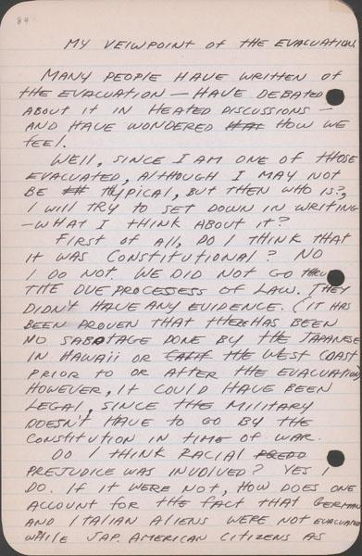
First page: http://www.oac.cdlib.org/ark:/13030/tf6k40056s/?brand=oac4
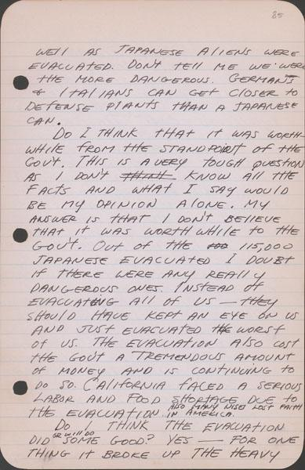
Second page: http://www.oac.cdlib.org/ark:/13030/tf3489n632/?brand=oac4
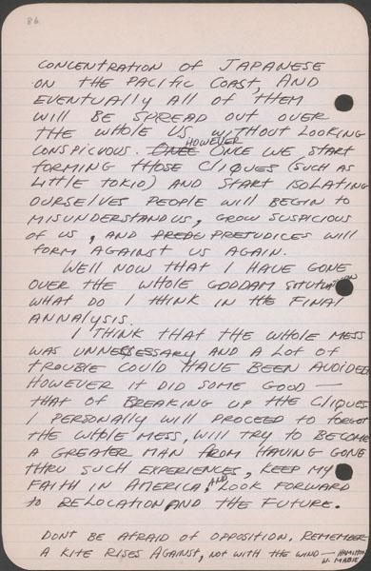
Third page: http://www.oac.cdlib.org/ark:/13030/tf2r29n604/?brand=o

