Essential Question: What conditions prompt immigrants to leave their homeland and/or draw them to come to the U.S. and what challenges do they face when they arrive?

Document Analysis

“The High Tide of Immigration”
Study the image below and answer the questions that follow. View a larger version of the image.
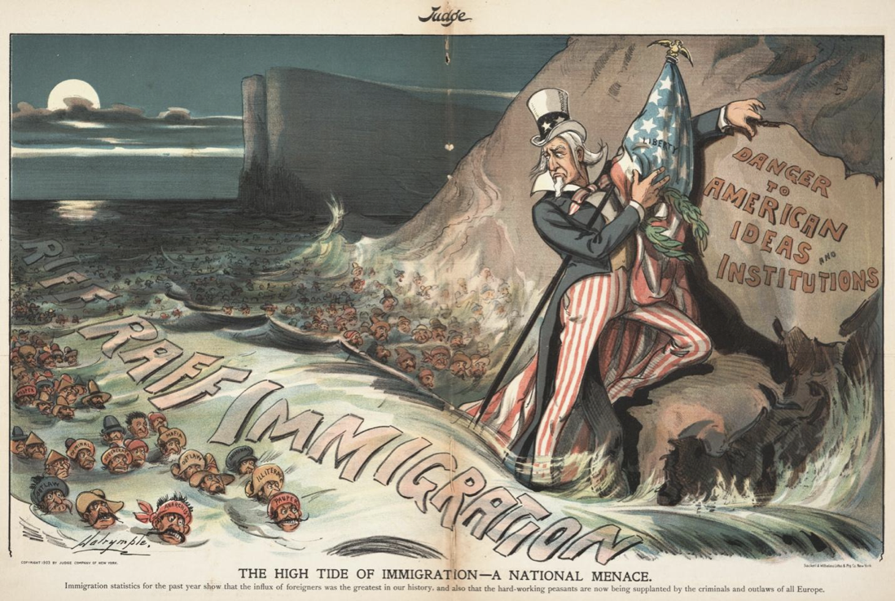
Source: Dalrymple, Louis. 1903. “The High Tide of Immigration—A National Menace.” Judge Magazine (August 22).
Word Bank  Anarchist (n.) – a person who rebels against authority Degenerate (n.) – an immoral person  Illiterate (adj.) – unable to read or write | Mafia (n.) – members of a criminal organization  Menace (n.) – a person who represents a threat  Pauper (n.) – a very poor person

Jot down examples and observations of the following (be specific!):
Words/Phrases:

Objects:

Setting:

Depiction of immigrants:

Discussion Questions
1. What does the cartoon reveal about attitudes and sentiments toward immigrants during the early 20th century? (Be sure to refer to specific words and depictions of the immigrants.)

2. What do you think the title of the illustration means: “The High Tide of Immigration—A National Menace”?

3. Do you think this image could be used today? Why or why not?

4. Think about your experience as Lena and your analysis of “The High Tide of Immigration.” How have attitudes toward immigrants changed, or stayed the same, from the early 20th century until now?

