Essential Questions:
- How do members of immigrant families depend on each other and their community for support?
- How do immigrants balance their commitment to family and ethnic or religious traditions with their desire to assimilate, or explore new opportunities and identities in America?

Document Analysis

Look closely at the image and read the caption. Then answer the questions below.
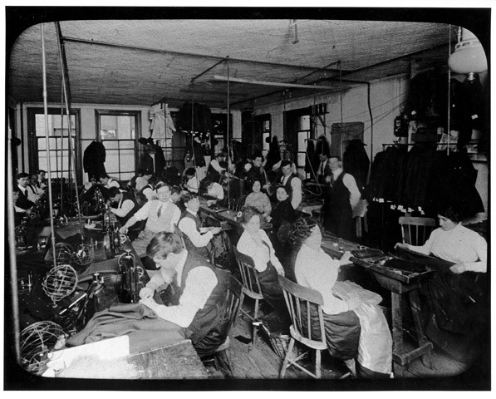
Lewis Hine, ca. 1910. Source: The 1911 Triangle Factory Fire, Kheel Center, Cornell University, https://trianglefire.ilr.cornell.edu/slides/231.html

Photographer’s Note: Hand sewing is done by men and women facing a narrow bench, while men operate sewing machines at a long row of paired workstations. Some unethical subcontractors took advantage of newly arrived immigrants, forcing them to work long hours for the right to keep their jobs. A standard 56-hour week might stretch to 70 hours without overtime pay.

Jot down your observations about the following (be specific!):
Physical setting:

What sitting and standing people are doing:

Gender and age of people:

Why Lena might want to be there:

Why Lena might not want to be there:

Discussion/Writing Questions

- What were some of the pros and cons of working in a workplace like this garment factory for an early-20th-century immigrant like Lena?

- How did workplaces like this, and other gathering places for young people, promote assimilation for early-20th-century immigrants—the process of “becoming American”?
- Do you think becoming “American” today is a similar process, or have the steps to embracing American culture changed?

