**Essential Questions:**

* How do members of immigrant families depend on each other and their community for support?
* How do immigrants balance their commitment to family and ethnic or religious traditions with their desire to assimilate, or explore new opportunities and identities in America?

# Document Analysis

Look closely at the image and read the caption. Then answer the questions below.

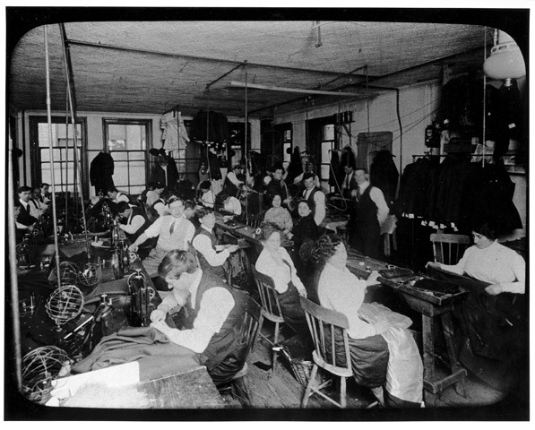

Lewis Hine, ca. 1910. Source: The 1911 Triangle Factory Fire, Kheel Center, Cornell University, <https://trianglefire.ilr.cornell.edu/slides/231.html>

*Photographer’s Note: Hand sewing is done by men and women facing a narrow bench, while men operate sewing machines at a long row of paired workstations. Some unethical subcontractors took advantage of newly arrived immigrants, forcing them to work long hours for the right to keep their jobs. A standard 56-hour week might stretch to 70 hours without overtime pay.*

Jot down your observations about the following (be specific!):

**Physical setting:**

**What sitting and standing people are doing:**

**Gender and age of people:**

**Why Lena might want to be there:**

**Why Lena might not want to be there:**

## Discussion/Writing Questions

1. What were some of the *pros* and *cons* of working in a workplace like this garment factory for an early-20th-century immigrant like Lena?
2. How did workplaces like this, and other gathering places for young people, promote *assimilation* for early-20th-century immigrants—the process of “becoming American”?
3. Do you think becoming “American” today is a similar process, or have the steps to embracing American culture changed?

**Time:** At least 20 minutes

**Instructions**

**Document Analysis** (10 min)

This document offers an opportunity to help students understand the difference between sweatshops (small, family-run operations, usually in tenement flats) and factories (larger operations that brought together workers from different ethnic backgrounds).

If possible, project the photograph large enough so that students can see details. Here is a link to a [large version](https://trianglefire.ilr.cornell.edu/slides/231.html).

Consider modeling a close reading of the image by pointing out some aspects. Then let students work in groups or individually to complete their close reading.

If needed, help students notice that whereas both men and women are seated and working, only men are standing (and are likely supervising).

**Discussion/Writing** (10 min)

Elicit from students a range of workplace pros and cons for immigrants, for example:

* **Pros**: wages to help your family, spending money for fun, a chance to meet new people from different backgrounds, time in mixed-gender company, more possibility for practicing English
* **Cons**: crowded and possibly unsafe conditions, long hours, low pay, pressure from bosses to work faster

Help students think about ways assimilation today may be similar (children of new immigrants still feel the pull of peers and usually find it easier to navigate American culture than their parents) and different (assimilation may happen faster now because of media and technology, and there is more opportunity for young immigrants to go to school longer and, perhaps, go to college) from the early 20th century.