Essential Question:
What were the conditions that immigrant workers faced in the large garment factories, and what were some of the ways that workers and urban reformers responded to those conditions?

Document-based Writing Activity

The Role of Women in the Progressive Era
How did young immigrant women like Lena contribute to social change in the Progressive Era? Drawing from the documents below, describe two ways that immigrant women participated in American society at the start of the 20th century—as workers, labor organizers, and/or social reformers.
First, use the note-taking tool below to take notes on the four documents.
Then write two paragraphs explaining two ways women participated in changing American society at this time. In each paragraph, be sure to cite details from the documents to support your statements.

Document Note-Taking Tool: Women’s Roles in the Progressive Era
Name of Document:
Activities women  are doing: | Why they are doing  the activity: | Social changes they are part of:
- Industrial work/labor organizing
- Social reform
How women are contributing to change:

Document 1

Inside a Garment Factory, 1910
After 1900, immigrant women played an ever-larger role in the garment industry. In this image, hand sewing is being done by men and women facing a narrow bench, whereas men operate sewing machines at a long row of paired workstations. Male managers (standing) keep watch over the workers.
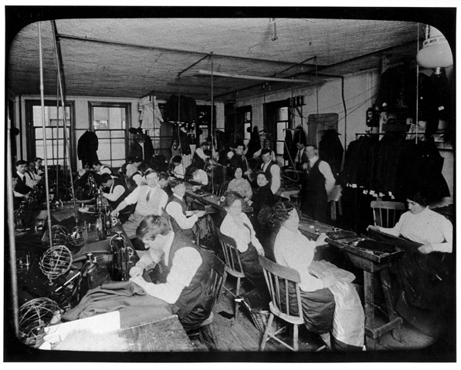
Photographer: Lewis Hine, ca. 1910. Source: The 1911 Triangle Factory Fire, Kheel Center, Cornell University, https://trianglefire.ilr.cornell.edu/slides/231.html

Document 2

“30,000 Waist Makers Declare Big Strike” (Article Excerpt)
This 1909 newspaper article describes a gathering of thousands of female shirtwaist makers. During the meeting, the workers made the decision to go on strike from their jobs to demand better working conditions. The article quotes strike supporters Samuel Gompers, the head of the American Federation of Labor Union, and Clara Lemlich, a young female worker.
Thirty thousand ladies waist makers, driven to desperation by the intolerable conditions prevailing in their trade, voted to go on a general strike last night at four enormous mass meetings.
The decision to strike was first reached at the Cooper Union meeting, where Samuel Gompers, president of the American Federation of Labor Union, said: "I have never declared a strike in all my life, but there comes a time when not to strike is but to rivet (fasten) the chains of slavery upon our wrists. When you can't get the manufacturers to give you what you want, then strike. And when you strike, let the manufacturers know you are on strike!”
This was greeted with a storm of applause.
Clara Lemlich, who was badly beaten up by thugs during the strike in the shop of Louis Leiserson, said: "I wanted to say a few words." Cries came from all parts of the hall, "Get up on the platform!"
Willing hands lifted the frail little girl with flashing black eyes to the stage. She said simply: "I have listened to all the speakers. I would not have further patience for talk, as I am one of those who feels and suffers from the things pictured. I move that we go on a general strike!"
Source: “30,000 Waist Makers Declare Big Strike.” 1909. The New York Call. November 23. [Text adapted for readability]

Word Bank  intolerable (adj.) – unable to be endured  prevailing (adj.) – existing | Cooper Union meeting (n.) – a large workers’ meeting held at the Cooper Union, a New York City auditorium  thugs (n.) – people hired by garment manufacturers to intimidate striking workers

Document 3

Jane Addams and Hull House: Aid for Immigrant Workers
Jane Addams was a reformer and social activist who created one of the first settlement houses for immigrants—Hull House in Chicago. In this document, a young Polish immigrant and garment worker describes what it was like to enter a settlement house for the first time and to meet Jane Addams.
One evening in 1900, after a particularly boring day at the factory, I decided to walk over to Hull House three blocks from where I lived. This event marked the beginning of a new life for me. I was lucky. Jane Addams happened to be in the reception room when I came in.
Miss Addams came up to me and asked whether I would like to join a club or a class or perhaps the gymnasium. For a moment I just stood there looking at her. Her face made me forget cuffs and monotony.
“I really don’t know what I want,” I said. “You come with me,” she said, taking my hand. “I think you will like to do this.” She took me up a flight of stairs and then down a flight and we came to the Labor Museum. The museum was a very special addition to the work at Hull House and very dear to her heart. I believe that I was the first student to work in the museum.
I soon branched out into other activities. I joined a reading class. The daily monotony of making cuffs was eased by thinking of these books and looking forward to evenings at Hull House.

Source: Polacheck, Hilda Satt. 1989. I Came a Stranger: The Story of a Hull House Girl (pp. 63–64). University of Illinois Press. [Text adapted for readability]
Word Bank

reception room (n.) – room where visitors are greeted
forget cuffs and monotony – forget about the boredom and difficulty of making shirtwaists all day
daily monotony (n.) – tiresome repetition

Document 4

Lillian Wald, Public Health Pioneer
In the 1890s, Lillian Wald, a New York City nurse, was shocked at the poor living conditions that immigrants on the Lower East Side had to endure. She founded the Henry Street Settlement, which sent nurses into tenement housing to provide public health services to poor immigrants. In the photo below, a visiting nurse crosses over roofs to save time and avoid endless flights of stairs.

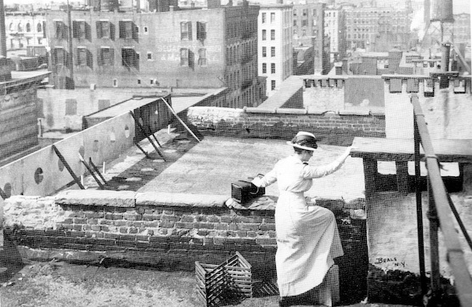
Photographer: Jesse Tarbox Beals, ca. 1915. Source: Jewish Women's Archive. "Visiting Nurse on Tenement Roof, 1915.” https://jwa.org/media/visiting-nurse-takes-shortcut-over-roofs-of-tenements.

