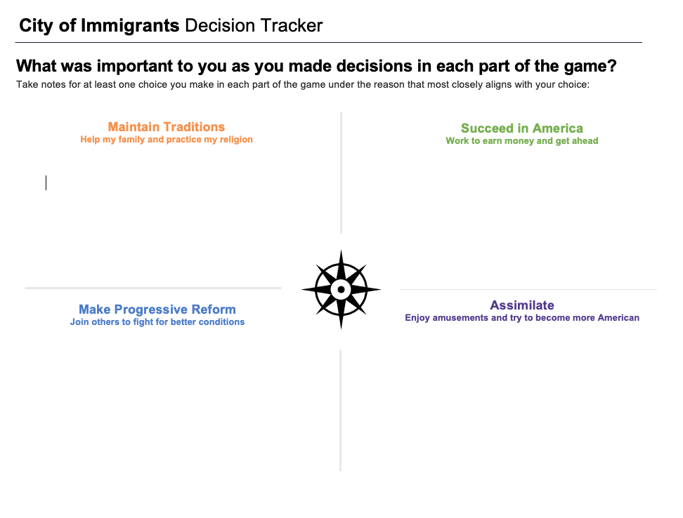

**Time:** At least 20 minutes

**Instructions**

Explain to students that as they play *City of Immigrants* they will be asked to make many choices that will determine the outcome for Lena, the character they are playing. They can choose what type of person they want their Lena to be through the choices they make. Part of the fun and value of role-playing games is the ability to take on different personalities and explore different options.

Assure students that there are no right or wrong answers and that it is fine to make choices that may be considered risky or bold. Explain that the process of thinking about different choices and their possible outcomes can help them to gain empathy—an understanding of the feelings of others—especially for historical characters. Ask students to consider how Lena as a young, Jewish woman and an immigrant from Russia may make different decisions than young people today.

Ask students to record their progress as they play the game on the **Decision Tracker**. They should make a short note whenever they make a key decision, pausing to think about the following:

* Why are they making that choice?
* Is this the choice they themselves would make or that they think a 1907 immigrant would make?
* How might Lena’s gender, ethnic background, religion, or age shape the choices they make for her?
* Which of the reasons on the chart does the choice represent?

Print the student version of the **Decision Tracker** and distribute to students so they can use it every time they play the game. The tracker will be used for a culminating activity.