Essential Question: What conditions did ordinary Americans face during the early years of the Great Depression, and how did they respond?

Document Analysis

Text Analysis: Bonus Army Memoir
Read the following excerpt from W.W. Waters’ memoir and answer the questions that follow.

In the following memoir, World War I veteran W.W. Waters recalls the high unemployment and low morale he witnessed on the streets of Portland, OR, during the first years of the Great Depression. Facing a similar situation himself, Waters was a founding member of the Bonus Expeditionary Force, a large group of veterans who marched from Oregon to Washington, DC, in the spring of 1932 demanding immediate payment of their war bonuses.
In my ceaseless beating about the city I found family after family in the same general condition or worse. I saw men half clad, in threadbare clothing, pacing the streets in soleless shoes. On their faces was the same look, part hope, part bewilderment, as they searched for a chance to earn a few dollars at honest work. I talked with hundreds of these men and found that, with few exceptions, they wanted not charity but work that would enable them to live and to regain their self-respect …
These men had fallen far down into the valley of despair. Some push was necessary to start them out and up over the hill. Jobs would have provided the best sort of impetus but there were no jobs. The Bonus, a lump sum of money, could act in the same fashion. Debts could be met, doctors’ bills paid, a fast fraying credit renewed, and one man could look another in the eye once more.
Source: Waters, W. W. & William C. White. 1933. B.E.F. The Whole Story of the Bonus Army (pp. 6–10). New York: The John Day Company. http://catalog.hathitrust.org/Record/001874081
Word Bank  memoir (n) – a first-person historical account  low morale – lack of confidence or motivation  ceaseless (adj) – without end  threadbare (adj) – cloth that is thin and tattered with age | soleless (adj) – shoes with bottoms that are worn out  bewilderment – a feeling of being confused or lost  valley of despair – a place with no hope  impetus (n) – a force that makes something happen  Bonus (n) – a payment the US government promised to those who fought in WWI, that veterans were demanding  fraying (v) – wearing out

Document Analysis Questions
Highlight three or four phrases that stick out to you in the passage.
- What do these phrases reveal about how the writer, W. W. Waters, felt after walking the streets of Portland during the early years of the Great Depression?

- According to Waters, what did these veterans need and why? How would a “bonus” for veterans provide relief?

Photograph Analysis: Hoovervilles
The images below capture Hoovervilles in the 1930s. Look closely at both images, read the descriptions, and then complete the chart that follows.

Seattle Hooverville
The Great Depression left millions of Americans unemployed. Some Americans and their families, unable to afford rents or mortgages on their homes, were forced to live on the streets. Massive shantytowns called “Hoovervilles”—named for President Hoover, whom many Americans blamed for the Depression—sprang up as temporary housing for the newly homeless. Seattle’s largest Hooverville (seen in this photograph from 1933) stretched over 9 acres and consisted of hundreds of shacks without electricity or running water.
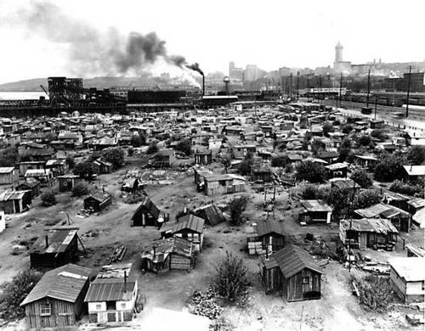
Homeless shantytown known as a “Hooverville,” foot of S. Atlantic St, ca. 1933, Seattle, Washington.
Source: University of Washington Libraries. Special Collections Division. Seattle Photograph Collection.
http://digitalcollections.lib.washington.edu/cdm/singleitem/collection/seattle/id/1167/rec/14

St. Louis, Missouri, Hooverville
Some of the Hoovervilles lasted for many years and created community-based services for the residents, including soup kitchens (as seen in this photo from 1932). Near this St. Louis Hooverville located along the Mississippi River, a local philanthropist helped set up a cooperative food distribution and canning center that supplied food for the needy and employed residents of the Hooverville.

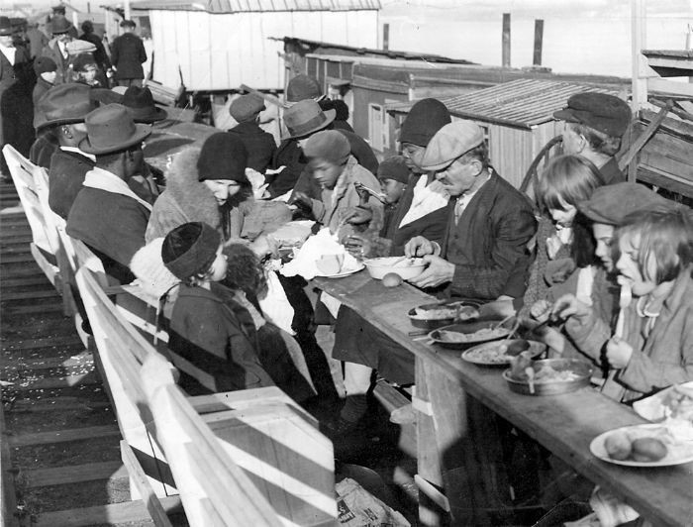
Hooverville residents eat meals provided by a charity on Dec. 4, 1932. Fortunately for the 1,500 diners, it was a balmy 52 degrees that day. St. Louis, Missouri.
Source: St. Louis Post-Dispatch photo archives
https://www.stltoday.com/news/archives/

Note-Taking Tool: Photograph Analysis
After closely studying the images, jot down your observations about the following in the chart (be specific!).
Describe what you see. | What do you learn about Hoovervilles by viewing the image?
What do you learn about Hoovervilles by reading the captions? | What is the mood or feeling of the image? How is that communicated?

Discussion Questions
- Based on Frank’s and Ginny’s experiences and your analysis of the images and memoir excerpt above, what conditions did ordinary Americans face during the early years of the Great Depression, and how did they respond? What strategies did they use?

- How does the response of Americans in the 1930s compare to how you think Americans would respond to similar conditions today?

