Essential Question: How did President Roosevelt and his New Deal programs try to ease the economic hardships of the Depression for many, but not all, Americans?

Document-based Writing Activity

Different Perspectives on the New Deal
In the 1930s, New Deal programs represented a huge increase in the role of the national government in Americans’ lives. For the first time, the government provided direct aid to the hungry, gave work to the unemployed on public works projects, and paid young men to build forest trails in Civilian Conservation Corp camps.
Most Americans were grateful for these government programs, which helped meet the needs of many citizens. But others found that the programs did not reach all Americans equally—and they asked the government to do more to reach all people in need.

Document and Photo Analysis
Use the Note-Taking Tool below to take notes on four of the six documents that follow.

Writing
Once you have completed the document analysis, write two paragraphs:
- Paragraph 1: How New Deal programs were successful in easing the economic hardships of many Americans
- Paragraph 2: How some Americans found the programs unfair or inequitable, and wanted changes
Be sure to cite details from the documents to support your statements.

Note-Taking Tool: Perspectives on the New Deal
Document Name | Whose experience is the focus of the document?  What do you know about them? | What New Deal program is the document about?  What impact is government relief having on ordinary people? | How does the speaker or subject feel about the New Deal program?  Note words or phrases that support your conclusion.

Document 1

A Citizen Reports on How the New Deal Has Affected His Life
In a June 1934 radio broadcast, President Roosevelt asked his listeners to answer four questions to see if they personally were experiencing recovery from the New Deal. The writer of this letter answers the questions and mentions the Home Owner’s Loan Corporation, a New Deal program that allowed homeowners to refinance their mortgages to prevent foreclosure.
July 3, 1934
My dear Mr. President:
Thank you many times for your cheerful message over the Radio. My family and I answered each of your questions as they were asked, in the affirmative, some in the negative. “Are you better off than last year?” Yes, decidedly. “Are your debts less burdensome?” Yes, Yes, thanks to your Home Owner’s Loan Corporation.
Before now only the wealthy could hope to receive favors from our Government, but now even the “forgotten man” is remembered. “Is your bank account more secure?” Absolutely! “Is your faith in your future more firmly grounded?” Yes.
And now the negatives. “Have you lost any rights of freedom of action or choice?” None whatsoever, but I have gained some greater freedom under the New Deal.
Let the Government continue to appoint and manage The New Dealers, and not listen to the clamoring of the Old Crowd...

John Pauer
Sacramento, Calif.

Source: Pauer, John. 2022. A Citizen Reports How the New Deal Has Impacted His Life (with text supports), SHEC: Resources for Teachers. https://shec.ashp.cuny.edu/items/show/730. [Text adapted for readability]

Word Bank  recovery (n) – return to a healthy state  refinance their mortgages – get a new loan on their homes or property  prevent foreclosure – stop the banks from taking over homes or property due to lack of loan payments  affirmative (n) – in agreement with | negative (n) – in disagreement with  New Dealers – politicians and policymakers supporting the New Deal  clamoring (v) – making noise or expressing dissatisfaction  Old Crowd – opponents of the New Deal

Document 2

Nursery in a Federally Run Migrant Workers Camp
As drought and dust storms forced Great Plains farmers to abandon their land, thousands migrated to California in search of agricultural work. Many work sites had only crude shacks for the workers to live in, and often they had to camp on roadsides. If migrants were lucky, they could find housing in a government-run migrant camp, like the Sunset Camp in Kern County, pictured below. This camp offered not only housing, but also childcare and medical services, so when parents were working in the fields their children were cared for.
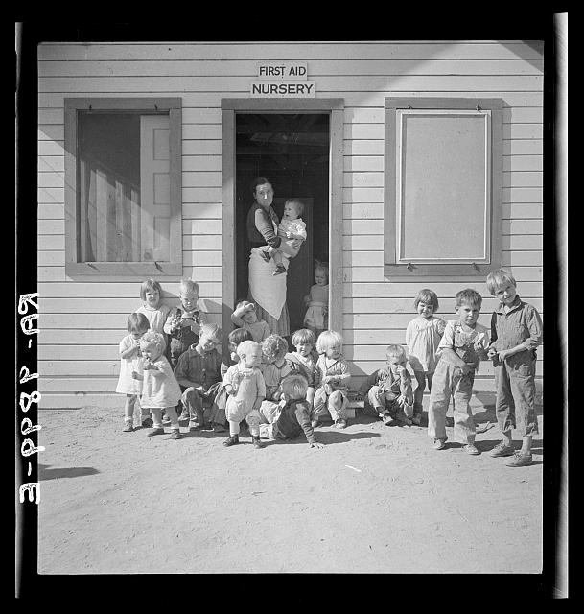
Source: Photographer: Dorothea Lang, 1936, November. FSA/OWI Photograph Collection (Library of Congress).
https://www.loc.gov/item/2017763241/

Document 3

Workers’ Views of the New Deal
In this letter to President Roosevelt written in 1936, Michigan workers express their gratitude for the Works Progress Administration (WPA) programs and urge the president to continue WPA efforts. The letter describes how working improves their self-esteem and makes them feel like active participants in society.
Battle Creek Mich.
April 5, 1936
President Roosevelt:
Please continue this W.P.A. program. It makes us feel like an American citizen to earn our own living. Being on the dole or relief roll makes us lazy and the funds are not enough to live decent on. We are thankful for what we receive though.
So we as W.P.A. workers in Battle Creek Michigan, appeal to you as our Great Leader to continue this great cause for Better citizens in Battle Creek Michigan.
Your Faithful,
W.P.A. workers of Battle Creek

Source: Various. 2022. Workers Applaud the New Deal's Works Progress Administration. SHEC: Resources for Teachers. https://shec.ashp.cuny.edu/items/show/680

Word Bank
gratitude – (n) being thankful
dole or relief (n) – government aid to the poor or unemployed

Document 4

“They give us black folks…nothing” A Black Resident of Georgia Writes to President Roosevelt
While the New Deal was a federal government program, much of the direct aid to families was distributed by local governments and organizations. In some regions, this aid was not distributed to all residents equally. In this letter, an African American in Georgia writes to Franklin D. Roosevelt to tell how discrimination in his community means that Black citizens are not receiving the relief they are entitled to under New Deal programs.

Reidsville, Georgia. Oct 19th, 1935
Hon. Franklin D. Roosevelt
President of U. S. Washington D. C.
Dear Mr. President,
Would you please direct the people in charge of the relief work in Georgia to issue the provisions and other supplies to our suffering colored people?
I am sorry to worry you with this Mr. President but, hard as it is to believe, the relief officials here are using up most everything that you send for themselves and their friends. They give out the relief supplies here on Wednesdays. They give us black folks, each one, nothing but a few cans of pickled meat, and to white folks they give blankets, bolts of cloth and things like that.
Please help us Mr. President because we can’t help ourselves and we know you are the president and a good Christian man and we are praying for you.
Yours truly,
Can’t sign my name Mr. President or they will beat me up and run me away from here and this is my home
Source: Anonymous. 2022. An African American Describes Why New Deal Relief Is Not Reaching the Black Community (with text supports). SHEC: Resources for Teachers. https://shec.ashp.cuny.edu/items/show/737 [Text adapted for readability]
Word Bank
discrimination (n) – unfair treatment
provisions (n) – food and clothing
colored – (adj) A commonly used term in the early 20th century for non-white people, places or things. The term is no longer used in the United States and now is considered offensive.
relief (n) – government aid to the poor or unemployed

Document 5

The NAACP Challenges Social Security
After President Roosevelt sent his Social Security bill to Congress in January 1935, Congress held committee hearings on it. Here, a representative of the National Association for the Advancement of Colored People (NAACP), a group dedicated to advancing the rights of African Americans, testifies before Congress about how the bill excludes African Americans.
Mr. Houston: The point I am making is that in order to qualify for Social Security benefits a person must pay taxes before the day when he reaches 60 years. Now, I want to ask — who would be excluded by that provision?
First, and very serious, Negro share croppers and cash tenants would be excluded. Negro share croppers and Negro cash farm tenants are just about at the bottom of the economic scale. They are not employed. They do not get wages on which a tax could be levied. Therefore, this population is excluded from the entire benefits of Social Security. And this represents approximately 490,000 Negroes according to the 1930 census.
Next, domestic servants are excluded from the act, because the system of employing domestic servants is so loose. You know that many Negroes are domestic workers.
In addition to that, Social Security does not provide for those who are unemployed. And it is well known that Negroes have suffered from unemployment more than any other class of the community.

Source: The Statement of Charles H. Houston, representing the NAACP, to the House Ways and Means Committee on the Economic Security bill. February 1, 1935. Washington, DC. Excerpt from Historical Thinking Matters. http://historicalthinkingmatters.org/socialsecurity/0/inquiry/main/resources/34/ [Text adapted for readability]

Word Bank
Social Security – government program that provides payments to elderly and disabled persons  testifies (v) – to speak publicly and provide evidence  share croppers – (n) farmers who do not own the land and owe a share of the crop to the landowner | cash tenants (n) – farmers who do not own the land and pay cash to the landowner  farm tenants (n) – farmers who do not own the land and pay cash or produce to the landowner  domestic servants (n) – persons who work in private homes as cooks, maids, or childcare workers

Document 6

New York Girls Ask the President for a CCC of Their Own
The Civilian Conservation Corps, established in 1933, employed a quarter of a million young men annually who lived in military-style camps and carried out conservation and construction projects. It proved to be one of the most popular New Deal programs, but it did not include women. … This letter, from eight anonymous young women in upstate New York, asked President Roosevelt for just such a program.
Homer, New York, Feb. 11, 1935
Mr. Roosevelt,
In Homer, a lot of us girls think that seeing there is a CCC camp for boys that there should be one for girls. In a book, we read about a military camp for girls. It told how in the morning the girls have to attend school for so long and in the afternoon too. They had to learn how to sew and nurse the sick. They had to make clothes for the poor. A camp like that would give young girls a place to go. We are not very old ourselves, from 13 on up, but we get in a lot of trouble just the same. And we think you might try to do something about it so that girls our age could do something like we mentioned and not have to wait until they are 17-18 or 19 years of age. We know how to sew and cook, we used to belong to “4-H” and “Girl Scouts” and in school there are a lot of cranky old teachers, and the children think themselves so high above us girls. If you should care to give us your answer, you can broadcast it over the Radio at noon between 5:00-5:30 at station B.E.N. Buffalo. If you don’t answer before the 28th of February, we will know you aren’t going to help us. Why we are writing is because we want to get away from home and get a change in life. And we thought maybe you would help us.
Don’t put this in the papers. If you do, leave out where the Letter came from.
Signed,
The Eight Secret X’s
XXX
Source: Anonymous. 2022. New York Girls Ask the President for a CCC of Their Own. SHEC: Resources for Teachers. https://shec.ashp.cuny.edu/items/show/729 [Text adapted for readability]
Word Bank
conservation (n) – protecting natural resources
anonymous (adj) – unknown
Homer – town in New York State

